**Case Study:**

**Paparazzi Love Your Shine Database System**

**Dayana Fernandez**

**Towson University**

**AIT 735**

**Prof. Harry Shasho**

**August 5, 2018**

Table of Contents

I. Abstract 2

II. Narrative Description 2

III. Detailed Requirements Specification 4

IV. Entity Relationship Diagram 7

V. Data Dictionary 8

VI. Proposed Architecture Plan 10

VII. Actual Architecture 11

VIII. Test Cases 12

IX. Proposed Schedule 68

X. Actual Schedule 69

XI. Challenges & Lessons Learned 70

XII. Acknowledgements 71

XIII. Reading List/Bibliography/Works Cited 72

## I. Abstract

The purpose of this case study is to develop a database for an independent consultant of Paparazzi Accessories, an online jewelry company. She has been a consultant for almost a year and hopes to expand her venture, meaning that her inventory and clientele will grow as well. This will have an impact because it will help her keep track of what she has, who shops with her, and her sales so it will aid in keeping her organized, and enable her to also keep track of trends, in order to provide a more personalized experience for her customers. I will primarily be using Oracle APEX for the development of this system.

## II. Narrative Description

This is a database that will be developed for a legitimate company consultant. I have a friend who has been an independent consultant for Paparazzi Accessories (an online jewelry company) for about a year. The consultant accepts online orders, and also does weekly online lives where customers can watch and order from her and have items shipped, picked up or delivered. Because her business continues to expand, and her inventory keeps increasing, she needs to keep track of what she has, and what she needs and would like to be able to do it in an efficient way, which is how the idea for this system came about. I am one of her customers, so I know a lot about her operation.

There are there four separate collections of inventories that she sells: the regular collection and the Blockbuster collection, where all pieces are $5.00, the Zi collection, where all pieces are $25, and lastly the children’s collection, Starlet Shimmer, where all pieces are $1. This will all be part of an inventory table. There will also be a customer table, an order table, and a sale by item table. The sales table will contain the individual sales by item and this table is being provided so that it can be connected to the inventory tables which will update automatically when items are sold. The order table will contain the orders placed by customers, by total, which will include everything they buy within an order, regardless of what collection they shop in. The customer table will contain identifying information, as well as birthday information. Reference tables will be used to keep track of popular trends. These tables are favorite color, item selection preference and payment preference. Customers have five payment options, but they can choose to change options at any point. Those options are: Cash, check, Paypal, Square, CashApp. The item selection table can have ten different options and it would be how customers can choose their jewelry. Those options are: Facebook live, house party, basket party, company website, in person, photo drop, vending event, hostess party, consultant Facebook wall, and the Facebook business page. The deliverables will be the detailed requirements specification, the entity relationship diagram, the data dictionary, and the architectural plan. The final deliverable is the actual functioning database with all elements included.

This project is suitable in terms of topical alignment because it aligns with all the concepts taught in both Database Management Systems courses, as well Systems Development Process and finally elements of Software Engineering fundamentals. The knowledge gained from all of these courses will ensure that I can develop a well-rounded and completely functional system to can be easily implemented and used with ease by anyone who has a need to do so. The learning elements are those of a relational DBMS, Database design, and advanced SQL to include procedures, triggers and functions. This is suitable because incorporating all of these elements will allow the system that I create to provide everything the consultant needs in order to manage her business and customers as quickly, efficiently, and as effortlessly as possible.

This project is appropriately complex and merits being a capstone project because it contains a significant number of requirements that will result in several main tables and well as several connected tables that serve as lookups, in order to be able to provide the consultant with the most complete system in order for her to keep track of her business and provide her customers with the best service possible. Although customers themselves will not be accessing the system, the fact that it will track all aspect of the business, will allow her to know exactly what she already has and what she needs to reorder in order to keep her customers happy. Further complexity is added because the system will also be able to track buying trends and customers preferences and birthdays so that a personal touch can be added to the customer experience.

I’ve chosen the Oracle Apex framework because of my familiarity with it and because is completely online, therefore accessible from anywhere. This makes it easy for the consultant because although I will be maintaining the system for her, I’ll be able to give her a quick rundown of what she needs to do to be able to use the system on her own, if I’m not available at some point.

## III. Detailed Requirements Specification

**Requirement 1:** (Using a procedure) The system should be able to add new customers making sure that the name is not a duplicate. If a duplicate is entered, the system will return an error message.

**Requirement 2:** (Using a procedure) The system should be able to add new inventory items making sure that items are not duplicates. If a duplicate is entered, the system will return an error message.

**Requirement 3:** (Using a procedure) The system should be able to add new orders. If the order number is a duplicate, an error message will be shown.

(Using a trigger) The system should be able to update the total number of items paid by that customer overall every time they place an order.

(Using a trigger) The system should be able to update the total amount spent by a customer overall every time they place an order.

**Requirement 4**: (Using a procedure) The system should be able to add sales by item.

(Using a trigger) The system should be able to update the quantity available of each item (in inventory) when it is sold.

(Using a trigger) The system should be able to update the price of quantity available (in inventory) of each item when it is sold.

**Requirement 5:** (Using a procedure) Given an order ID, the system should be able to change the payment status from “pending” to “paid” when the order is paid, while also checking to make sure that the order ID is valid. If it is invalid, a message will be displayed to the user.

**Requirement 6:** (Using a procedure) Given an order ID, the system will be able to update order delivery status when an order is shipped, picked up, or personally delivered to a customer while also checking to make sure that the order ID is valid. If it is invalid, a message will be displayed to the user.

**Requirement 7**: (Using a procedure) The system will be able to add multiple favorite colors for customers. If that color has already been entered for the customer, a message will be returned.

**Requirement 8:** (Using a procedure) The system will be able to update customer information, while making sure that a valid customer ID is entered. If not, an error message will be returned.

**Requirement 9:** (Using a procedure) Given a state, the system should be able to list all customers from that state. If there are no customers from that state, an error message will be returned.

**Requirement 10:** (Using a procedure) The system will be able to add multiple payment preferences for customers. If that payment preference has already been entered for the customer, a message will be returned.

**Requirement 11**: (Using a procedure) The system will be able to add multiple selection preferences for customers. If that selection preference has already been entered for the customer, a message will be returned.

**Requirement 12:** (Using a procedure) Given a payment preference, the system should be able to select all customers that prefer to use that particular payment method, while also making sure that the payment method is valid. If it is not valid or if there are no customers that prefer that particular payment method, a message will be displayed.

**Requirement 13:** (Using a procedure) Given an item selection preference, the system should be able to select all customers that prefer to use that particular item selection method, while also making sure that the selection method is valid. If it is not valid or if there are no customers that prefer that particular selection method, a message will be displayed.

**Requirement 14:** (Using a procedure) Given a month, the system should be able to list all customers that have a birthday during that month. If there are no birthdays during that month, a message will be returned.

**Requirement 15:** (Using a procedure) Given a color, the system should be able to select all customers that have that color listed as a favorite. If there are no customers that like that color, an error message will be returned.

**Requirement 16:** (Using a procedure) Given a city, the system should be able to select all customers that live in that city. If there are no customers that like that color, an error message will be returned.

**Requirement 17:** (Using a procedure) Given a zip code, the system should be able to select all customers that live in that zip code. If there are no customers from that zip code, an error message will be returned.

**Requirement 18:** (Using a procedure) Given a collection, the system should be able to select all inventory from that collection, while also making sure that the user has entered a valid collection. If not, a message will be displayed.

**Requirement 19:** (Using a procedure) Given an item type, the system should be able to select all inventory of that type. If the inventory type is not valid or if there is not inventory of that type, a message will be returned.

**Requirement 20:** (Using a procedure) Given an item color, the system should be able to select all inventory of that color. If no inventory of that color is available, then a message will be returned.

**Requirement 21**: (Using a procedure): Given a month, the system will be able to select all orders placed within that month. If there are no orders during that month, then a message will be returned.

**Requirement 22**: (Using a procedure): Given an Item_ID, the system will be able to select all sales of that item. If there are no sales of that item, then a message will be returned.

**Requirement 23**: (Using a procedure): Given a payment status, the system should be able to select all orders with that status.

**Requirement 24**: (Using a procedure): Given a delivery status, the system should be able to select all orders with that status.

**Requirement 25**: (Using a procedure) Given an item type, the system should be able to select all customers who have frequently bought that particular item type.

**Requirement 26:** (Using a procedure) Given a customer ID, the system should be able to select all the orders placed by that customer.

## IV. Entity Relationship Diagram



## V. Data Dictionary

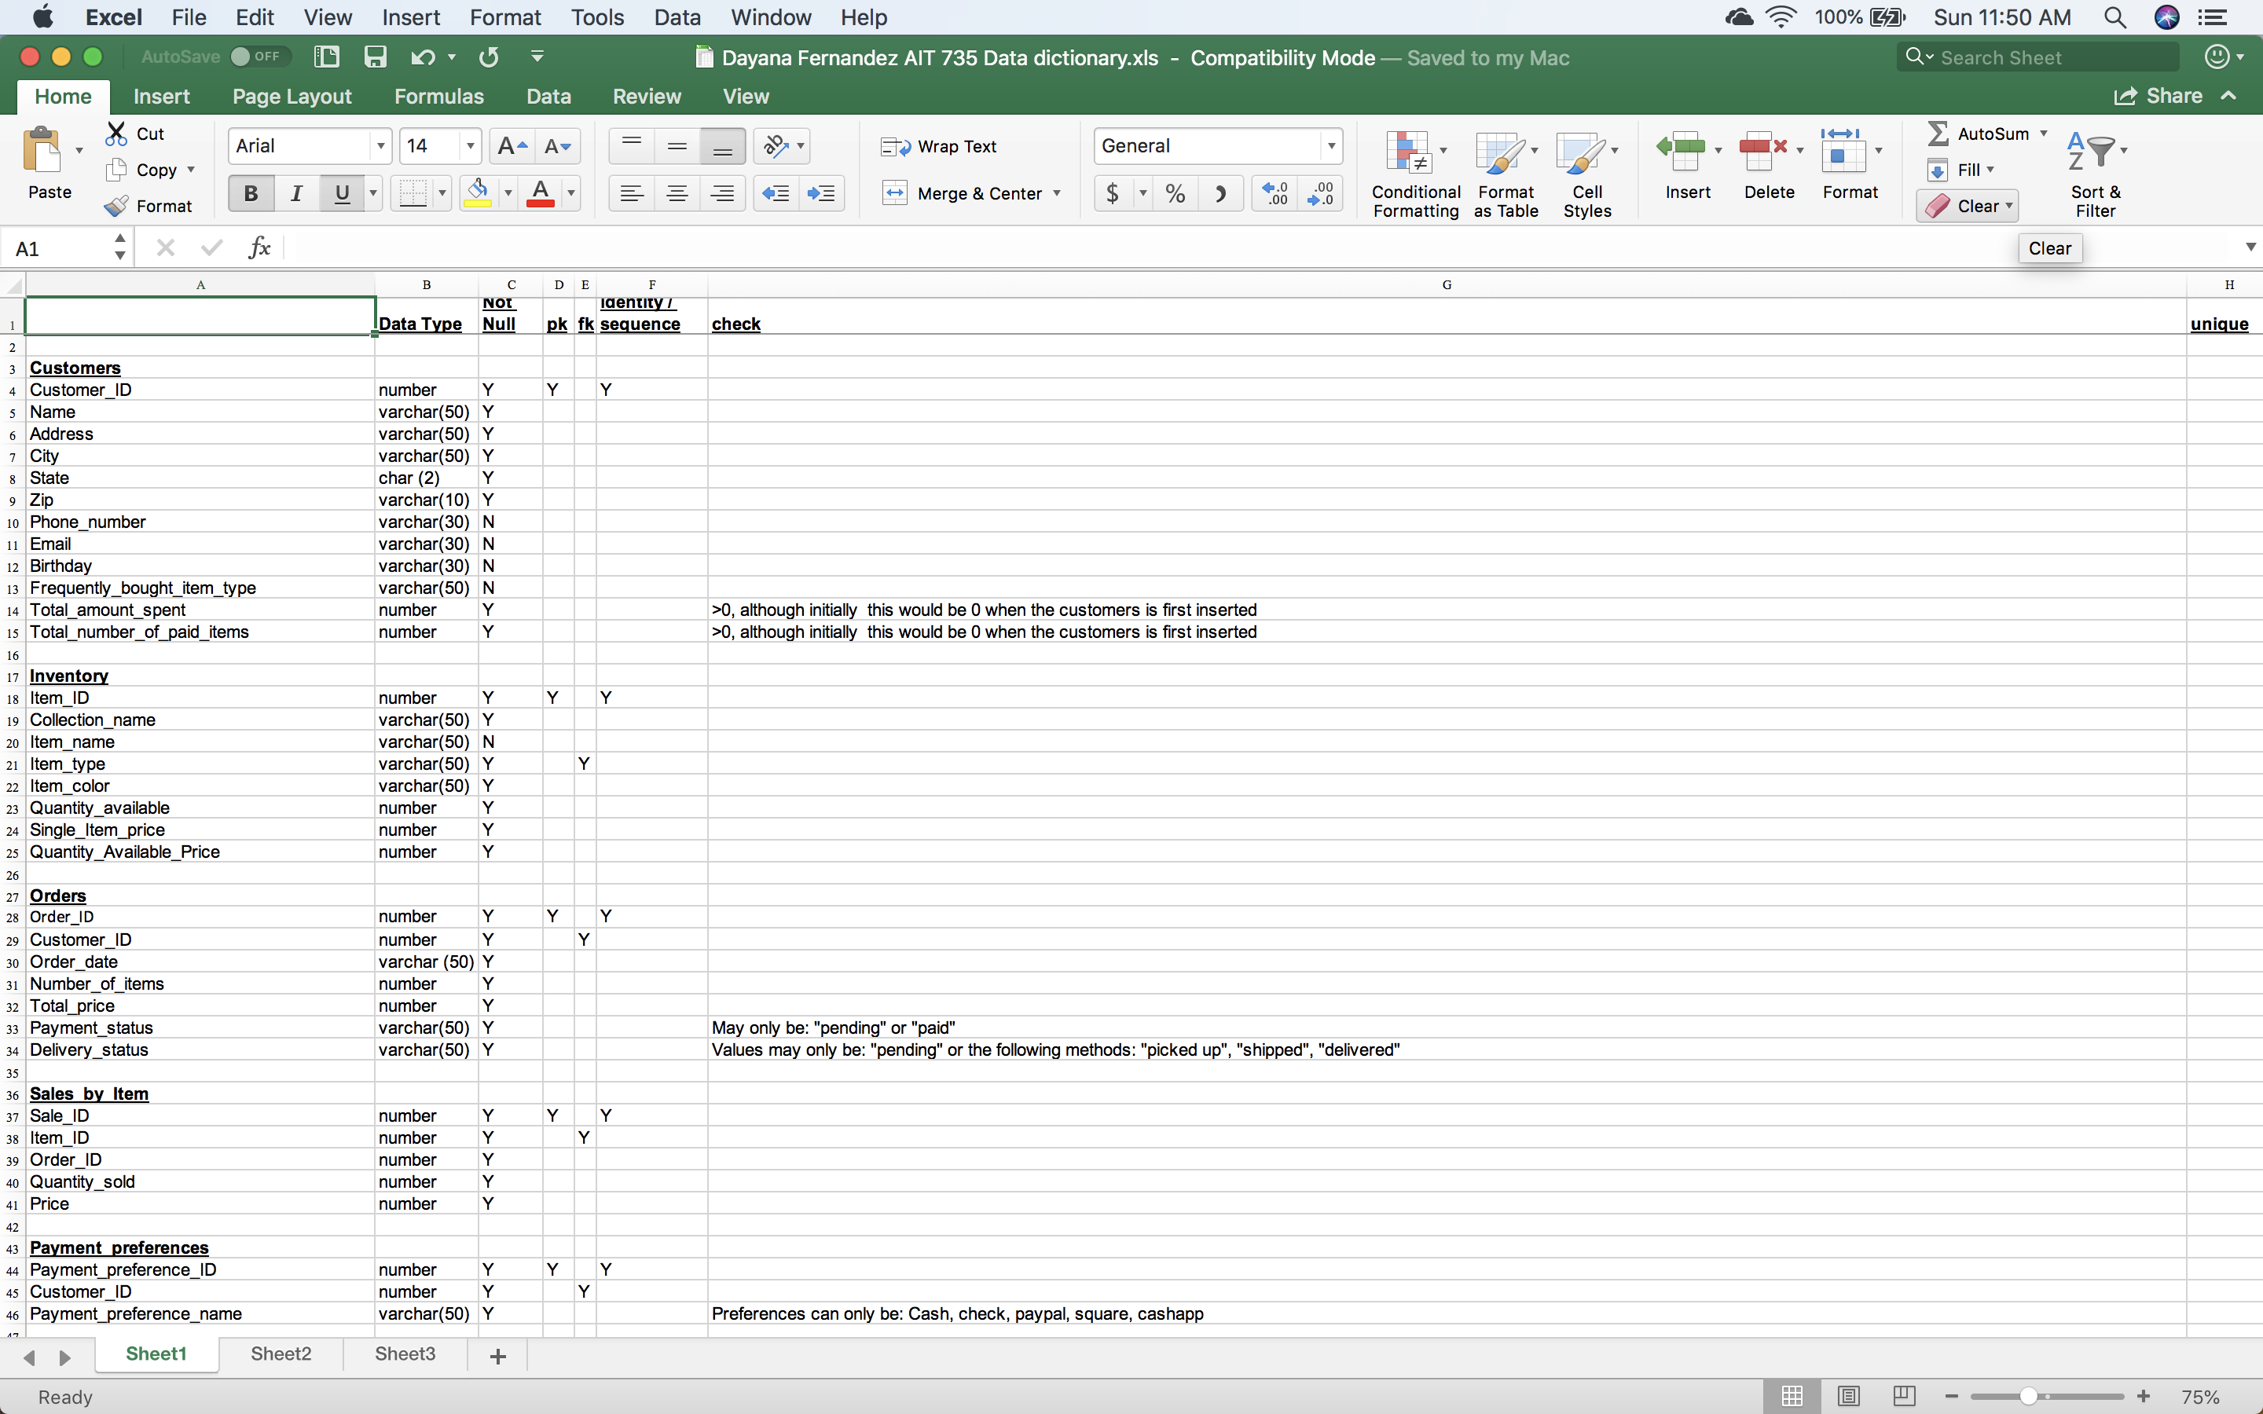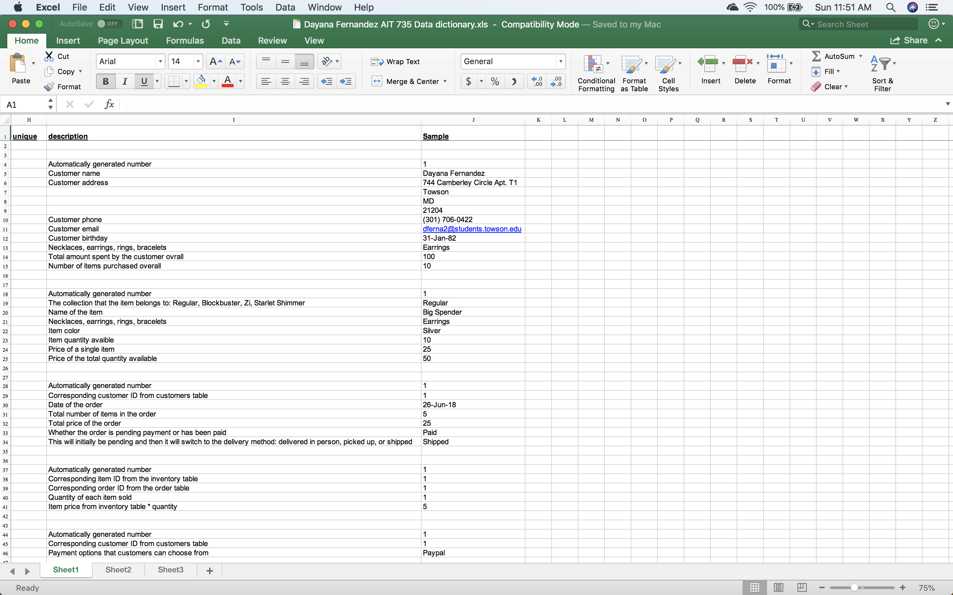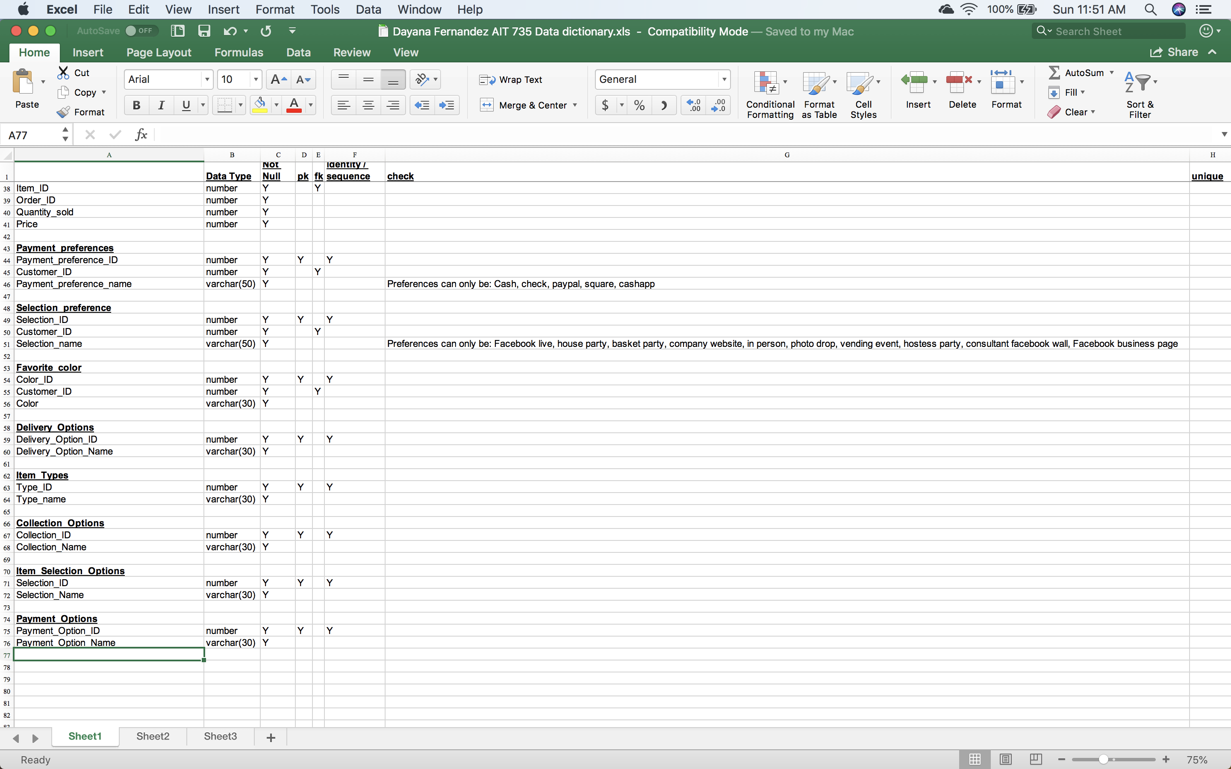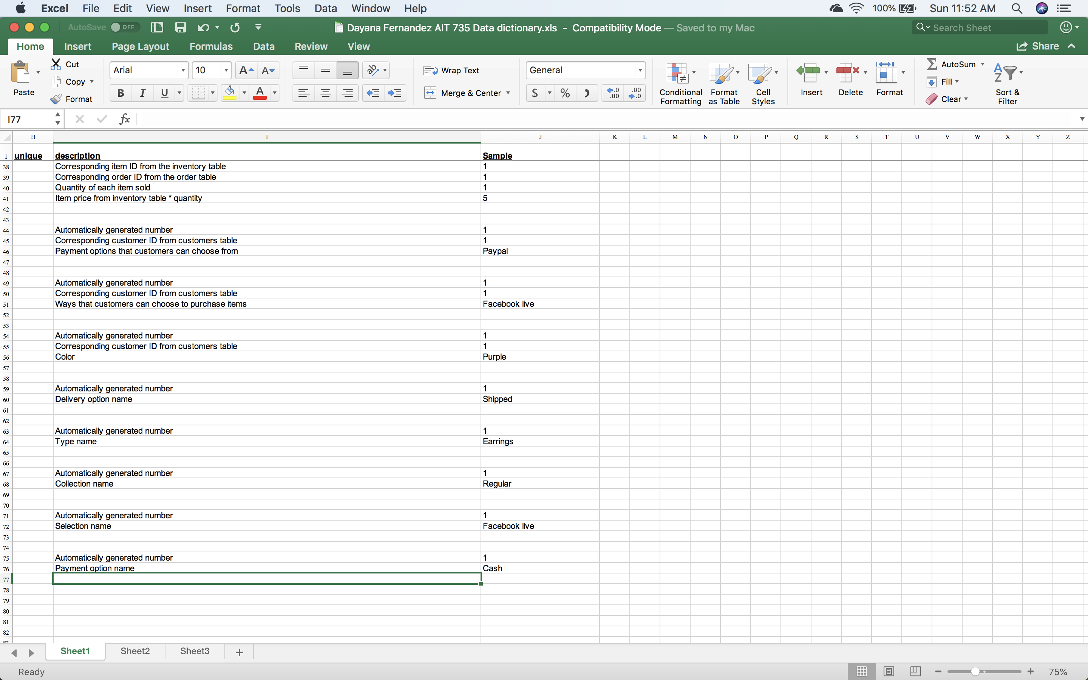

## VI. Proposed Architecture Plan

I will be using Oracle Apex to design and implement this system. I’ve chosen this framework because of my familiarity with it and because is completely online, therefore accessible from anywhere. This makes it easy for the consultant because although I will be maintaining the system for her, I’ll be able to give her a quick rundown of what she needs to do to be able to use the system on her own, if I’m not available at some point. This database will be accessed by the consultant and myself (at least initially), as I will be the one maintaining it on a regular basis. In terms of actual memory, disk space and the number of servers, APEX documentation mentions that in order to be used effectively “the system global area (SGA) and program global area (PGA) is required to be at least 300 MB.” [8] But I would probable use one or two servers if I were going to implement something other than an online tool because of the amount of information that I’ll be dealing with because of inventory size, and the expanding customer base. If we were to open it up to user access at this particular point, it would be between 20-50 possible concurrent users, but obviously we hope that number grows. For geographical location, the expectation is that it will be used only within the United States, as the business is only within the United States and there is no international shipping available.

If I were going to build this out to handle customers, I would use a two-socket server intel processor with high performance Intel Xeon E5-2699 v3 (22nm Haswell-EP), 2.3 GHz base clock speed, 45MB L3 cache, 9.6 GT/s Intel QPI 1, 18 cores, Turbo Boost 2.0 (3.6 GHz), hyper-threading, Four memory channels, twelve memory slots per processor, 768GB RAM with 32GB DIMMs so that we know that the system will run as smoothly as possible, as information starts expanding. In terms of memory and disk space, the fastest and most reliable variant is to use RAID. However, not every RAID is reliable and fast at the same time. For the file groups, it is recommended to choose RAID10, since it contains well-balanced features. In terms of operating system requirements, it would have to be options for both Windows and MAC, so that all users would be able to access if needed without having to worry about having to alter their own system.

In terms of hardware, if we weren’t using the online oracle APEX tool, I’d most likely choose a commercial cloud based so that if there was a problem, I would contact the external company instead of having to deal with it on my own. On the other hand, I see the advantage of locally managed hardware because I would be able to modify to fit the exact needs, versus having to use the cloud base exactly as it is.

In terms of backup and recovery, I would definitely keep the source information in files on a tool like github (expect for confidential customer information, obviously) and in files, just in case the online page goes down temporarily or even permanently (although that is highly unlikely) so that I would be able to transfer the information to a different tool or even eventually set up an actual full-fledged database. In terms of security, I would definitely make sure that all sensitive information is encrypted and that only those people who absolutely need access to the system are the only ones that would have the appropriate credentials to do so.

## VII. Actual Architecture

I did go ahead and use the Oracle APEX online tool to develop and deploy the entire system. I did this precisely because of the ease of use, the fact that it is a free online tool, so nothing had to be downloaded and it can be accessed from anywhere, as long as there is an internet connection available. All of these are advantages, but on the other hand, the fact that everything is online can also be a disadvantage because if the website goes down for some reason, then there would be no access for that amount of time. Then again, this could happen with any database and of course even if the database is on your own computer, you’ll lose everything if your computer goes down, as I can certainly attest to. Another major advantage is that by using an online tool, you don’t have to worry about coming up with back-up and recovery or security aspects that you would have to consider if you were to set up your own database.

Oracle APEX makes it relatively easy to manipulate and use data. The user interface is also relatively easy to figure out and use. Security, accessibility globalization and monitoring are built in to the application so that users don’t have to worry about those aspects. But APEX is a multiplatform tool, meaning that you can use it to deploy not only databases, but you can deploy an application from the bottom up, or from a spreadsheet. APEX also gives you the opportunity to use packaged applications. For this particular aspect, there are a wide range of tools available right at your fingertips. This gives users the opportunity to choose packages that you could complement with your database, in order to get the best use out of the application. In the future I’d like to explore some of these features so that I might use some to complement them with my system and add even more functionality. Unfortunately, because of time constraints, I can’t do it in time to incorporate them into the project now and furthermore these applications would be out of scope for this case study.

## VIII. Test Cases

**Requirement 1:** (Using a procedure) The system should be able to add new customers making sure that the name is not a duplicate. If a duplicate is entered, the system will return an error message.

*Original table before latest procedure execution. Giving you 2 so that you can see that there are 10 records*

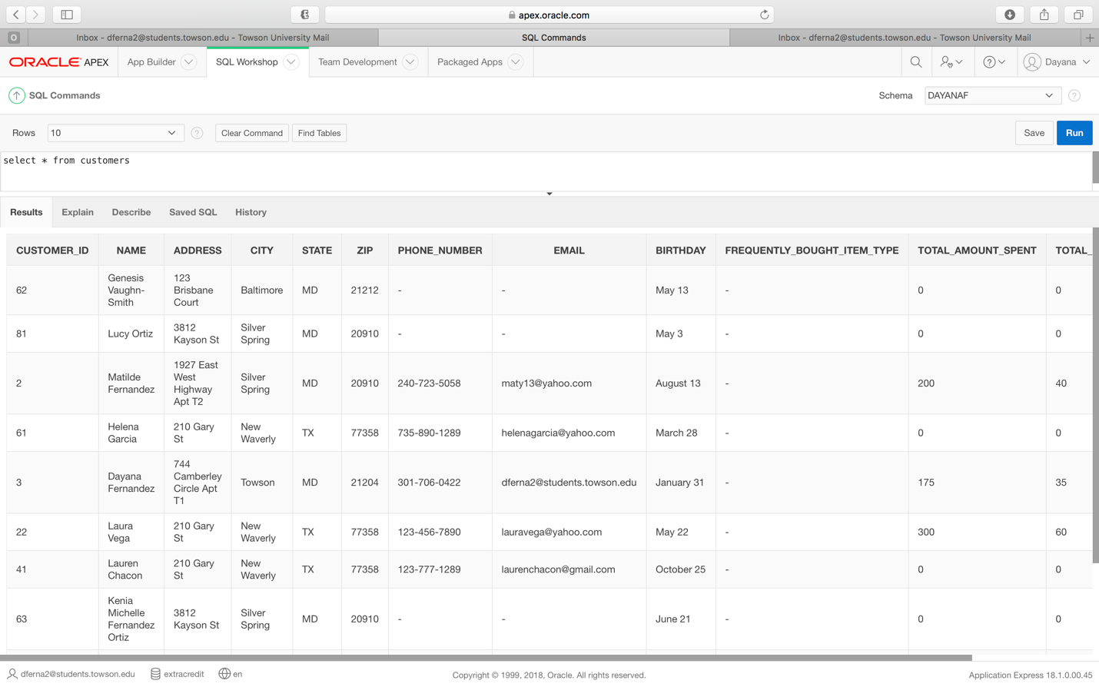

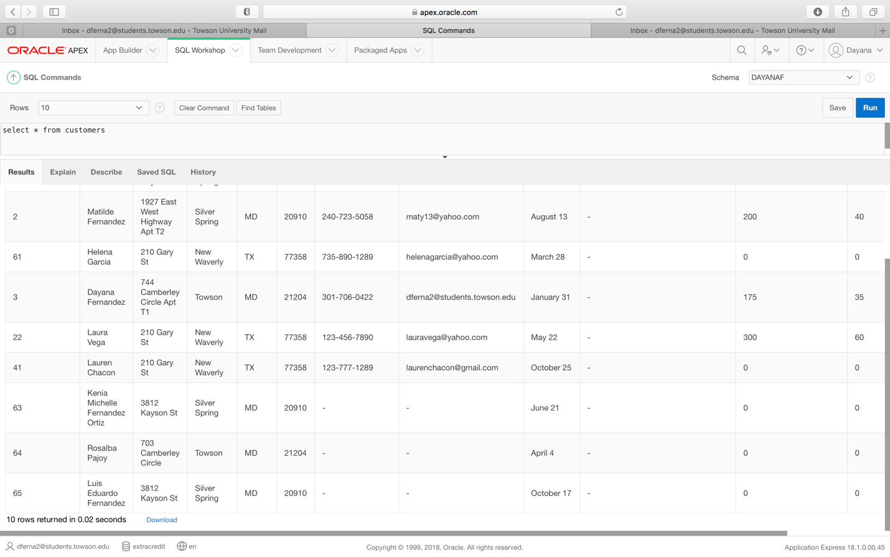

***Requirement 1 Procedure code***

create or replace procedure insert_customer

(v_name customers.name%TYPE,v_address customers.address%TYPE, v_city customers.city%TYPE, v_state customers.state%TYPE, v_zip customers.zip%TYPE, v_phone_number customers.phone_number%TYPE , v_email customers.email%TYPE , v_birthday customers.birthday%TYPE , v_frequently_bought_item_type customers.frequently_bought_item_type%TYPE , v_total_amount_spent customers.total_amount_spent%TYPE , v_total_number_of_paid_items customers.total_number_of_paid_items%TYPE)

is

v_ErrorCode number; --USED FOR ERROR CHECKING

v_ErrorMsg Varchar2(200);

v_CurrentUser Varchar2(100);

v_record_count number;

duplicate_exception Exception; -- User Defined Error

--Cursor to check for duplicates

Cursor customer_exists

IS

Select count(*) from customers where upper(name) = upper(v_name);

begin

--Validation to see if customer exists

v_record_count := 0;

OPEN customer_exists;

FETCH customer_exists INTO v_record_count;

CLOSE customer_exists;

IF v_record_count > 0 THEN

RAISE duplicate_exception;

END IF;

--INSERT HERE

INSERT INTO customers (name, address, city, state, zip, phone_number, email, birthday, frequently_bought_item_type, total_amount_spent, total_number_of_paid_items) values

(v_name , v_address , v_city , v_state , v_zip , v_phone_number , v_email , v_birthday , v_frequently_bought_item_type , v_total_amount_spent , v_total_number_of_paid_items);

commit;

EXCEPTION

When duplicate_exception THEN

dbms_output.put_line ('Customer already exists');

WHEN OTHERS THEN

v_ErrorCode := SQLCODE;

v_ErrorMsg := substr(SQLERRM,1,200);

v_CurrentUser := USER;

DBMS_OUTPUT.PUT_LINE( TO_CHAR(SYSDATE) || v_CurrentUser

|| TO_CHAR(v_ErrorCode) || v_ErrorMsg);

end;

***Requirement 1 Procedure execution***

begin

insert_customer ('Gabriela Fernandez', '1833 Billman Lane', 'Silver Spring', 'MD', '20910', '301-555-1267', 'gaby@yahoo.com', 'May 29', '', 0, 0);

end;

/

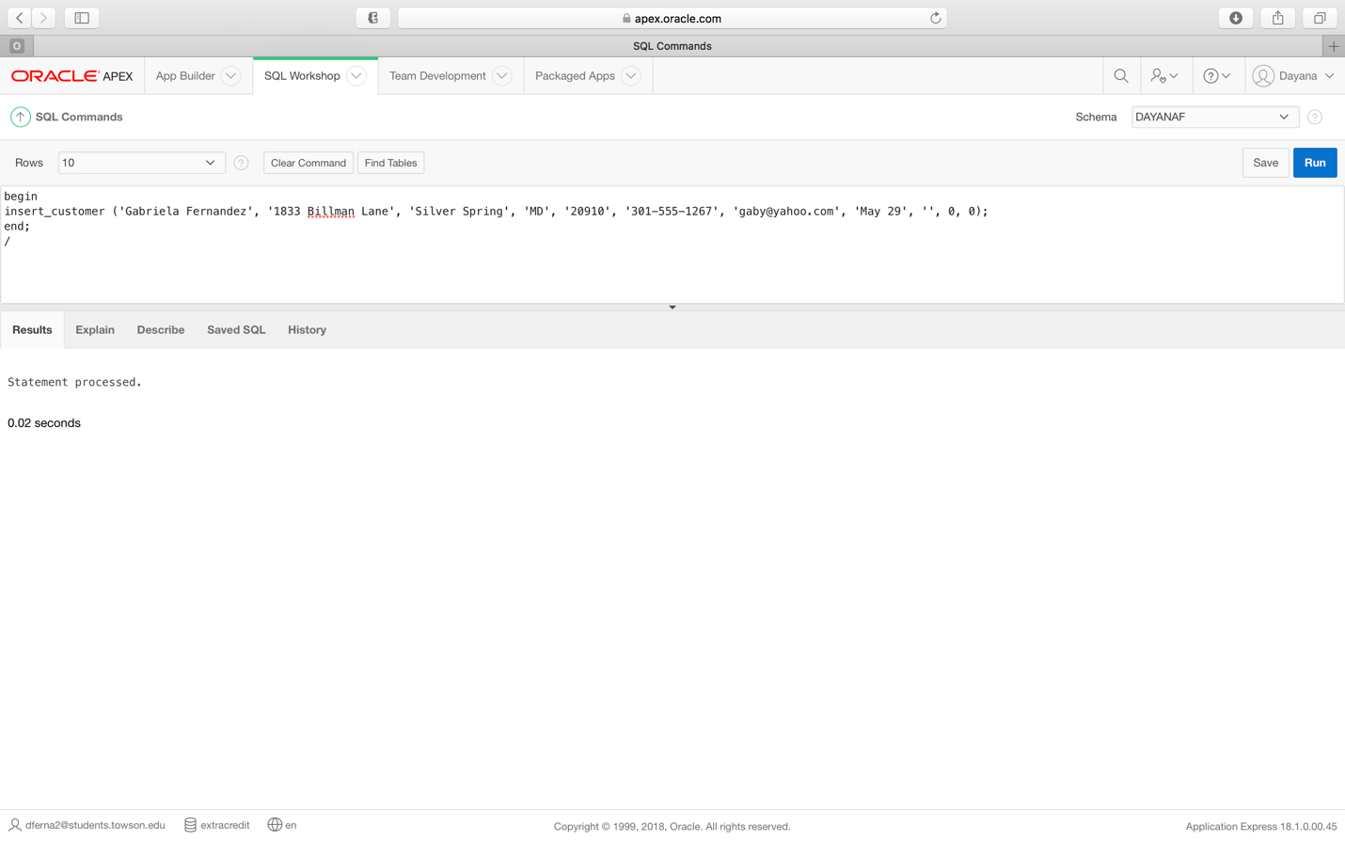

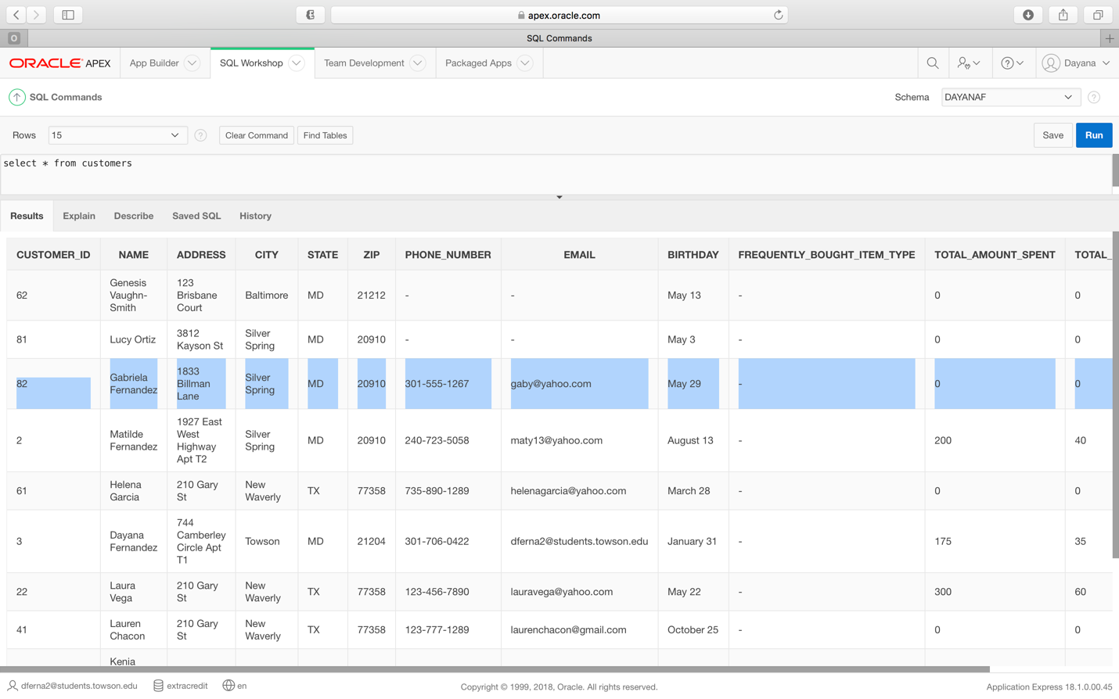

***Requirement 1 Error message:***

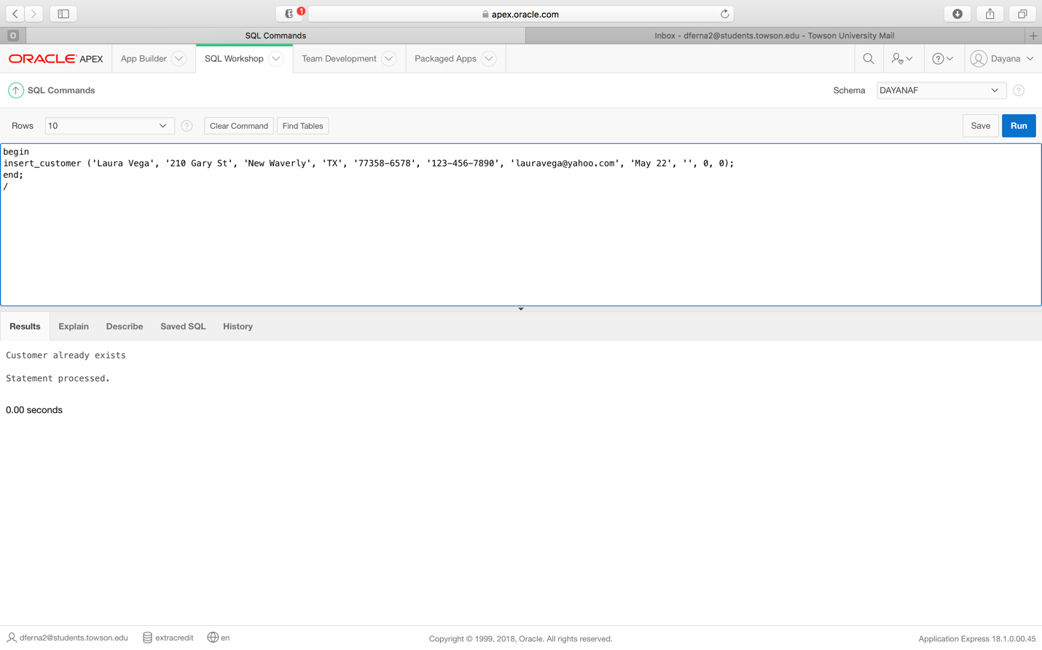

**Requirement 2:** (Using a procedure) The system should be able to add new inventory items making sure that items are not duplicates. If a duplicate is entered, the system will return an error message.

*Original table before latest procedure execution.*

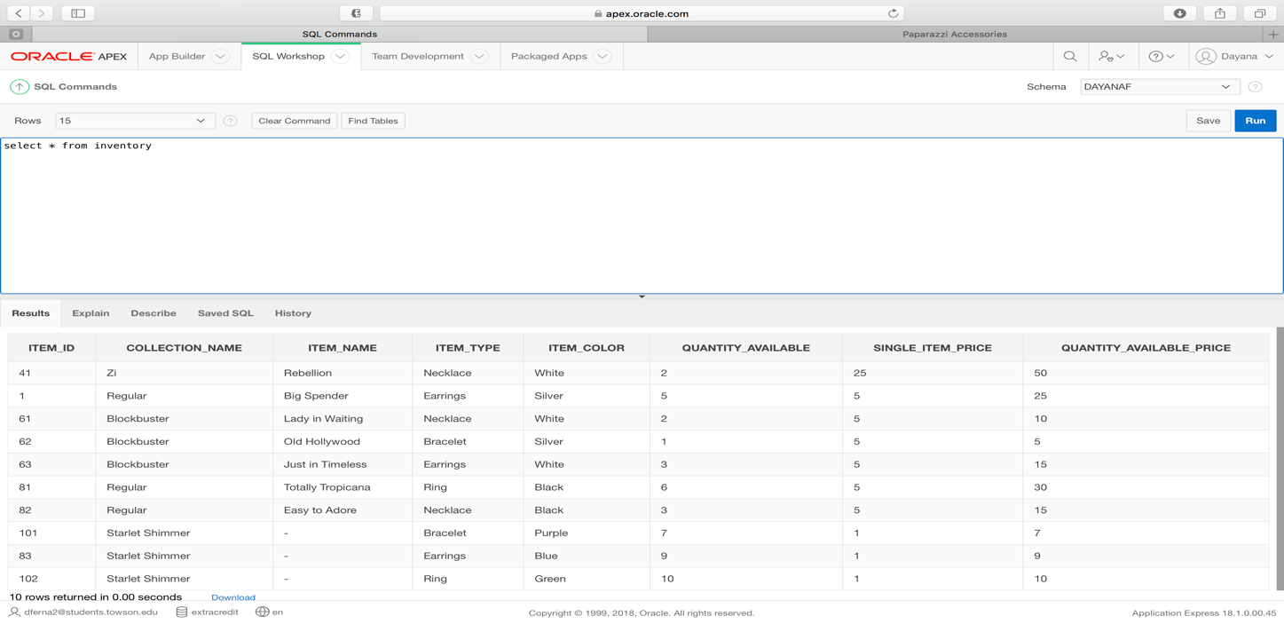

***Requirement 2 Procedure code***

create or replace procedure insert_inventory

(v_collection_name inventory.collection_name%TYPE , v_item_name inventory.item_name%TYPE , v_item_type inventory.item_type%TYPE , v_item_color inventory.item_color%TYPE , v_quantity_available inventory.quantity_available%TYPE , v_single_item_price inventory.single_item_price%TYPE , v_quantity_available_price inventory.quantity_available_price%TYPE)

is

v_ErrorCode number; --USED FOR ERROR CHECKING

v_ErrorMsg Varchar2(200);

v_CurrentUser Varchar2(100);

v_record_count number;

duplicate_exception Exception; -- User Defined Error

--Cursor to check for duplicates

Cursor inventory_exists

IS

Select count(*) from inventory where upper(item_name) = upper(v_item_name);

begin

--Validation to see if item exists

v_record_count := 0;

OPEN inventory_exists;

FETCH inventory_exists INTO v_record_count;

CLOSE inventory_exists;

IF v_record_count > 0 THEN

RAISE duplicate_exception;

END IF;

--INSERT HERE

INSERT INTO inventory (collection_name, item_name, item_type, item_color, quantity_available, single_item_price, quantity_available_price) values

(v_collection_name , v_item_name , v_item_type , v_item_color , v_quantity_available , v_single_item_price , v_quantity_available_price);

commit;

EXCEPTION

When duplicate_exception THEN

dbms_output.put_line ('Inventory already exists');

WHEN OTHERS THEN

v_ErrorCode := SQLCODE;

v_ErrorMsg := substr(SQLERRM,1,200);

v_CurrentUser := USER;

DBMS_OUTPUT.PUT_LINE( TO_CHAR(SYSDATE) || v_CurrentUser

|| TO_CHAR(v_ErrorCode) || v_ErrorMsg);

end;

***Requirement 2 Procedure execution***

begin

insert_inventory ('Regular', 'Gypsy Globetrotter', 'Bracelet', 'Pink', 3, 5, 15);

end;

/

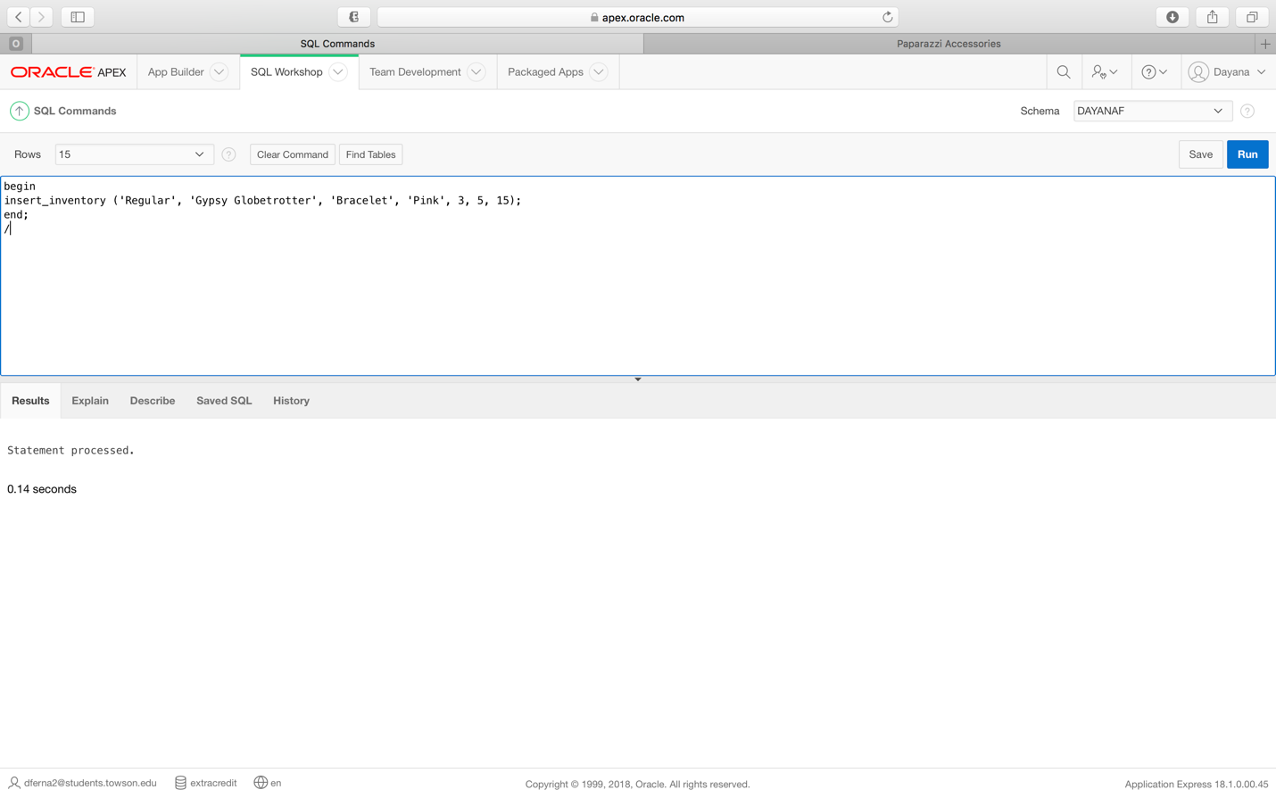

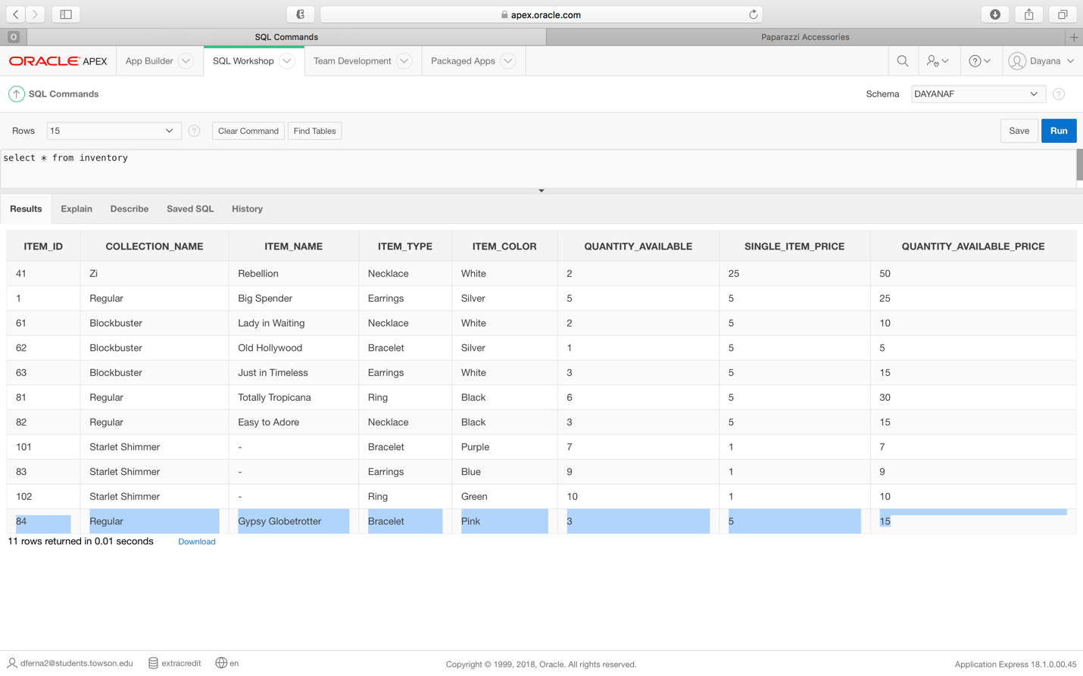

***Requirement 2 Error message:***

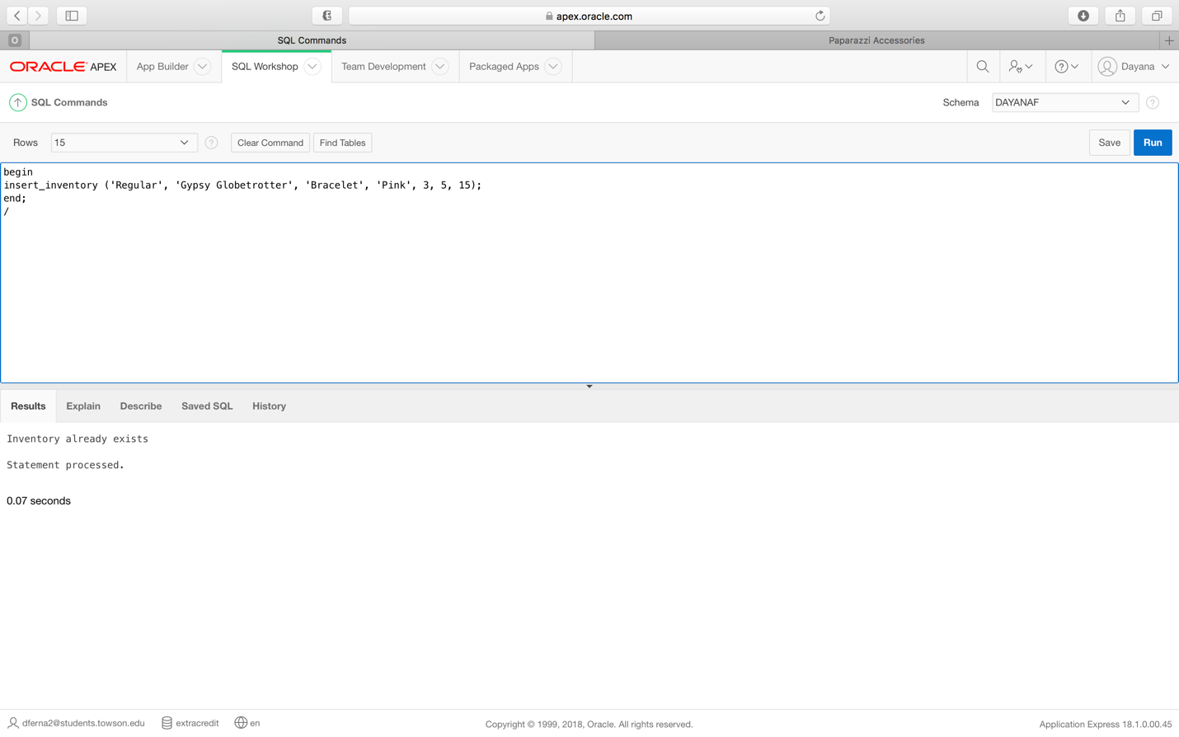

**Requirement 3:** (Using a procedure) The system should be able to add new orders.

(Using a trigger) The system should be able to update the total number of items paid by that customer overall every time they place an order.

(Using a trigger) The system should be able to update the total amount spent by a customer overall every time they place an order.

*Original table before latest procedure execution.*

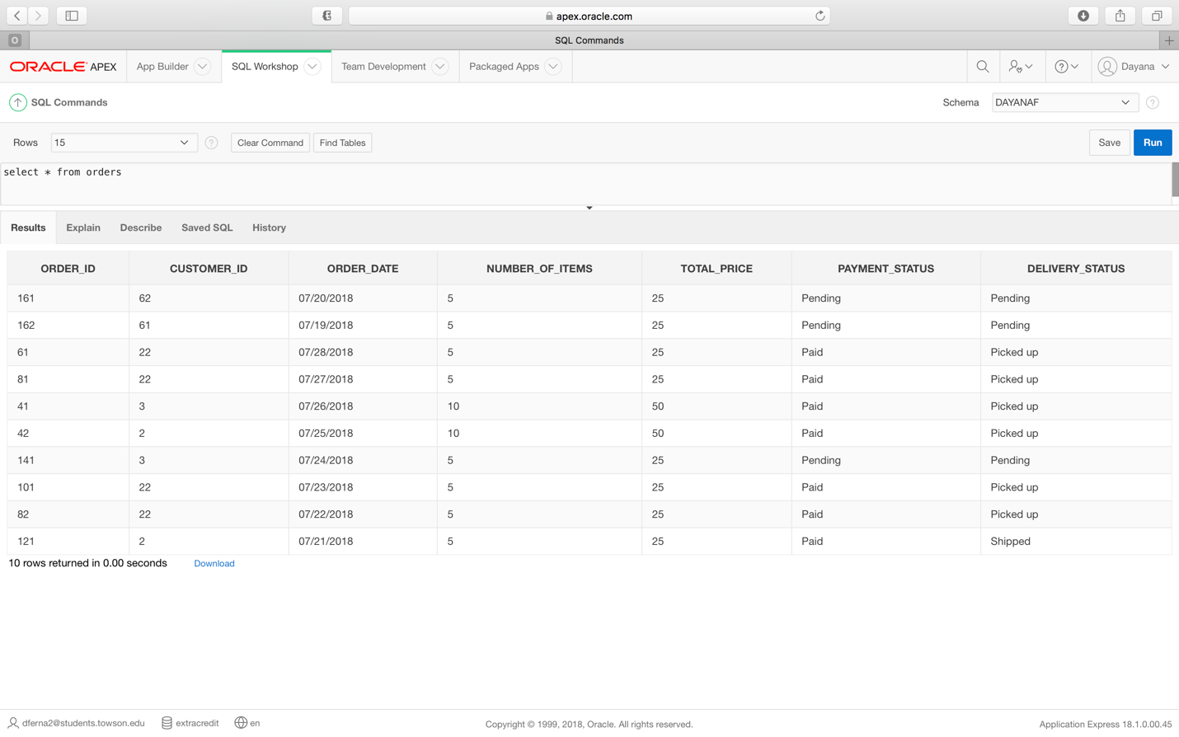

***Requirement 3 Procedure code:***

create or replace procedure insert_order

(v_customer_ID orders.customer_ID%TYPE , v_order_date orders.order_date%TYPE , v_number_of_items orders.number_of_items%TYPE , v_total_price orders.total_price%TYPE , v_payment_status orders.payment_status%TYPE , v_delivery_status orders.delivery_status%TYPE)

is

v_ErrorCode number; --USED FOR ERROR CHECKING

v_ErrorMsg Varchar2(200);

v_CurrentUser Varchar2(100);

v_record_count number;

duplicate_exception Exception; -- User Defined Error

--Cursor to check for duplicates

Cursor order_exists

IS

Select count(*) from orders where upper(order_date) = upper(v_order_date);

begin

--Validation to see if order exists

v_record_count := 0;

OPEN order_exists;

FETCH order_exists INTO v_record_count;

CLOSE order_exists;

IF v_record_count > 0 THEN

RAISE duplicate_exception;

END IF;

--INSERT HERE

INSERT INTO orders (customer_ID, order_date, number_of_items, total_price, payment_status, delivery_status) values

(v_customer_ID , v_order_date , v_number_of_items , v_total_price , v_payment_status , v_delivery_status);

commit;

EXCEPTION

When duplicate_exception THEN

dbms_output.put_line ('Order already exists');

WHEN OTHERS THEN

v_ErrorCode := SQLCODE;

v_ErrorMsg := substr(SQLERRM,1,200);

v_CurrentUser := USER;

DBMS_OUTPUT.PUT_LINE( TO_CHAR(SYSDATE) || v_CurrentUser

|| TO_CHAR(v_ErrorCode) || v_ErrorMsg);

end;

***Requirement 3 Procedure execution***

begin

insert_order (82, 'July 17 2018', 3, 15, 'Pending', 'Pending');

end;

/

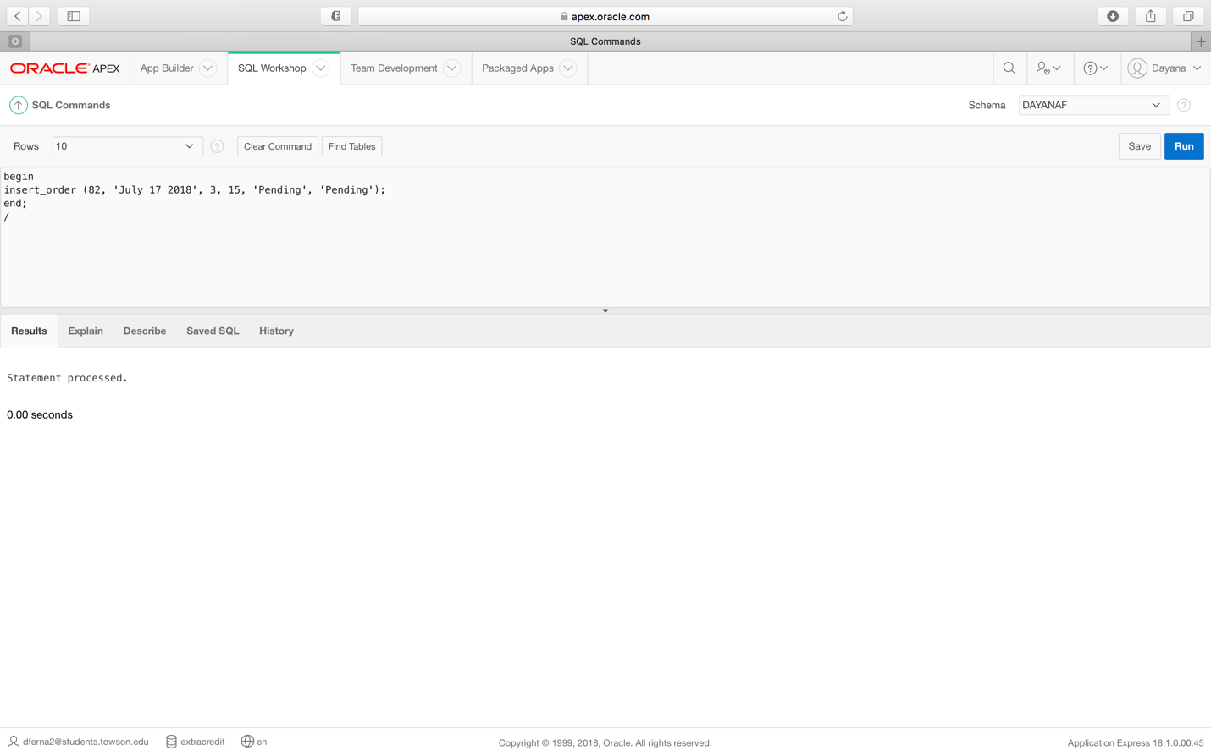

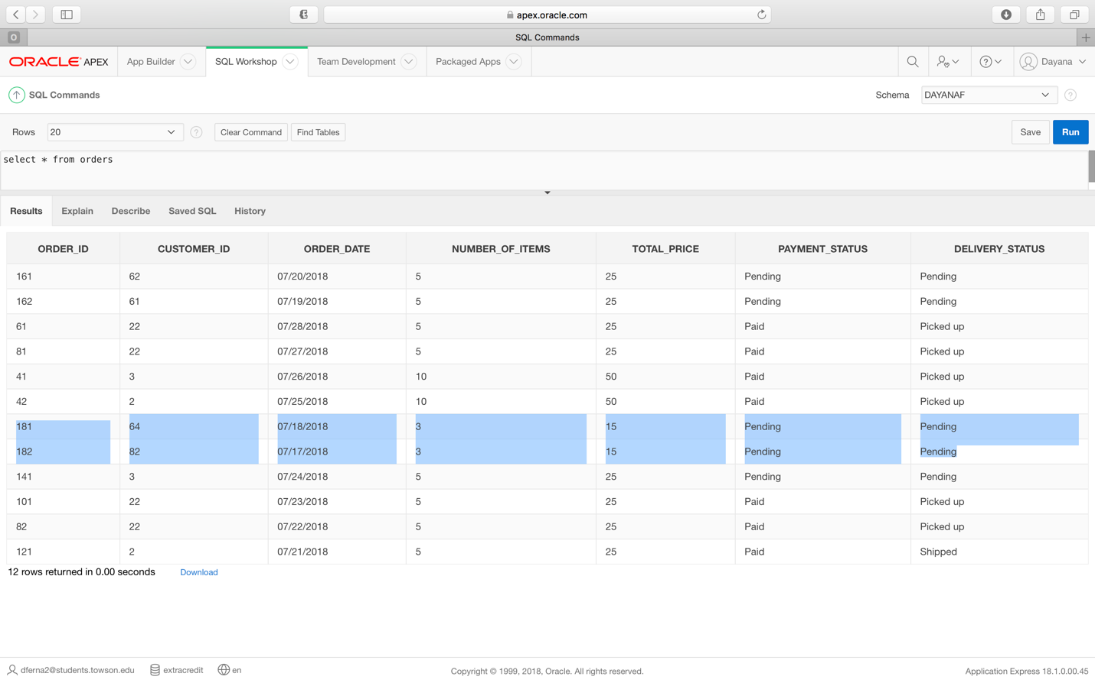

*Customer table before creation and execution of both triggers*

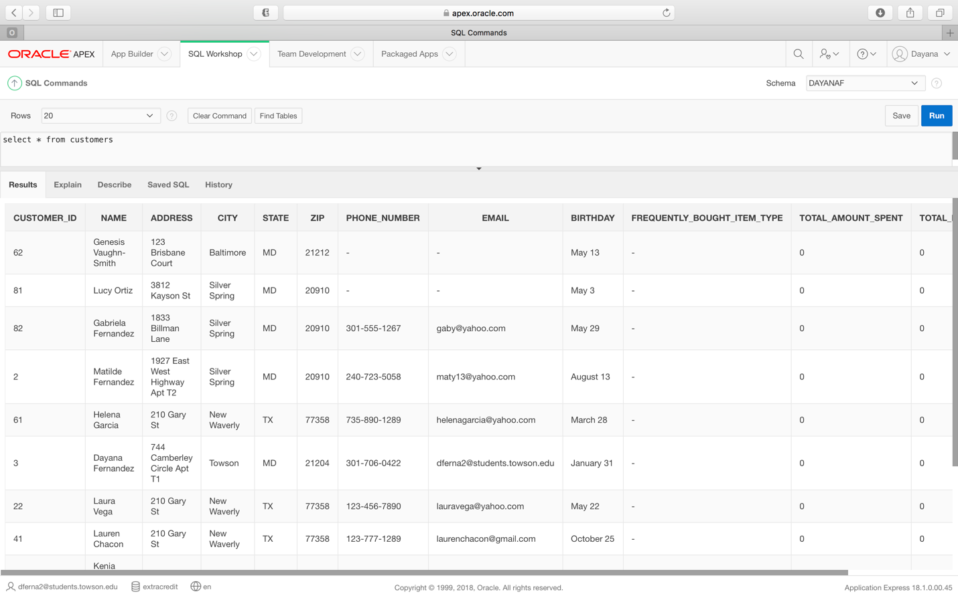

***Requirement 3 Customer items trigger code***

create or replace TRIGGER UPDATE_CUSTOMER_ITEMS

AFTER UPDATE

ON ORDERS

FOR EACH ROW

begin

update customers set total_number_of_paid_items = total_number_of_paid_items + :new.number_of_items where customer_id = :new.customer_id;

EXCEPTION

When Others then

raise_application_error

(-20000,'Update of count failed.

Customer modification also failed.');

end UPDATE_CUSTOMER_ITEMS;

***Requirement 3 Customer total amount trigger code:***

create or replace TRIGGER UPDATE_CUSTOMER_TOTAL

AFTER UPDATE

ON ORDERS

FOR EACH ROW

begin

update customers set total_amount_spent = total_amount_spent + :new.total_price where customer_id = :new.customer_id;

EXCEPTION

When Others then

raise_application_error

(-20000,'Update of count failed.

Customer modification also failed.');

end UPDATE_CUSTOMER_TOTAL;

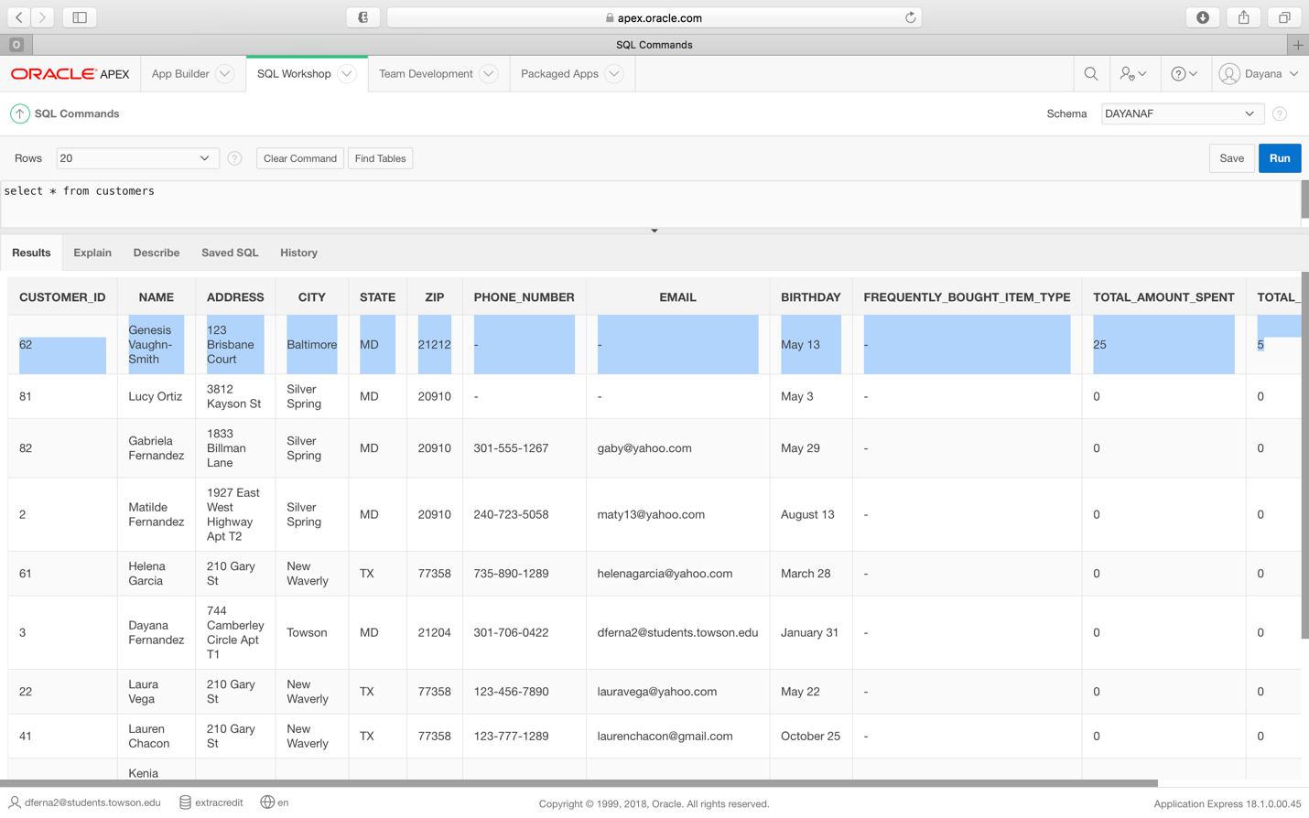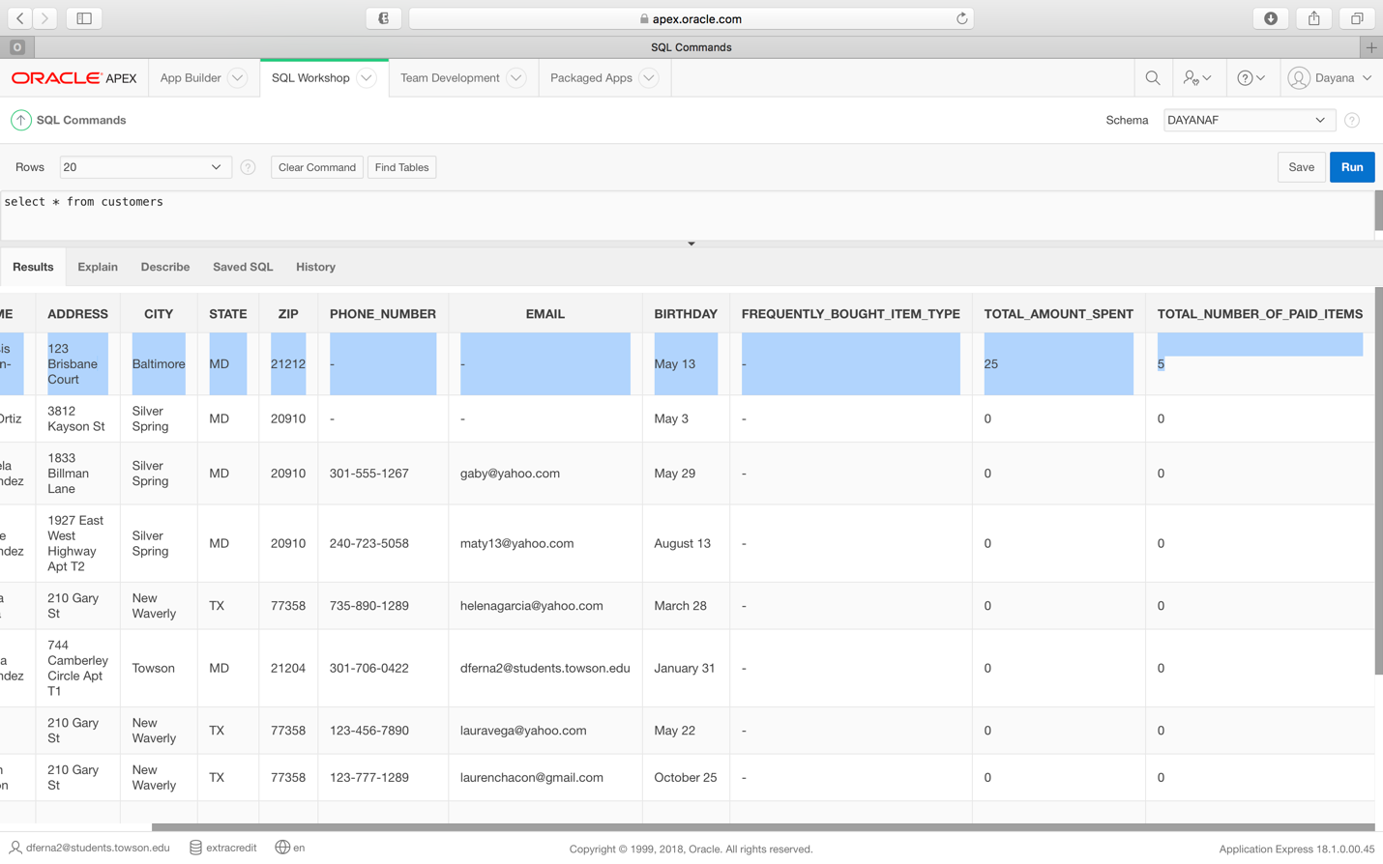

**Requirement 4**: (Using a procedure) The system should be able to add sales by item.

(Using a trigger) The system should be able to update the quantity available of each item (in inventory) when it is sold.

(Using a trigger) The system should be able to update the price of quantity available (in inventory) of each item when it is sold.

*Original table before latest procedure execution.*

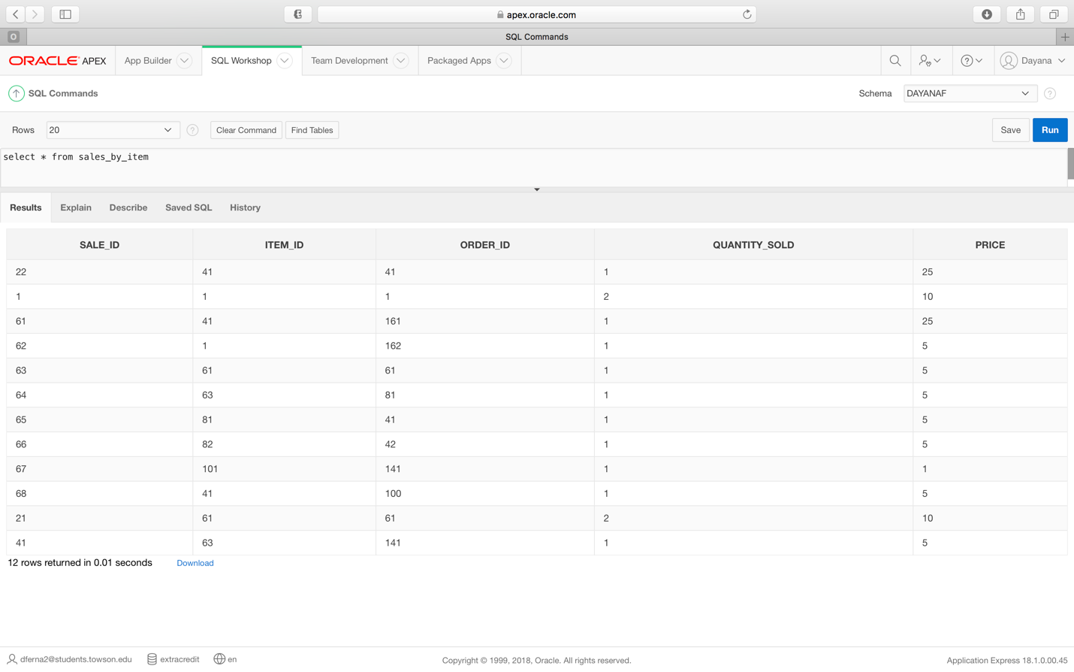

***Requirement 4 Procedure code:***

create or replace procedure insert_sale

(v_item_ID sales_by_item.item_ID%TYPE , v_order_ID sales_by_item.order_ID%TYPE , v_quantity_sold sales_by_item.quantity_sold%TYPE , v_price sales_by_item.price%TYPE)

is

v_ErrorCode number; --USED FOR ERROR CHECKING

v_ErrorMsg Varchar2(200);

v_CurrentUser Varchar2(100);

v_record_count number;

duplicate_exception Exception; -- User Defined Error

--Cursor to check for duplicates

Cursor sale_exists

IS

Select count(*) from sales_by_item where upper(order_ID) = upper(v_order_ID);

begin

--Validation to see if sale exists

v_record_count := 0;

OPEN sale_exists;

FETCH sale_exists INTO v_record_count;

CLOSE sale_exists;

IF v_record_count > 0 THEN

RAISE duplicate_exception;

END IF;

--INSERT HERE

INSERT INTO sales_by_item (item_ID, order_ID, quantity_sold, price) values

(v_item_ID , v_order_ID , v_quantity_sold , v_price);

commit;

EXCEPTION

When duplicate_exception THEN

dbms_output.put_line ('Sale already exists');

WHEN OTHERS THEN

v_ErrorCode := SQLCODE;

v_ErrorMsg := substr(SQLERRM,1,200);

v_CurrentUser := USER;

DBMS_OUTPUT.PUT_LINE( TO_CHAR(SYSDATE) || v_CurrentUser

|| TO_CHAR(v_ErrorCode) || v_ErrorMsg);

end;

***Requirement 4 Procedure execution***

begin

insert_sale (41, 105, 1, 5);

end;

/

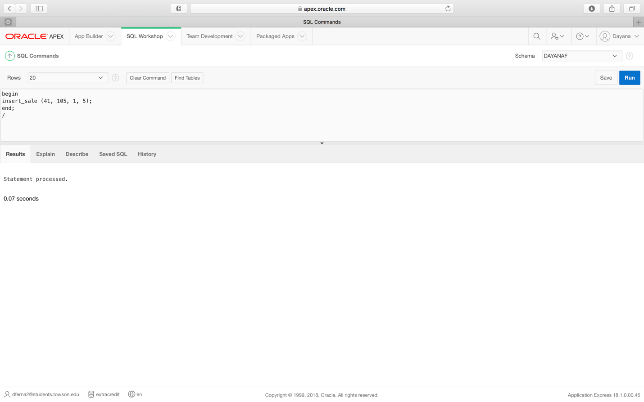

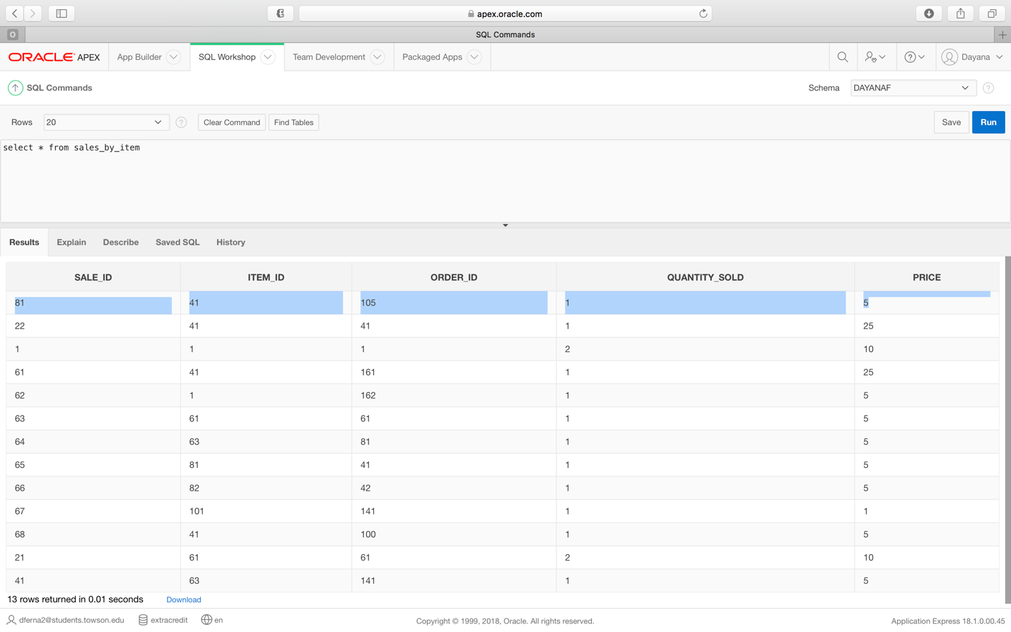

***Requirement 4 Error message:***

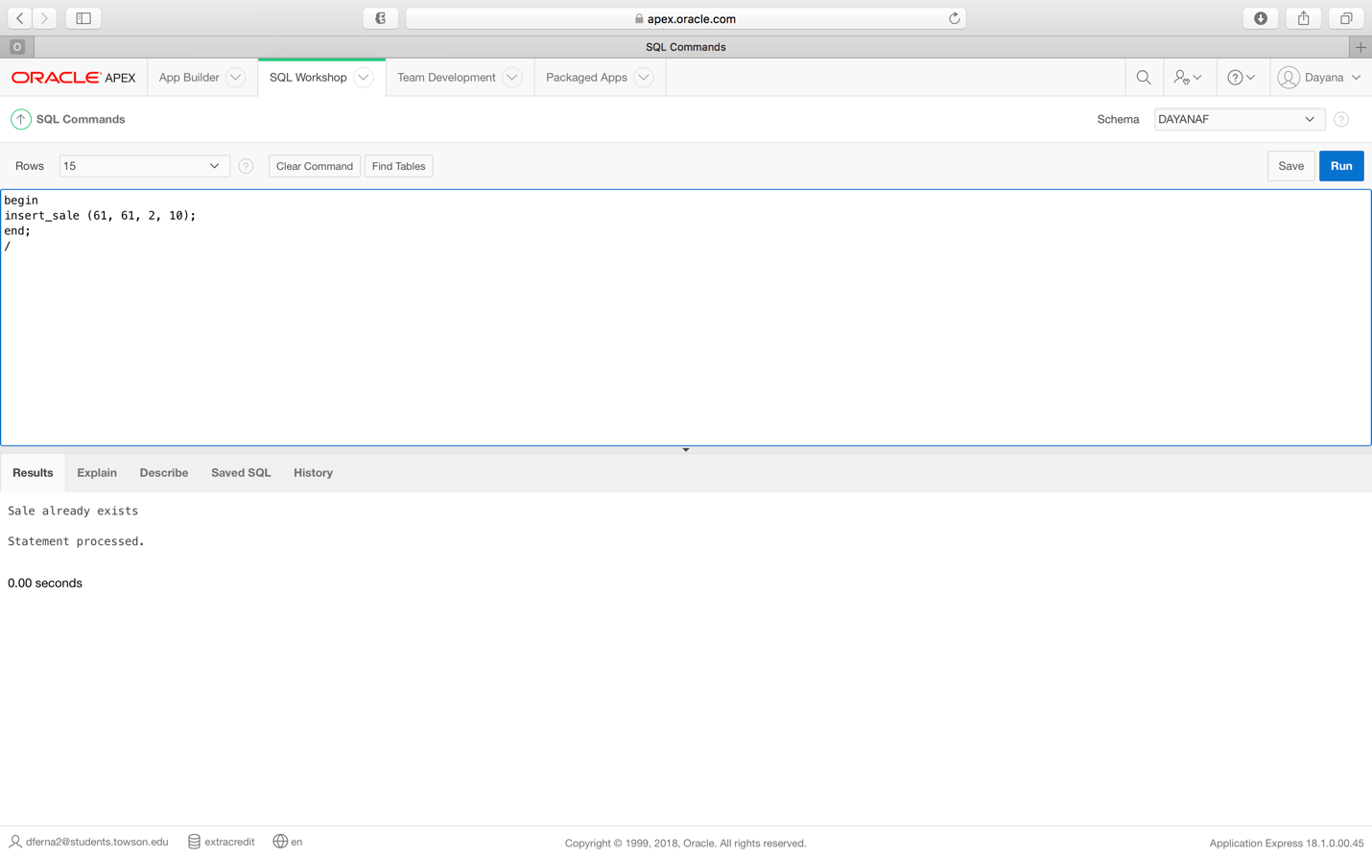

*Inventory table before creation and execution of both triggers*

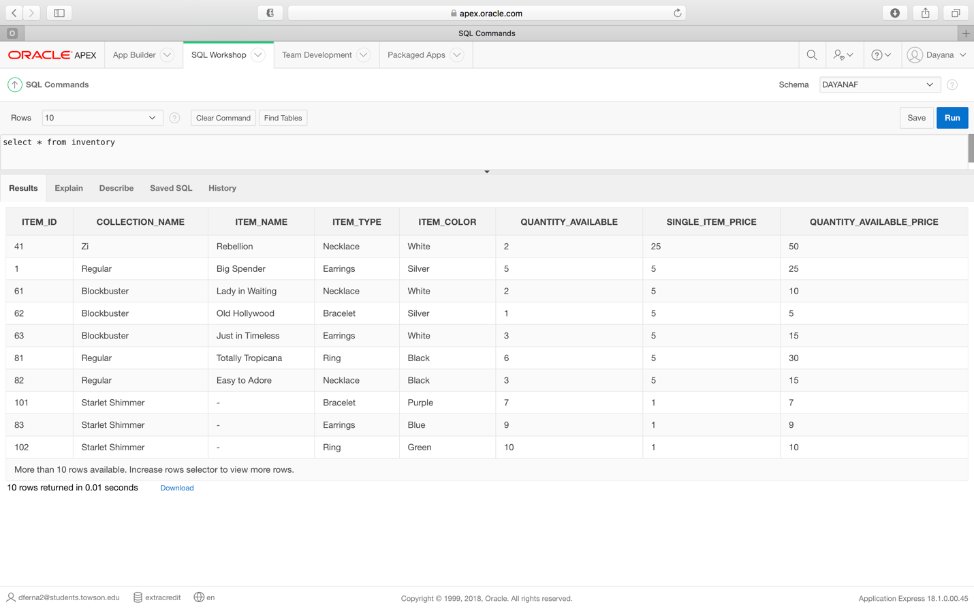

***Requirement 4 Quantity trigger code:***

create or replace TRIGGER UPDATE_INVENTORY_QUANTITY

AFTER UPDATE

ON SALES_BY_ITEM

FOR EACH ROW

begin

update inventory set quantity_available = quantity_available + :new.quantity_sold where item_id = :new.item_id;

EXCEPTION

When Others then

raise_application_error

(-20000,'Update of count failed.

Customer modification also failed.');

end UPDATE_INVENTORY_QUANTITY;

***Requirement 4 Price trigger code***

create or replace TRIGGER UPDATE_INVENTORY_PRICE

AFTER UPDATE

ON SALES_BY_ITEM

FOR EACH ROW

begin

update inventory set quantity_available_price = quantity_available_price + :new.price where item_id = :new.item_id;

EXCEPTION

When Others then

raise_application_error

(-20000,'Update of count failed.

Customer modification also failed.');

end UPDATE_INVENTORY_PRICE;

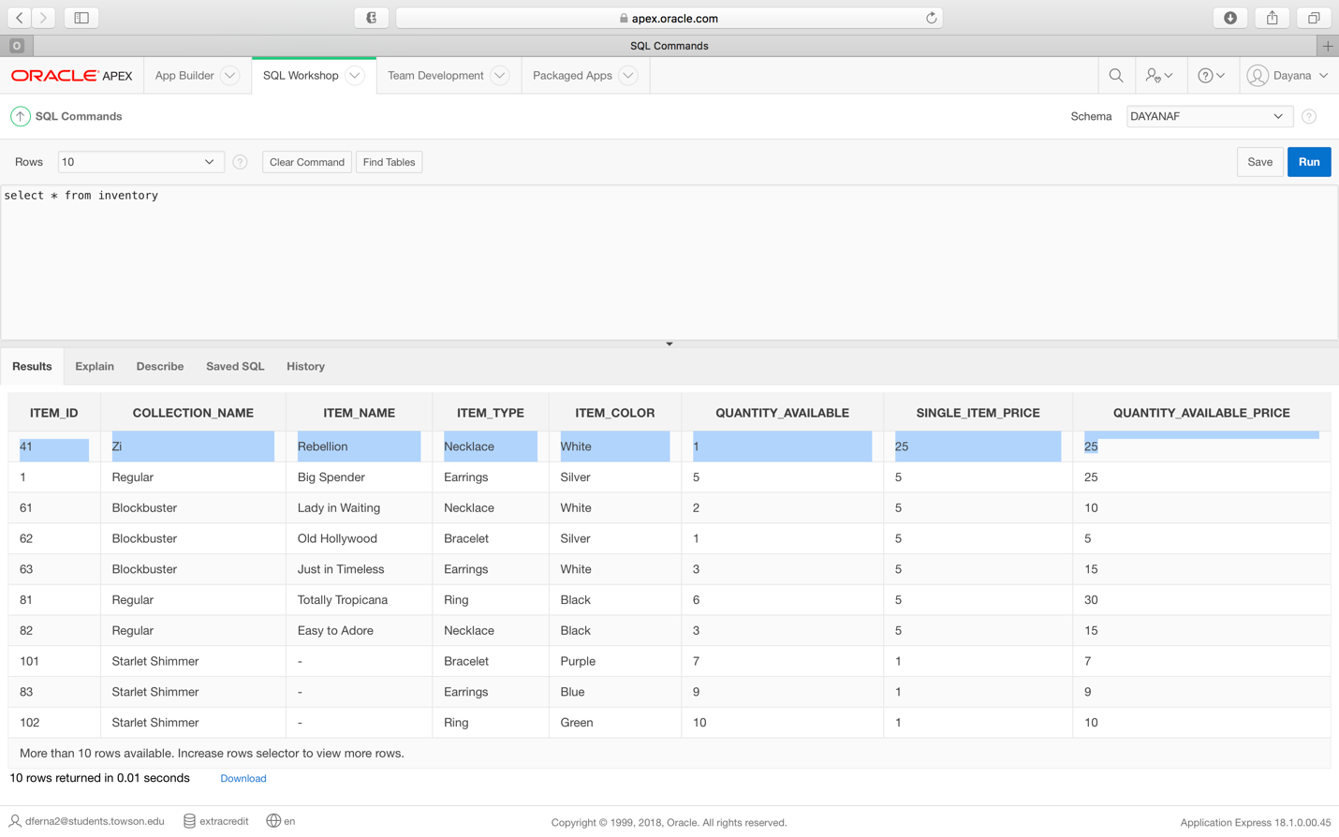

**Requirement 5:** (Using a procedure) Given an order ID, the system should be able to change the payment status from “pending” to “paid” when the order is paid, while also checking to make sure that the order ID is valid. If it is invalid, a message will be displayed to the user.

*Table before procedure execution*

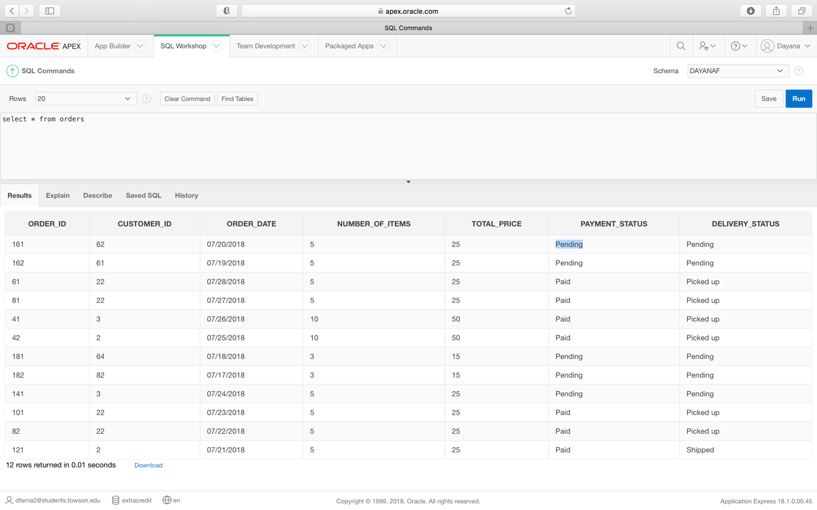

***Requirement 5 Procedure code:***

create or replace procedure payment_status

(v_order_id number , v_payment_status varchar)

is

v_count int;

BEGIN

select count(*)

into v_count

from orders

where v_order_id = order_id;

if v_count = 0 then

dbms_output.put_line('There is no order listed with that ID. Please double check the number.');

else

begin

UPDATE orders set payment_status = v_payment_status where v_order_id = order_id;

commit;

end;

end if;

end payment_status;

***Requirement 5 Procedure execution***

begin

payment_status (161, 'Paid');

end;

/

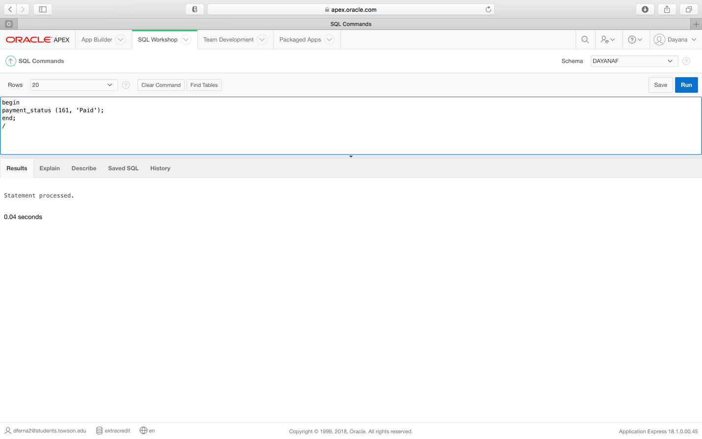

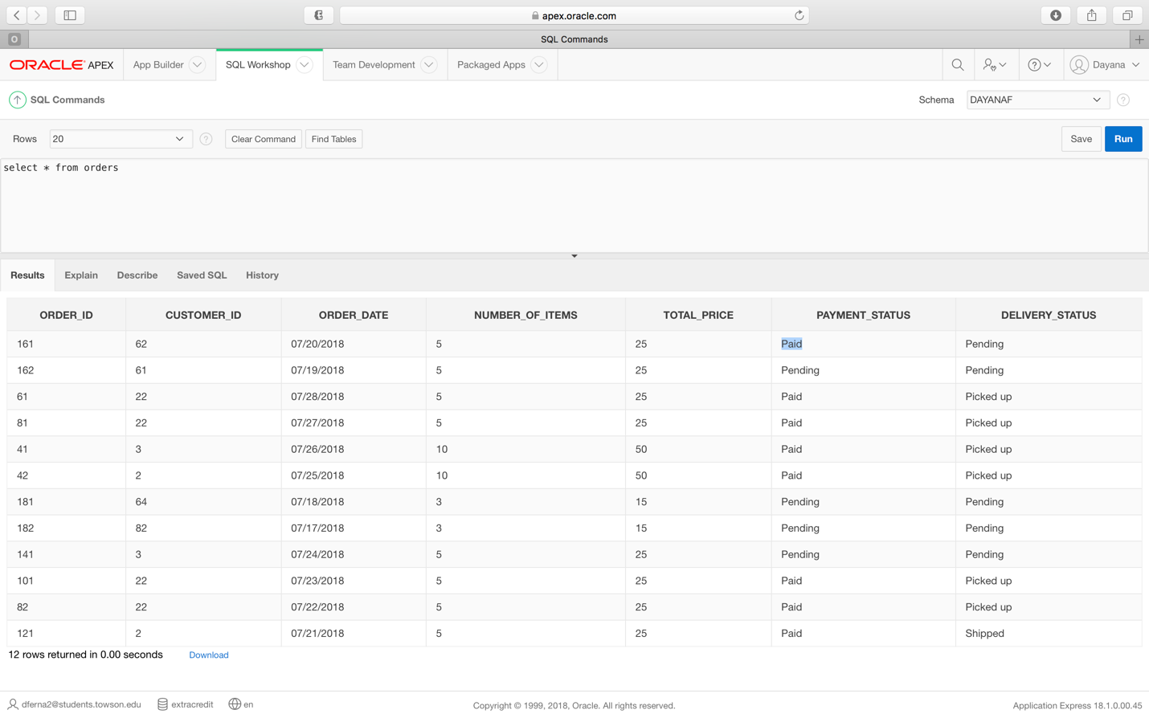

***Requirement 5 Error message:***

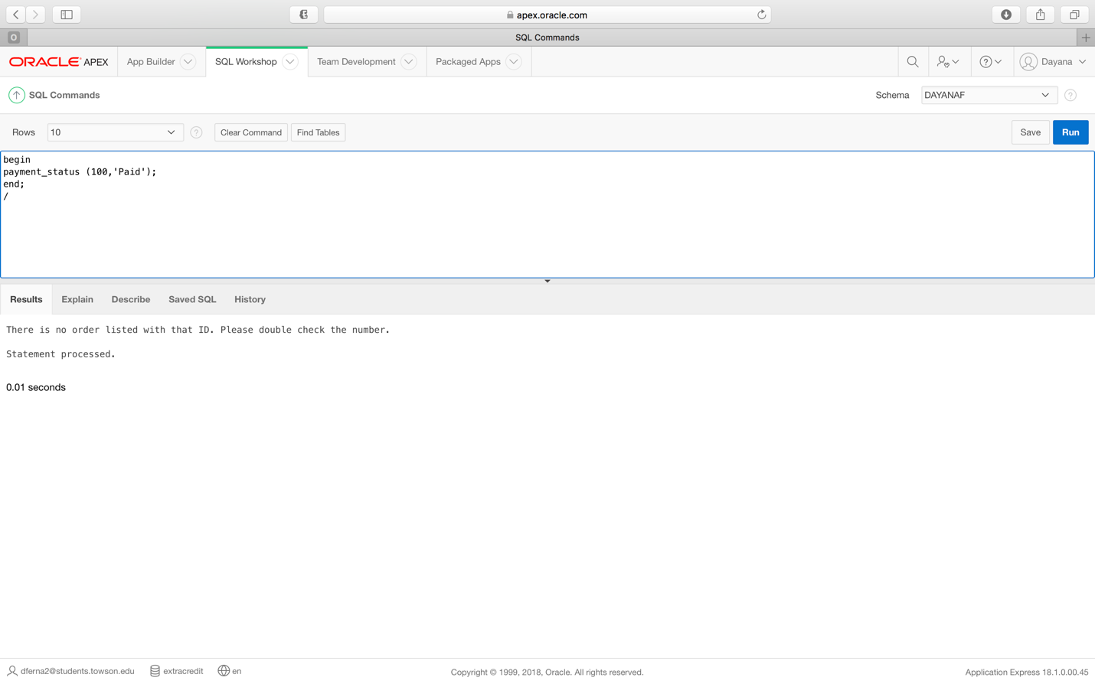

**Requirement 6:** (Using a procedure) Given an order ID, the system will be able to update order delivery status when an order is shipped, picked up, or personally delivered to a customer while also checking to make sure that the order ID is valid. If it is invalid, a message will be displayed to the user.

*Table before procedure execution*

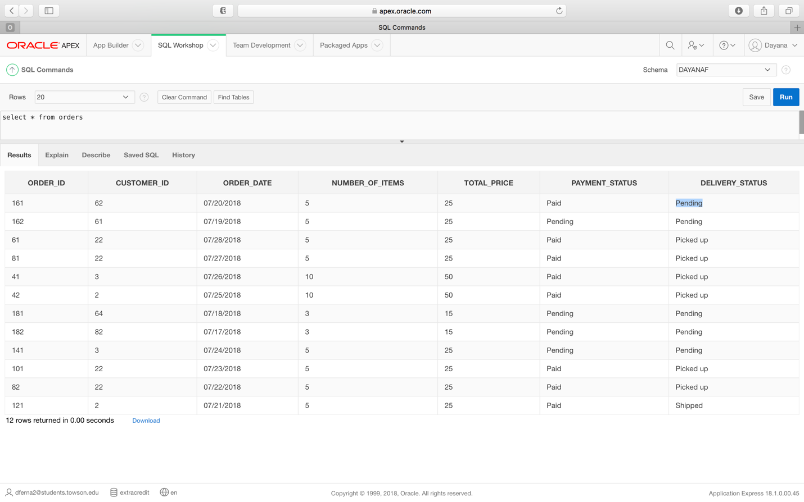

***Requirement 6 Procedure code:***

create or replace procedure delivery_status

(v_order_id number , v_delivery_status varchar)

is

v_count int;

BEGIN

select count(*)

into v_count

from orders

where v_order_id = order_id;

if v_count = 0 then

dbms_output.put_line('There is no order listed with that ID. Please double check the number.');

else

begin

UPDATE orders set delivery_status = v_delivery_status where v_order_id = order_id;

commit;

end;

end if;

end delivery_status;

***Requirement 6 Procedure execution***

begin

delivery_status (161, 'Shipped');

end;

/

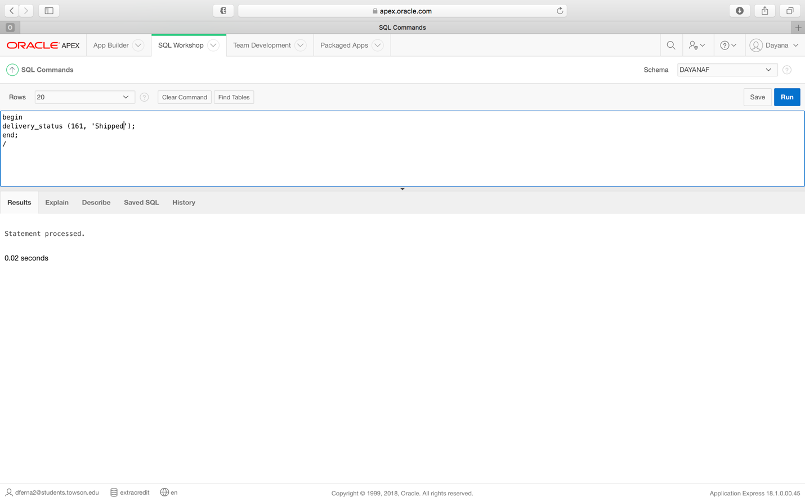

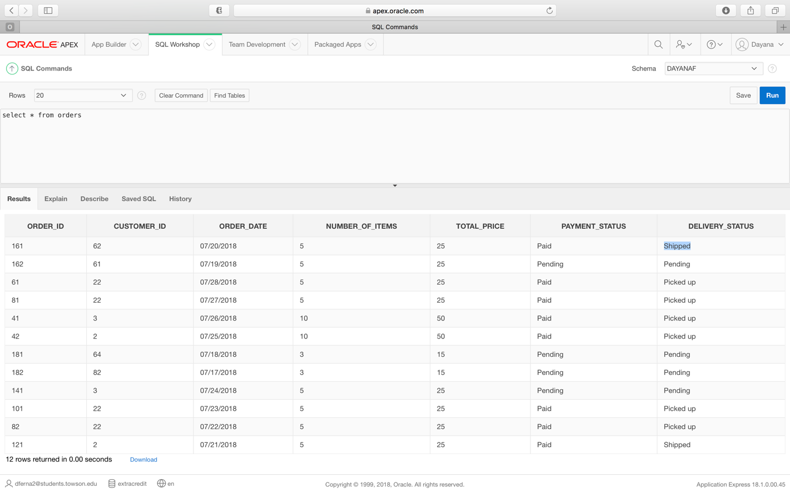

***Requirement 6 Error message:***

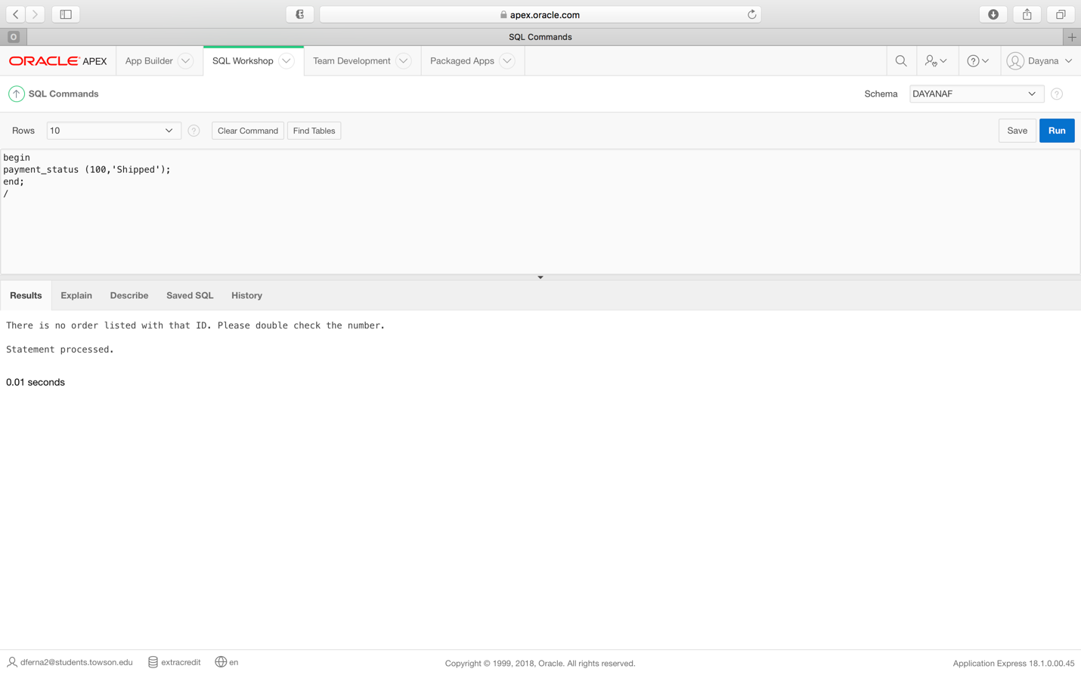

**Requirement 7**: (Using a procedure) The system will be able to add multiple favorite colors for customers. If that color has already been entered for the customer, a message will be returned.

*Table prior to latest procedure execution.*

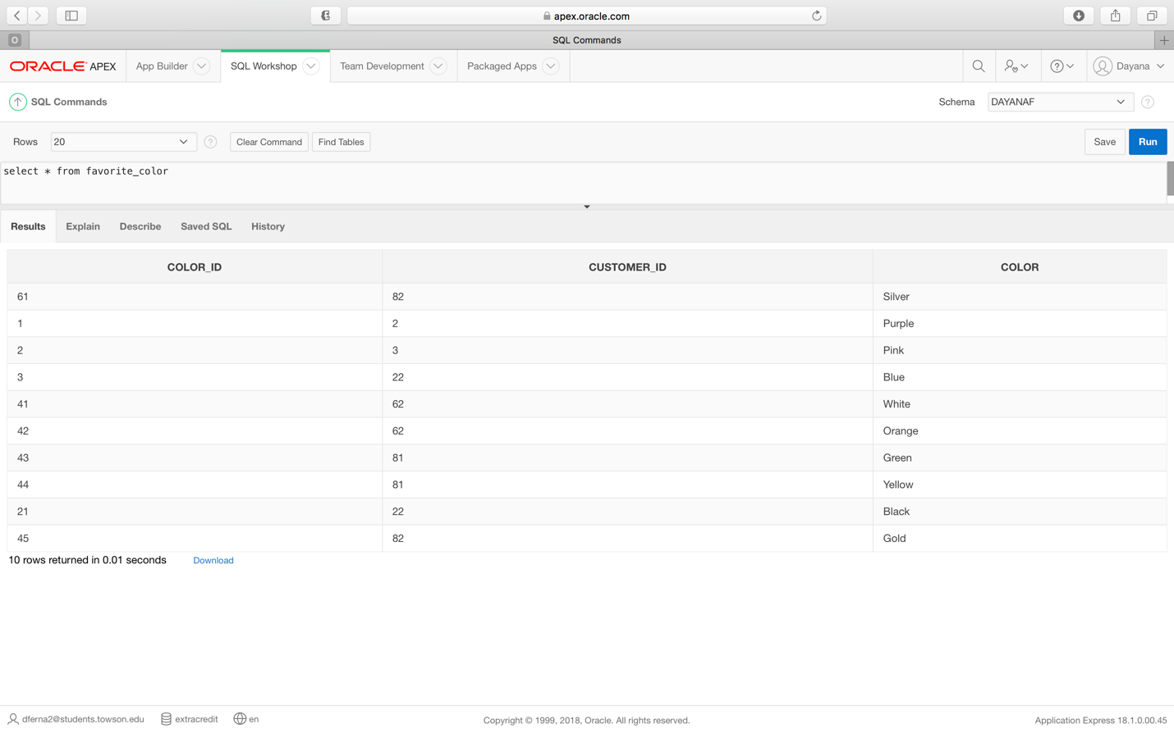

***Requirement 7 Procedure code:***

create or replace Procedure customer_favorite_color

(v_color favorite_color.color%TYPE)

AS

CURSOR c_favorite_color IS

Select color_id,customer_id,color

From favorite_color

where upper(color) = upper(v_color);

BEGIN

FOR v_favorite_color_data IN c_favorite_color LOOP

DBMS_OUTPUT.PUT_LINE(TO_CHAR(v_favorite_color_data.color_id) || ' ' ||

v_favorite_color_data.customer_id || ' ' || TO_CHAR(v_favorite_color_data.color));

END LOOP;

END;

**Requirement 7 Procedure execution**

begin

insert_color (22,'Navy Blue');

end;

/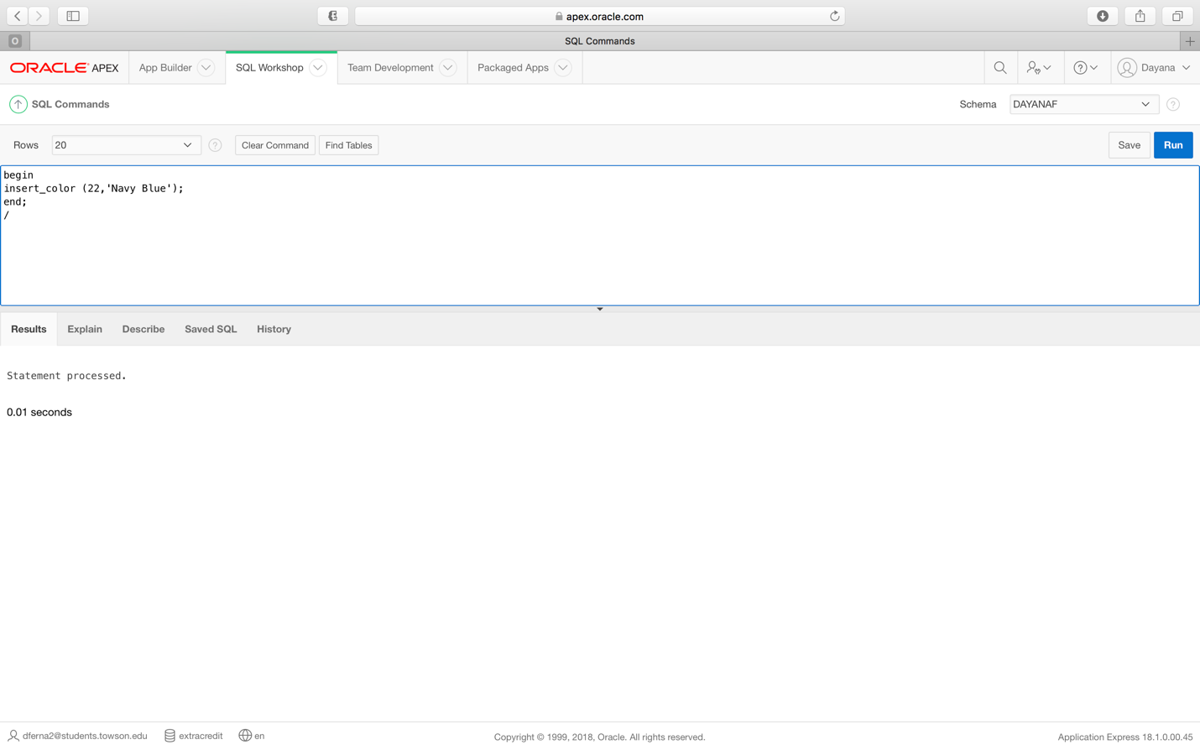

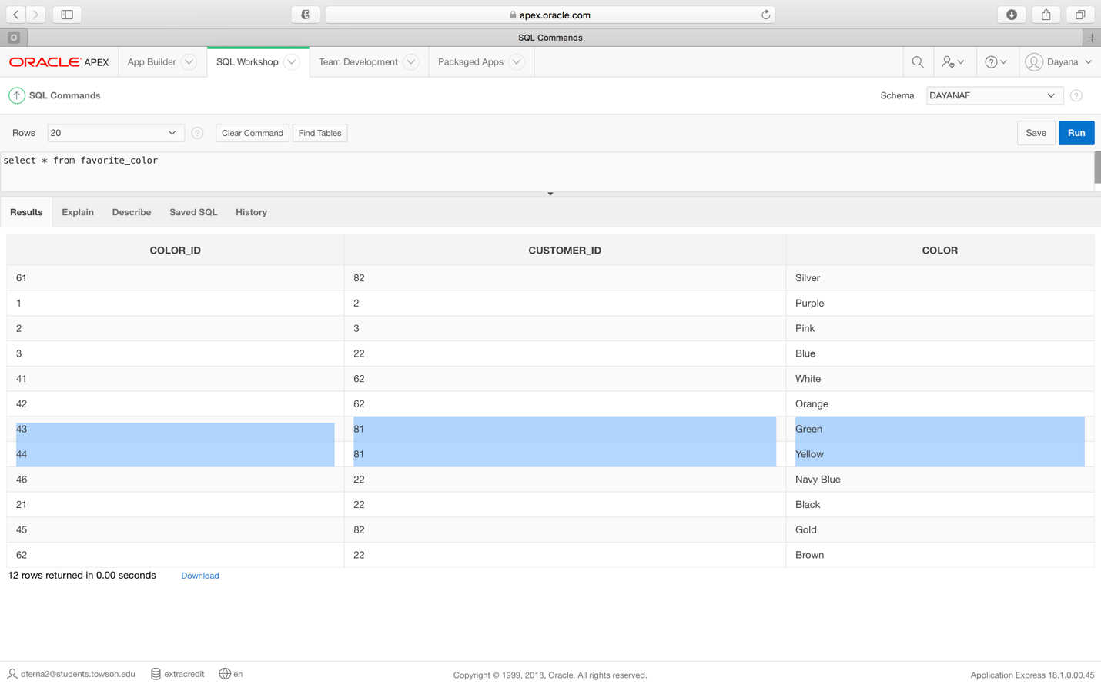

***Requirement 7 Error message:***

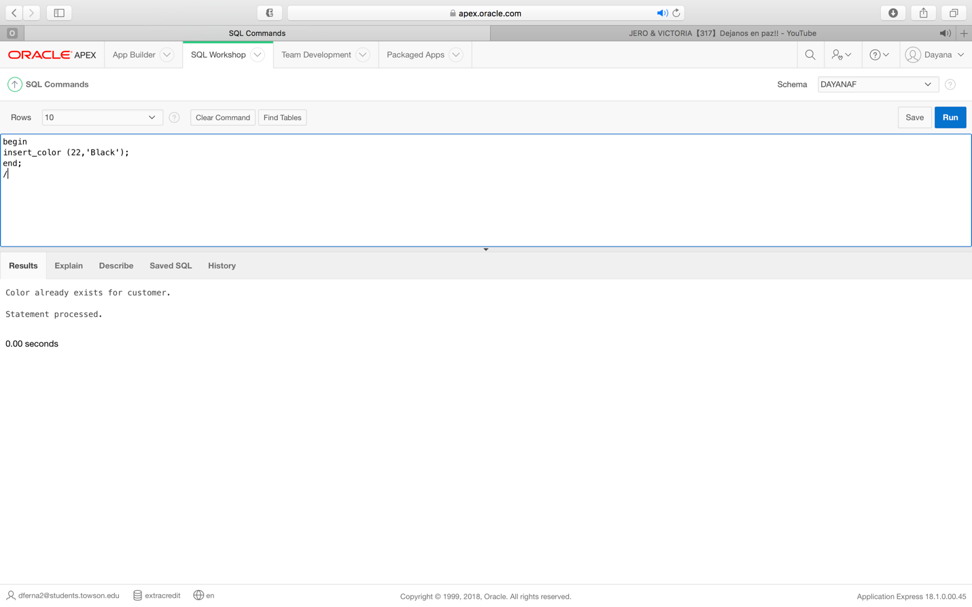

**Requirement 8:** (Using a procedure) The system will be able to update customer information, while making sure that a valid customer ID is entered. If not, an error message will be returned.

*Customer table prior to latest execution of procedure.*

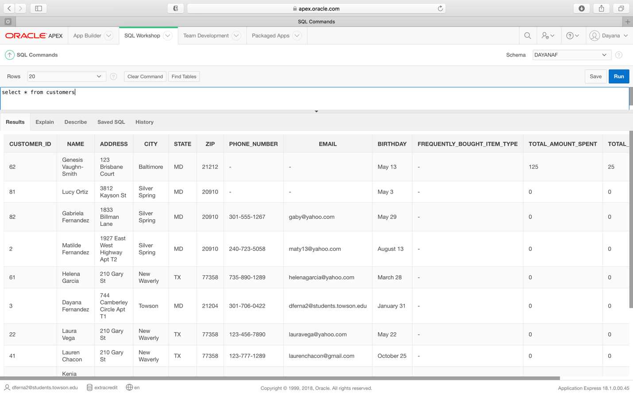

***Requirement 8 Procedure code***

create or replace procedure update_customer

(v_customer_id int, new_email varchar)

is

v_count int;

BEGIN

select count(*)

into v_count

from customers

where v_customer_id = customer_id;

if v_count = 0 then

dbms_output.put_line('There is no customer listed with that ID so no information could be updated. Please double check the number.');

else

begin

UPDATE customers

set email = new_email where customer_id = v_customer_id;

commit;

end;

end if;

end update_customer;

***Requirement 8 Procedure execution***

begin

update_customer (62,'loveyourshine247@gmail.com');

end;

/

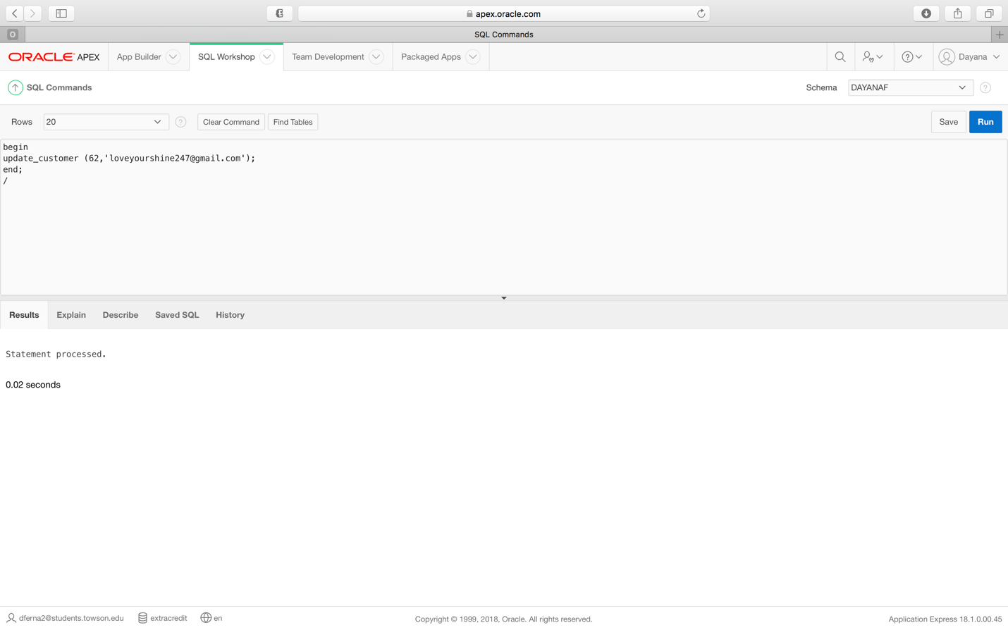

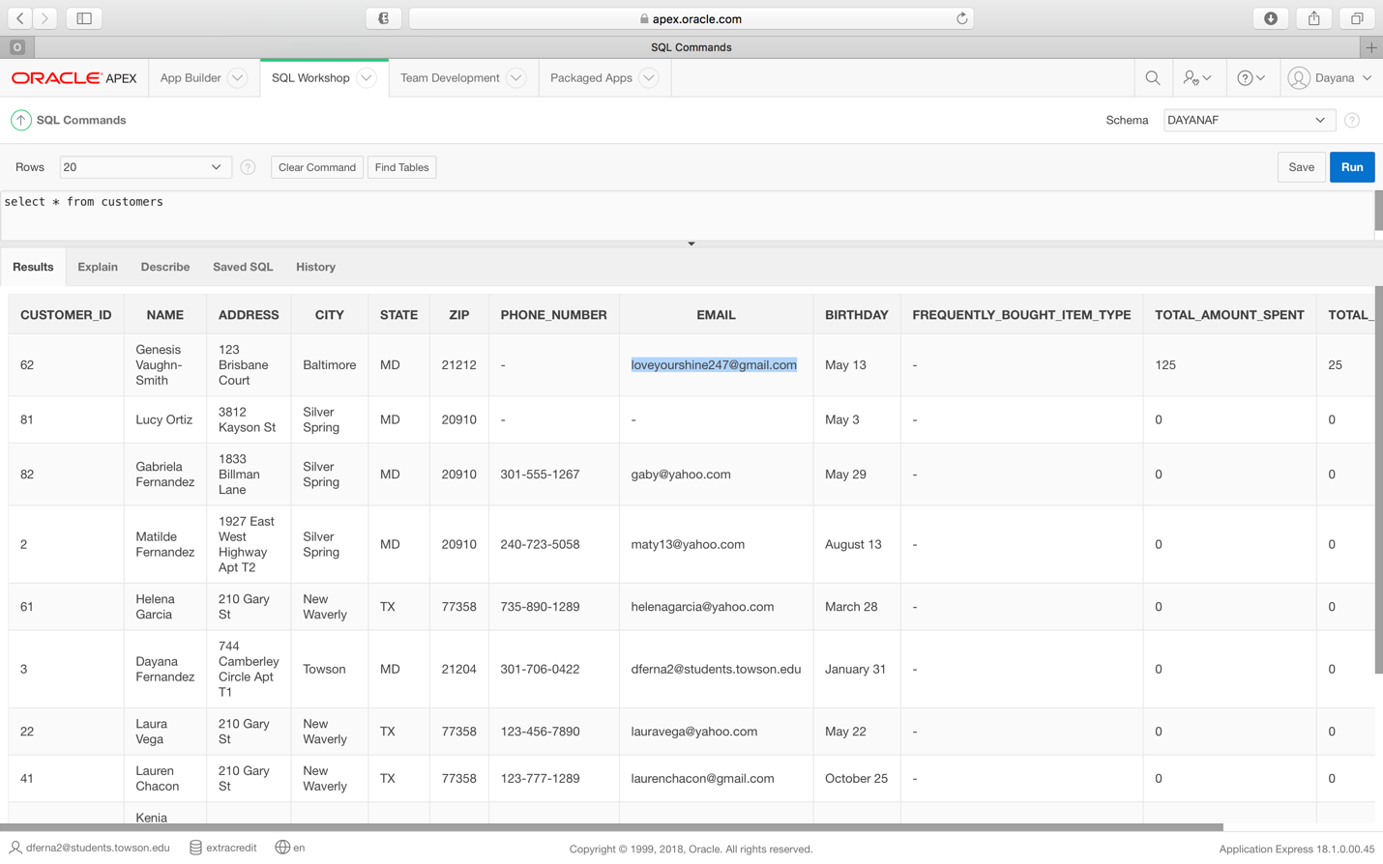

***Requirement 8 Error message:***

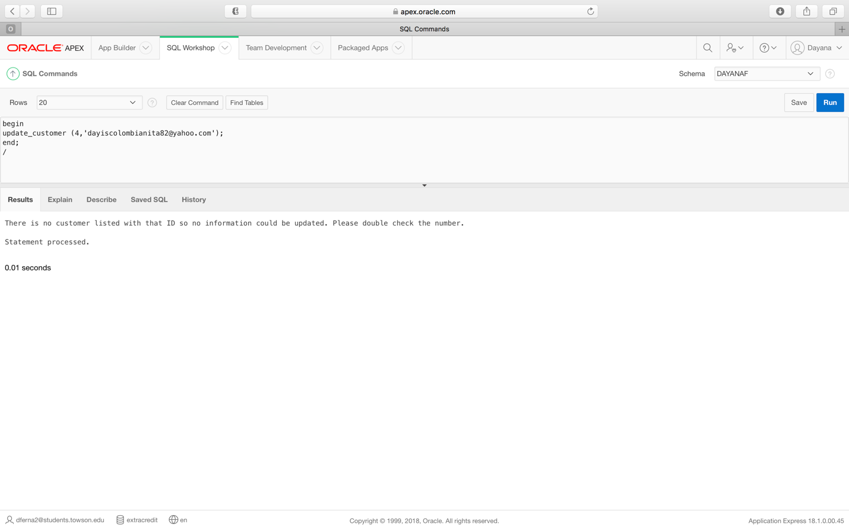

**Requirement 9:** (Using a procedure) Given a state, the system should be able to list all customers from that state. If there are no customers from that state, an error message will be returned.

**Requirement 9 procedure code:**

create or replace Procedure customer_by_state

(v_state customers.state%TYPE)

AS

v_count number;

CURSOR c_customers IS

Select customer_ID,name,address,city,state,zip

From customers

where upper(state) = upper(v_state);

begin

select count(*)

into v_count

from customers

where upper(v_state) = (state);

if v_count = 0 then

dbms_output.put_line('There are no customers from that state.');

end if;

FOR v_customers_data IN c_customers LOOP

DBMS_OUTPUT.PUT_LINE(TO_CHAR(v_customers_data.customer_id) || ' ' ||

v_customers_data.name || ' ' || TO_CHAR(v_customers_data.address) ||

' ' || v_customers_data.city ||

' ' || TO_CHAR(v_customers_data.state) ||

' ' || v_customers_data.zip);

END LOOP;

END;

**Requirement 9 procedure execution**

begin

customer_by_state ('md');

end;

/

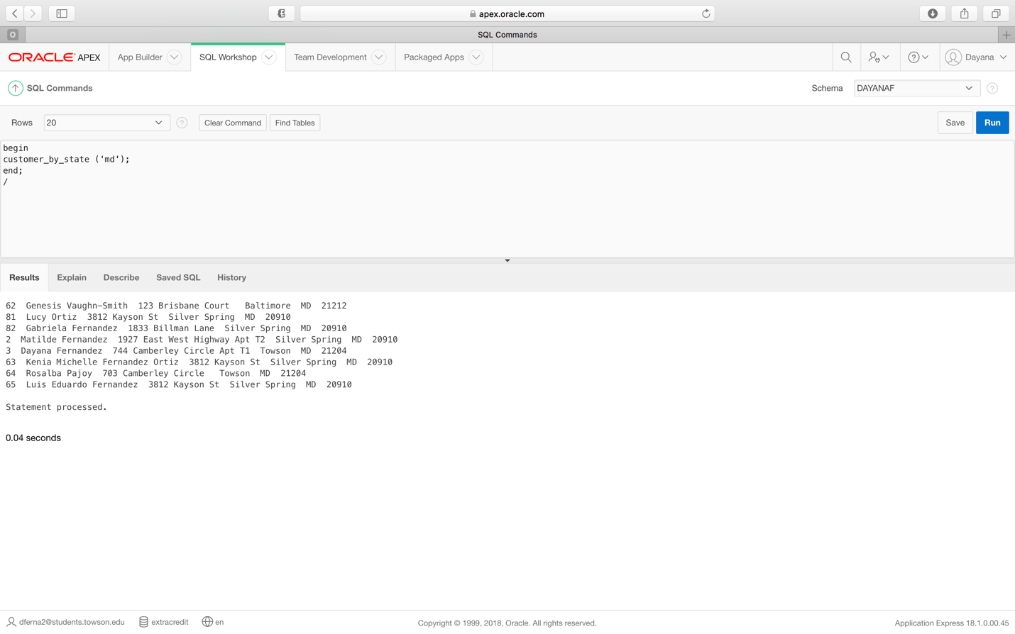

**Requirement 9 error message**

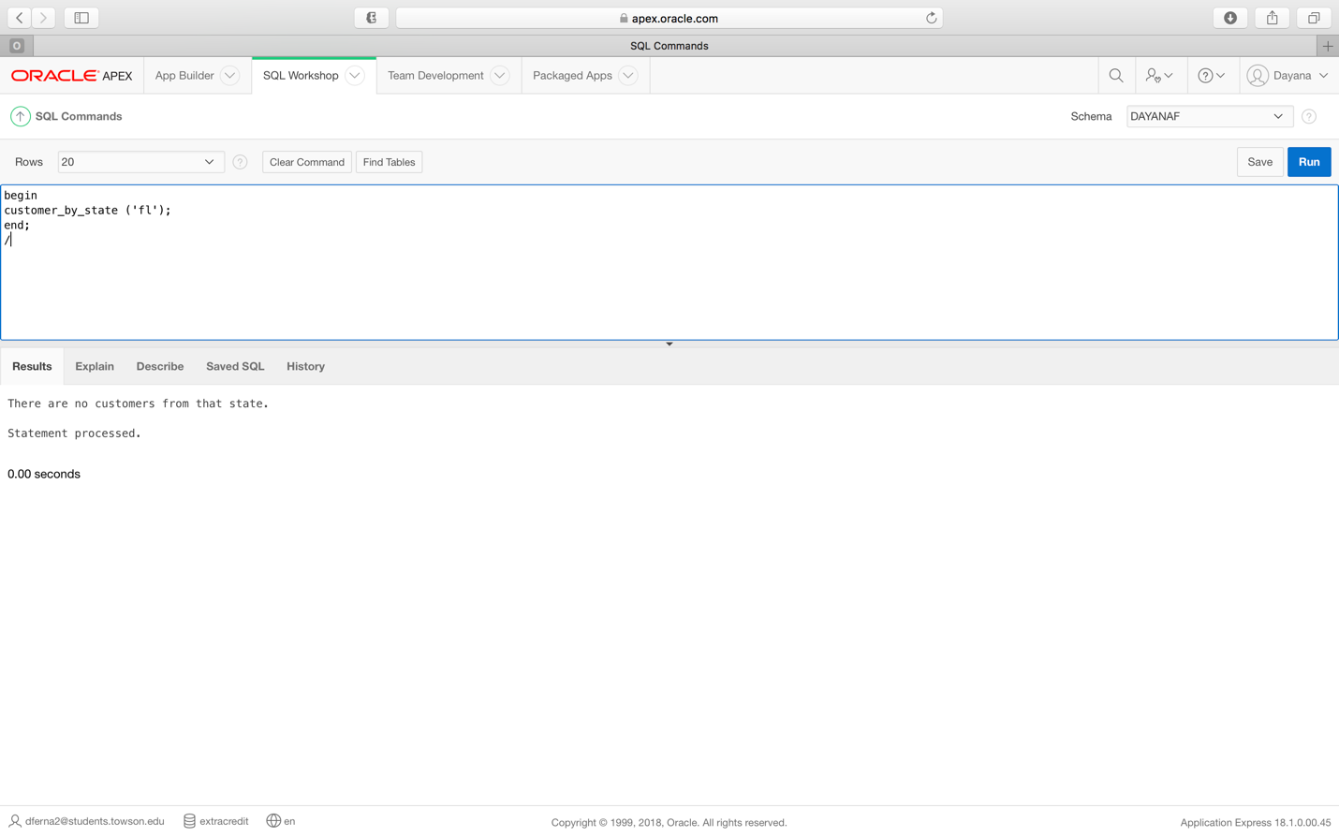

**Requirement 10:** (Using a procedure) The system will be able to add multiple payment preferences for customers. If that payment preference has already been entered for the customer, a message will be returned.

*Table before latest procedure execution*

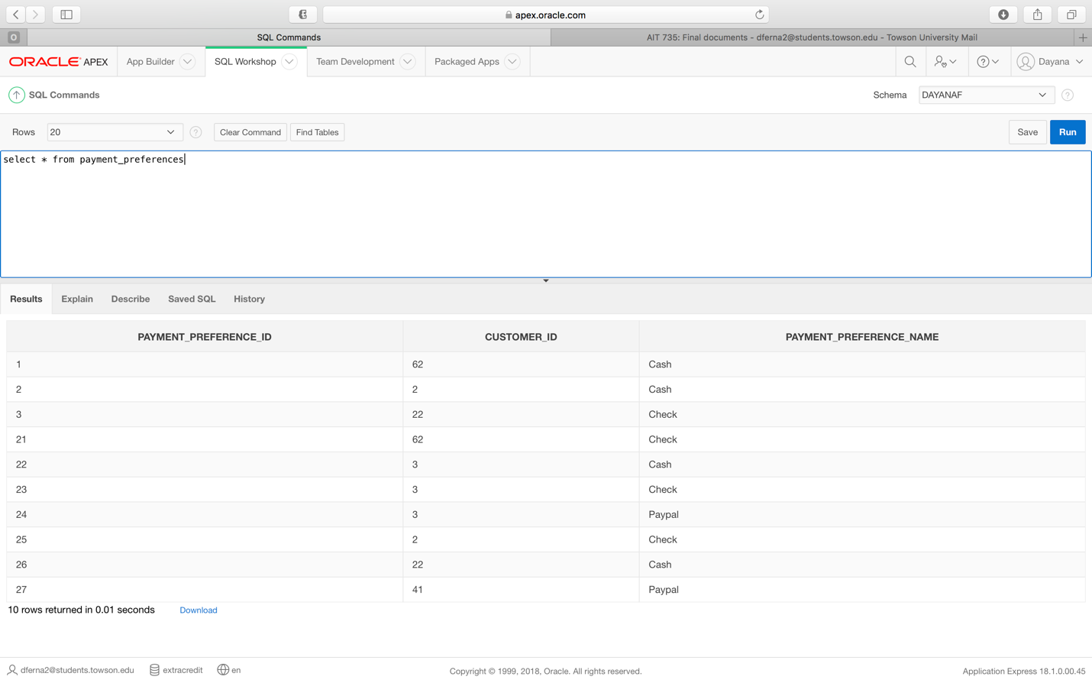

***Requirement 10 procedure code:***

create or replace procedure insert_payment_preference

(v_customer_ID payment_preferences.customer_ID%TYPE , v_payment_preference_name payment_preferences.payment_preference_name%TYPE)

is

v_ErrorCode number; --USED FOR ERROR CHECKING

v_ErrorMsg Varchar2(200);

v_CurrentUser Varchar2(100);

v_record_count number;

duplicate_exception Exception; -- User Defined Error

--Cursor to check for duplicates

Cursor payment_preference_exists

IS

Select count(*) from payment_preferences where payment_preference_name = (v_payment_preference_name);

begin

--Validation to see if payment preference exists for customer

v_record_count := 0;

OPEN payment_preference_exists;

FETCH payment_preference_exists INTO v_record_count;

CLOSE payment_preference_exists;

IF v_record_count > 0 THEN

RAISE duplicate_exception;

END IF;

--INSERT HERE

INSERT INTO payment_preferences (customer_ID, payment_preference_name) values

(v_customer_ID , v_payment_preference_name);

commit;

EXCEPTION

When duplicate_exception THEN

dbms_output.put_line ('Payment preference already exists for customer.');

WHEN OTHERS THEN

v_ErrorCode := SQLCODE;

v_ErrorMsg := substr(SQLERRM,1,200);

v_CurrentUser := USER;

DBMS_OUTPUT.PUT_LINE( TO_CHAR(SYSDATE) || v_CurrentUser

|| TO_CHAR(v_ErrorCode) || v_ErrorMsg);

end;

***Requirement 10 procedure execution***

begin

insert_payment_preference (3,'Square');

end;

/

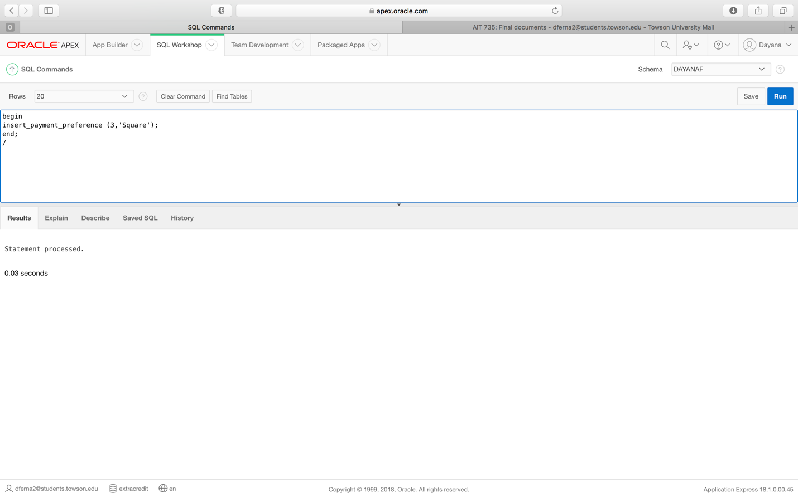

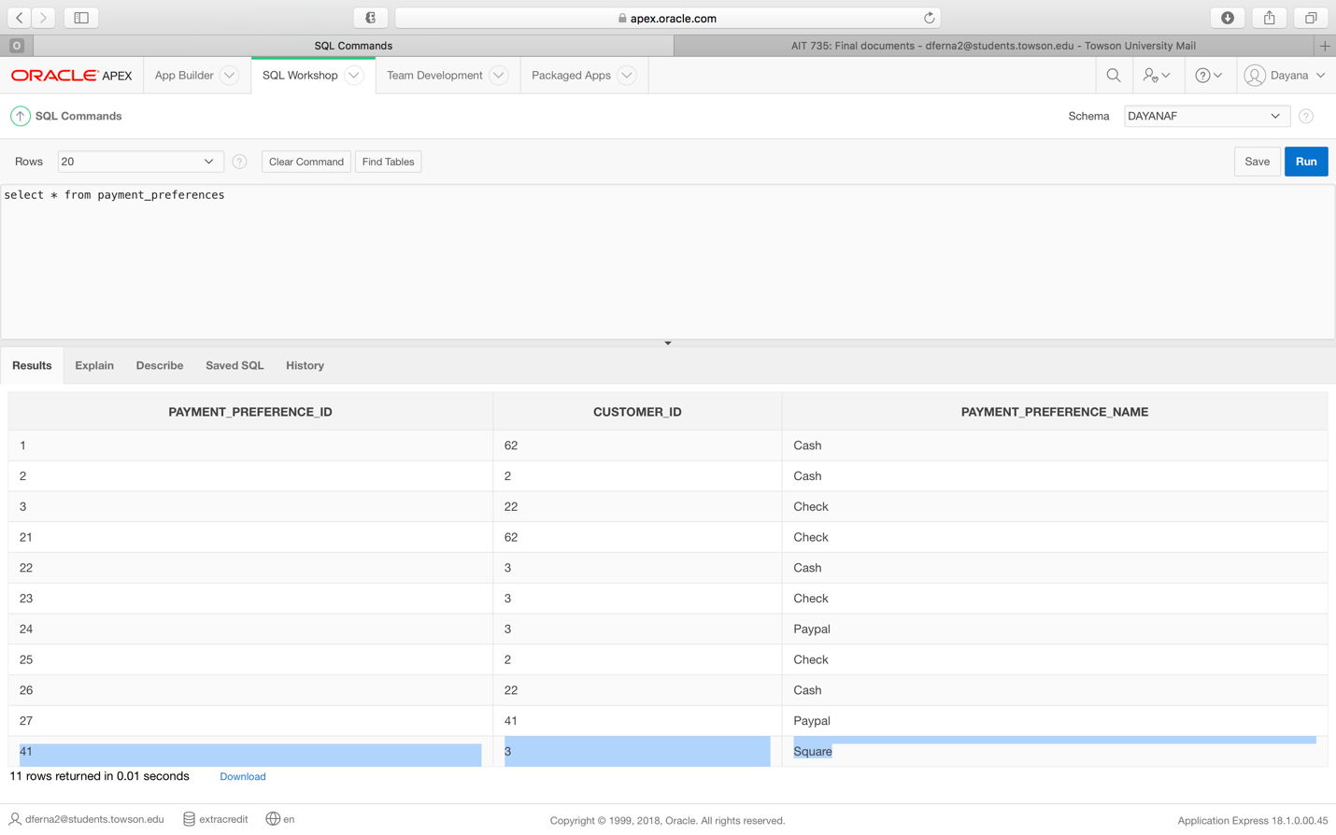

***Requirement 10 error message***

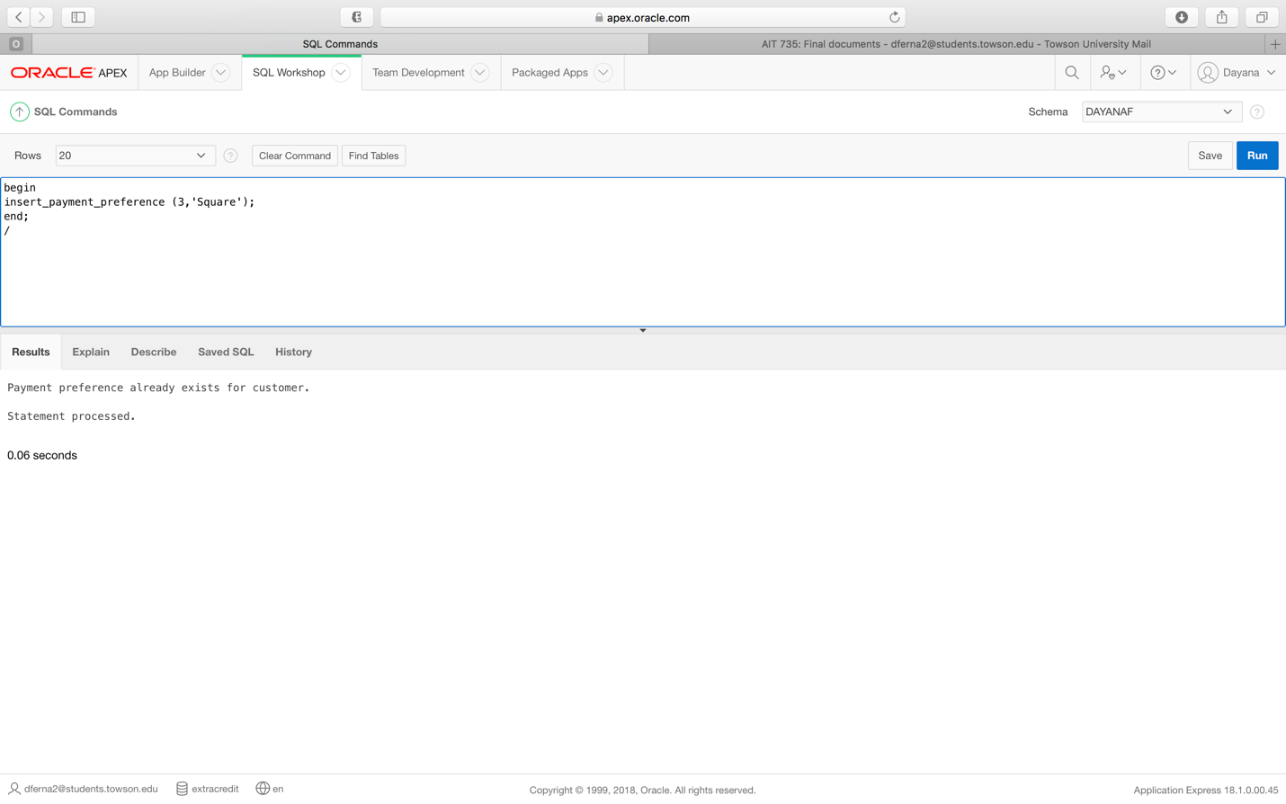

**Requirement 11**: (Using a procedure) The system will be able to add multiple selection preferences for customers. If that selection preference has already been entered for the customer, a message will be returned.

*Table prior to latest procedure execution*

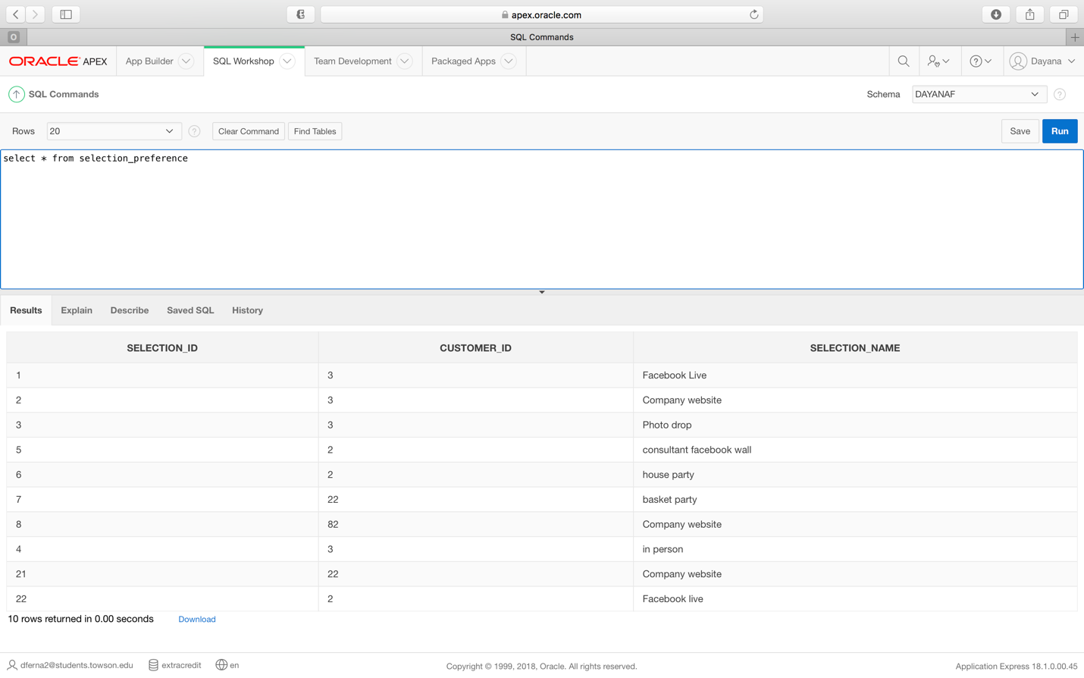

***Requirement 11 procedure code***

create or replace procedure insert_payment_preference

(v_customer_ID payment_preferences.customer_ID%TYPE , v_payment_preference_name payment_preferences.payment_preference_name%TYPE)

is

v_ErrorCode number; --USED FOR ERROR CHECKING

v_ErrorMsg Varchar2(200);

v_CurrentUser Varchar2(100);

v_record_count number;

duplicate_exception Exception; -- User Defined Error

--Cursor to check for duplicates

Cursor payment_preference_exists

IS

Select count(*) from payment_preferences where payment_preference_name = (v_payment_preference_name);

begin

--Validation to see if payment preference exists for customer

v_record_count := 0;

OPEN payment_preference_exists;

FETCH payment_preference_exists INTO v_record_count;

CLOSE payment_preference_exists;

IF v_record_count > 0 THEN

RAISE duplicate_exception;

END IF;

--INSERT HERE

INSERT INTO payment_preferences (customer_ID, payment_preference_name) values

(v_customer_ID , v_payment_preference_name);

commit;

EXCEPTION

When duplicate_exception THEN

dbms_output.put_line ('Payment preference already exists for customer.');

WHEN OTHERS THEN

v_ErrorCode := SQLCODE;

v_ErrorMsg := substr(SQLERRM,1,200);

v_CurrentUser := USER;

DBMS_OUTPUT.PUT_LINE( TO_CHAR(SYSDATE) || v_CurrentUser

|| TO_CHAR(v_ErrorCode) || v_ErrorMsg);

end;

***Requirement 11 procedure execution***

begin

insert_selection_preference (2,'hostess party');

end;

/

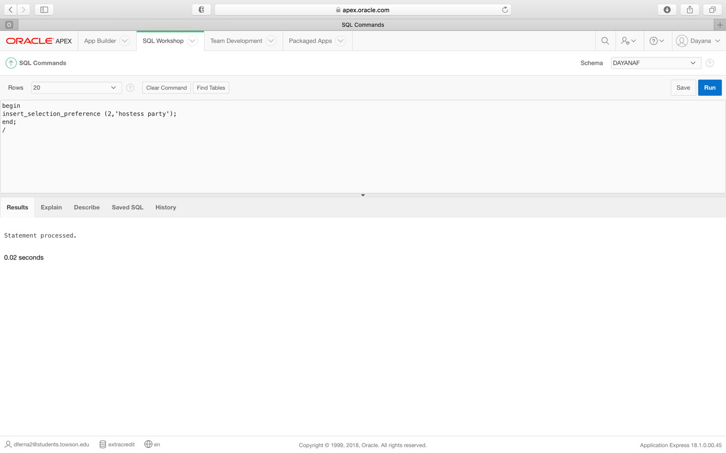

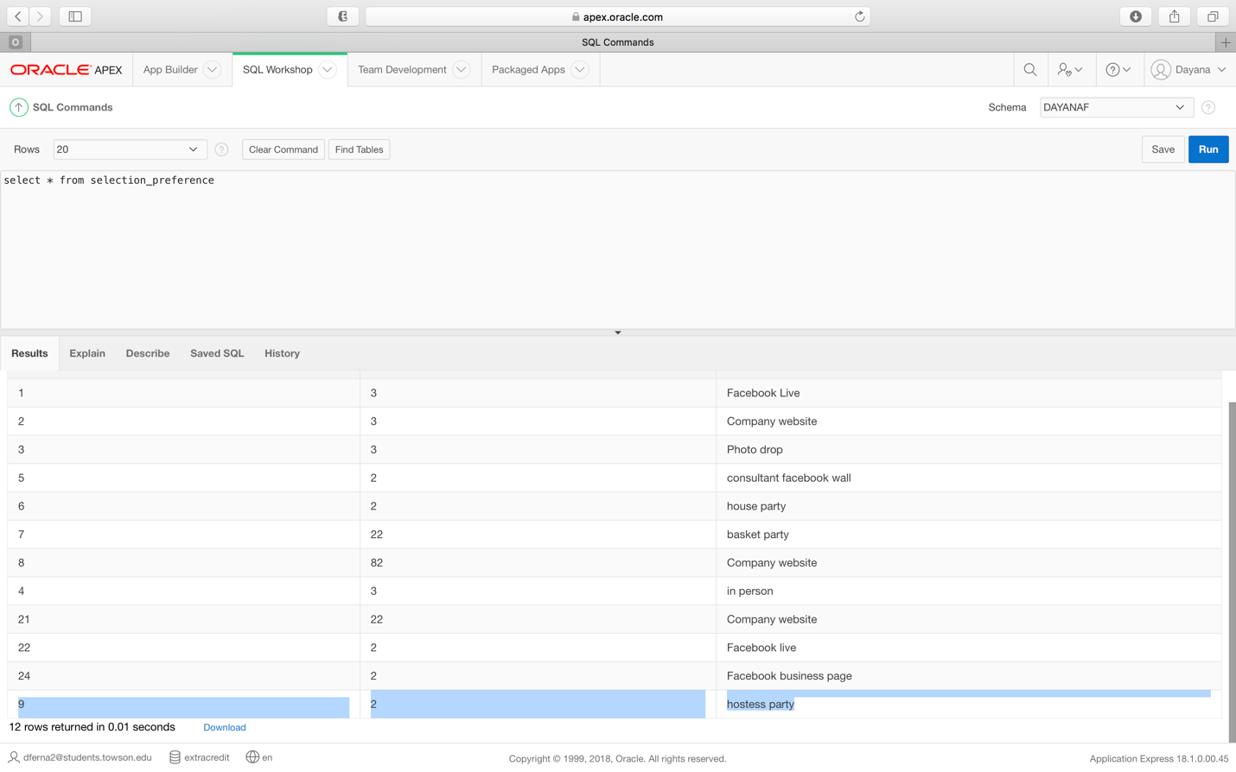

***Requirement 11 error message***

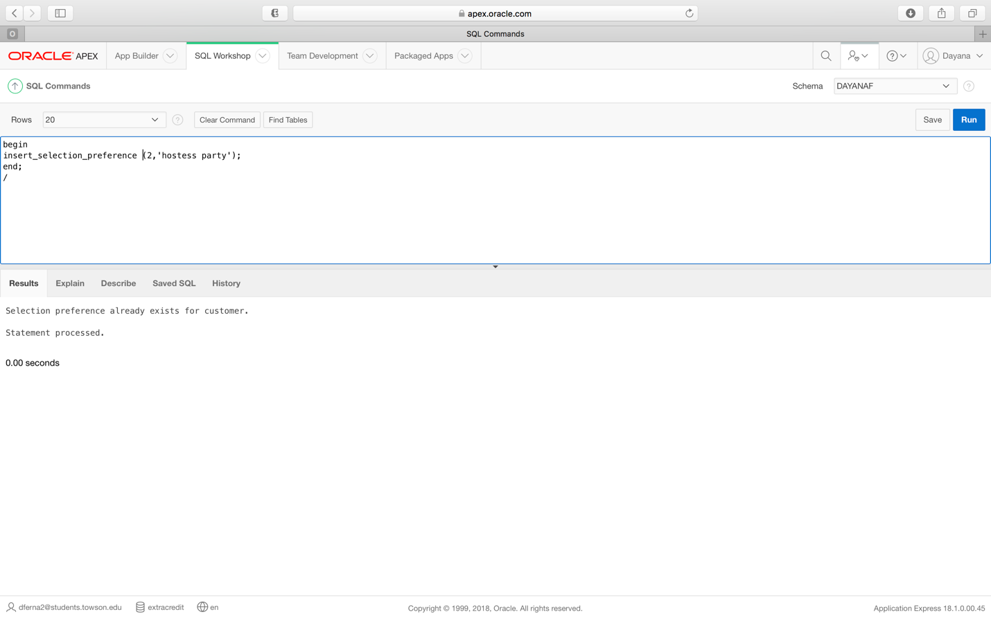

**Requirement 12:** (Using a procedure) Given a payment preference, the system should be able to select all customers that prefer to use that particular payment method, while also making sure that the payment method is valid. If it is not valid or if there are no customers that prefer that particular payment method, a message will be displayed.

***Requirement 12 procedure code***

create or replace Procedure customer_by_payment

(v_payment_preference_name payment_preferences.payment_preference_name%TYPE)

AS

v_count number;

CURSOR c_payment_preferences IS

Select customer_ID,payment_preference_name

From payment_preferences

where upper(payment_preference_name) = upper(v_payment_preference_name);

begin

select count(*)

into v_count

from payment_preferences

where upper(v_payment_preference_name) = (payment_preference_name);

if v_count = 0 then

dbms_output.put_line('There are no customers that prefer that payment method or you have entered an invalid payment method.');

end if;

FOR v_payment_preferences_data IN c_payment_preferences LOOP

DBMS_OUTPUT.PUT_LINE(TO_CHAR(v_payment_preferences_data.customer_id) || ' ' ||

v_payment_preferences_data.payment_preference_name);

END LOOP;

END;

***Requirement 12 procedure execution***

begin

customer_by_payment ('cash');

end;

/

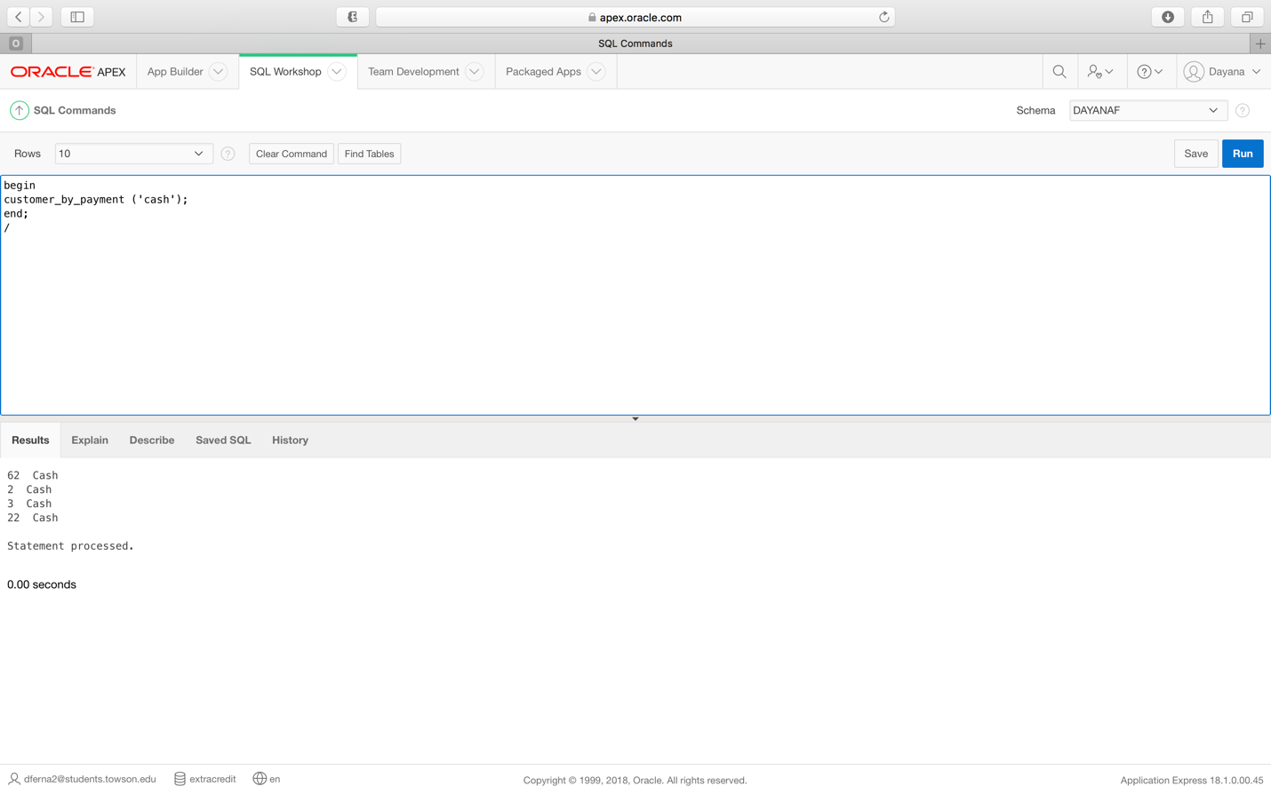

***Requirement 12 error message***

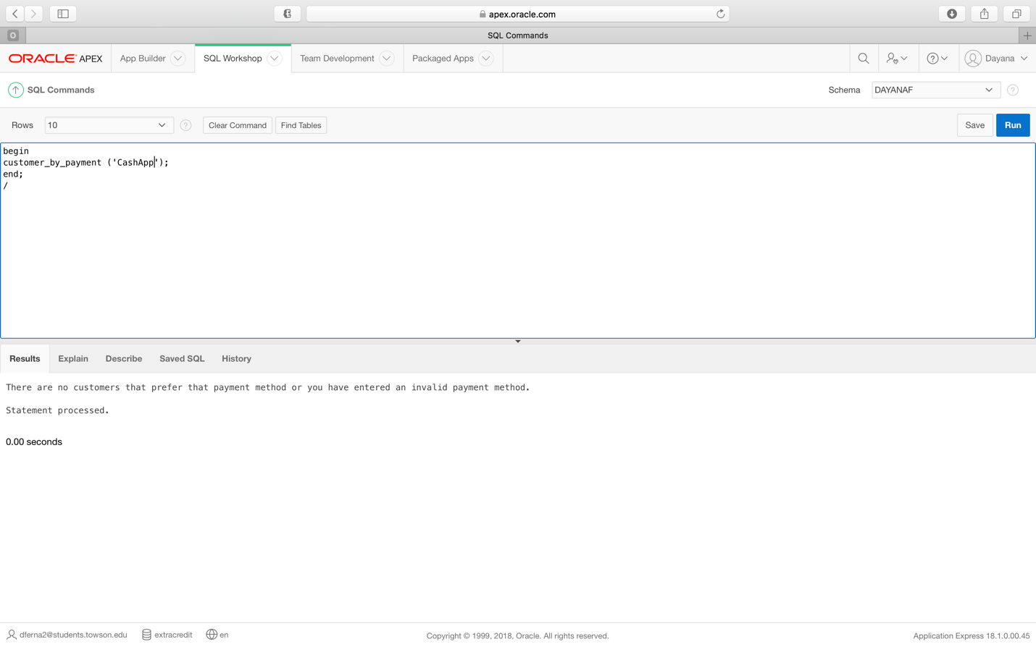

**Requirement 13:** (Using a procedure) Given an item selection preference, the system should be able to select all customers that prefer to use that particular item selection method, while also making sure that the selection method is valid. If it is not valid or if there are no customers that prefer that particular selection method, a message will be displayed.

***Requirement 13 procedure code***

create or replace Procedure customer_by_selection

(v_selection_name selection_preference.selection_name%TYPE)

AS

v_count number;

CURSOR c_selection_preference IS

Select customer_ID,selection_name

From selection_preference

where upper(selection_name) = upper(v_selection_name);

begin

select count(*)

into v_count

from selection_preference

where upper(v_selection_name) = (selection_name);

if v_count = 0 then

dbms_output.put_line('There are no customers that prefer that selection method or you have entered an invalid selection method.');

end if;

FOR v_selection_preference_data IN c_selection_preference LOOP

DBMS_OUTPUT.PUT_LINE(TO_CHAR(v_selection_preference_data.customer_id) || ' ' ||

v_selection_preference_data.selection_name);

END LOOP;

END;

***Requirement 13 procedure execution***

begin

customer_by_selection ('Facebook live');

end;

/

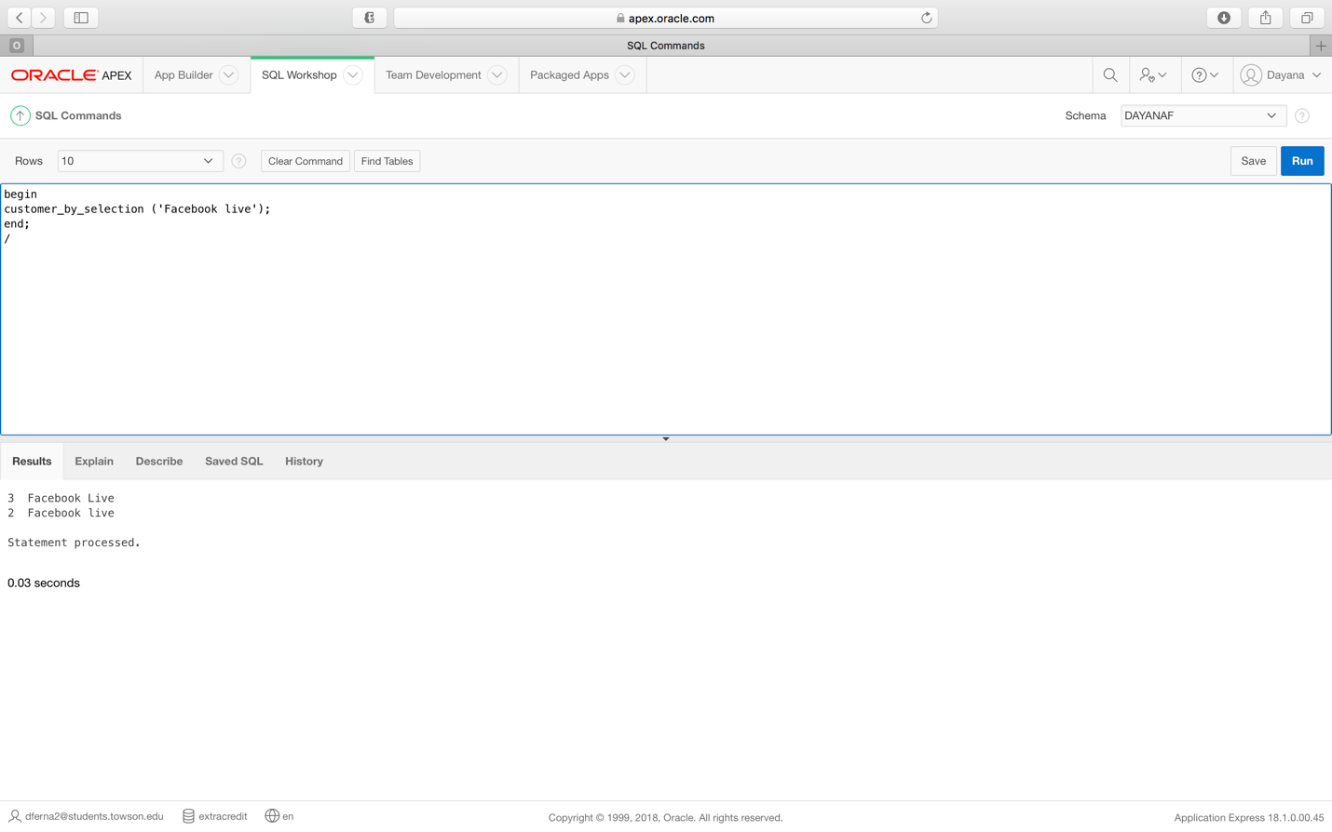

***Requirement 13 error message***

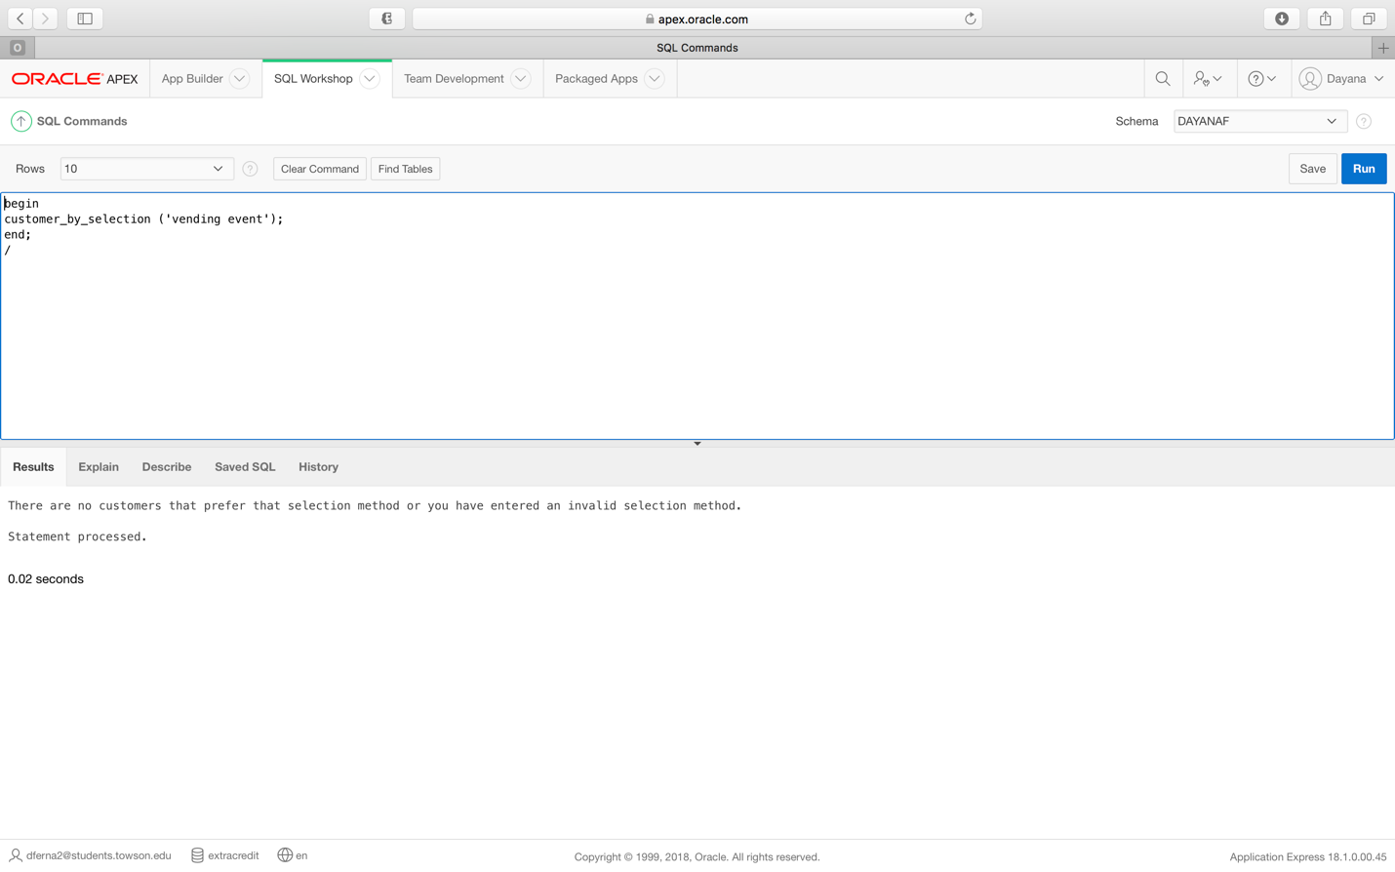

**Requirement 14:** (Using a procedure) Given a month, the system should be able to list all customers that have a birthday during that month. If there are no birthdays during that month, a message will be returned.

***Requirement 14 procedure code:***

create or replace Procedure customer_by_birthday

(v_birthday customers.birthday%TYPE)

AS

v_count number;

CURSOR c_customers IS

Select name,birthday

From customers

where upper(birthday) like '%' || upper(v_birthday) || '%';

begin

select count(*)

into v_count

from customers

where upper(v_birthday) = (birthday);

if v_count = 0 then

dbms_output.put_line('There are no customers that have a birthday during that month.');

end if;

FOR v_customers_data IN c_customers LOOP

DBMS_OUTPUT.PUT_LINE(TO_CHAR(v_customers_data.name) || ' ' ||

v_customers_data.birthday);

END LOOP;

END;

***Requirement 14 Procedure execution:***

begin

customer_by_birthday ('May');

end;

/

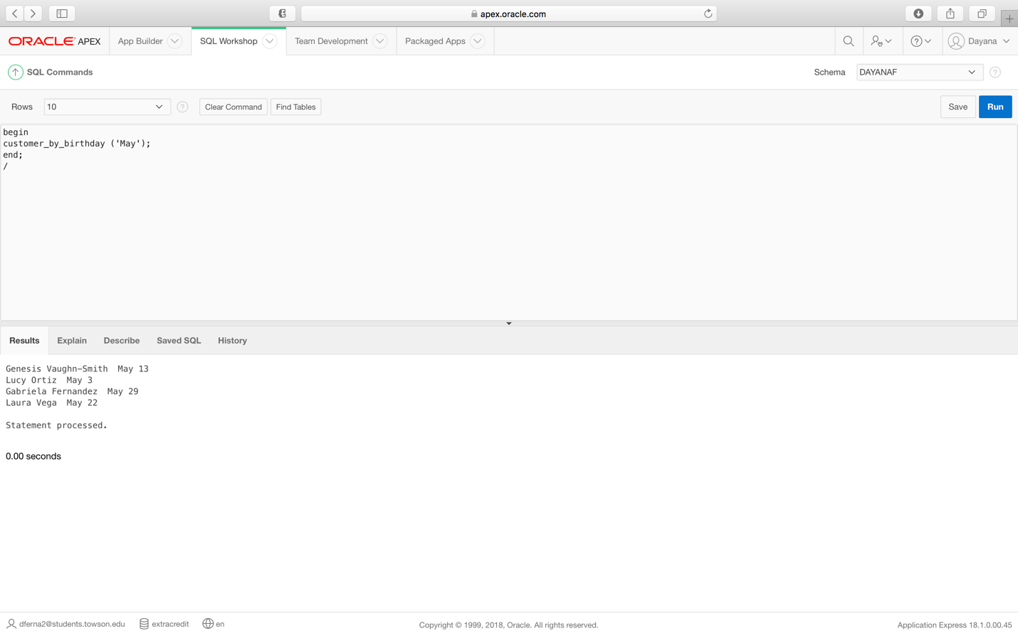

***Requirement 14 Error message:***

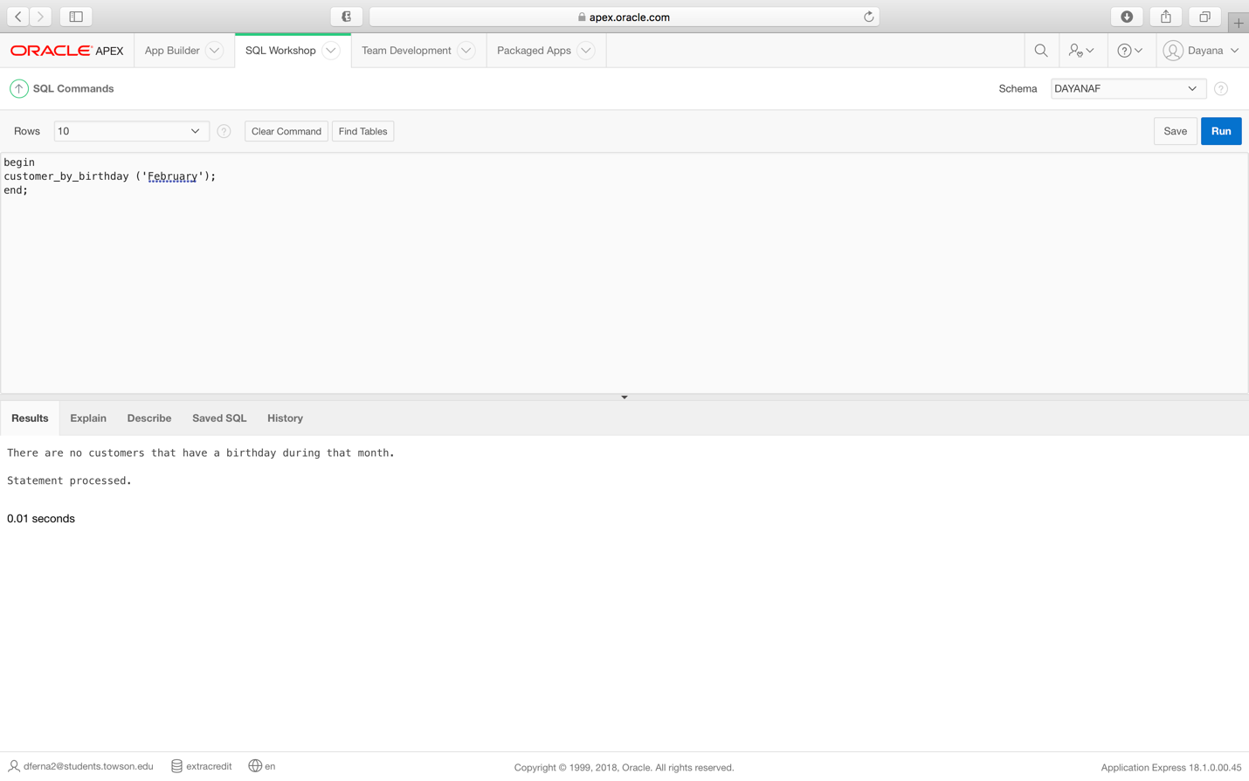

**Requirement 15:** (Using a procedure) Given a color, the system should be able to select all customers that have that color listed as a favorite. If there are no customers that like that color, an error message will be returned.

***Requirement 15 procedure code***

create or replace Procedure customer_by_color

(v_color favorite_color.color%TYPE)

AS

v_count number;

CURSOR c_favorite_color IS

Select customer_ID,color

From favorite_color

where upper(color) = upper(v_color);

begin

select count(*)

into v_count

from favorite_color

where upper(v_color) = (color);

if v_count = 0 then

dbms_output.put_line('There are no customers that like that color.');

end if;

FOR v_favorite_color_data IN c_favorite_color LOOP

DBMS_OUTPUT.PUT_LINE(TO_CHAR(v_favorite_color_data.customer_id) || ' ' ||

v_favorite_color_data.color);

END LOOP;

END;

***Requirement 15 procedure execution***

begin

customer_by_color ('Purple');

end;

/

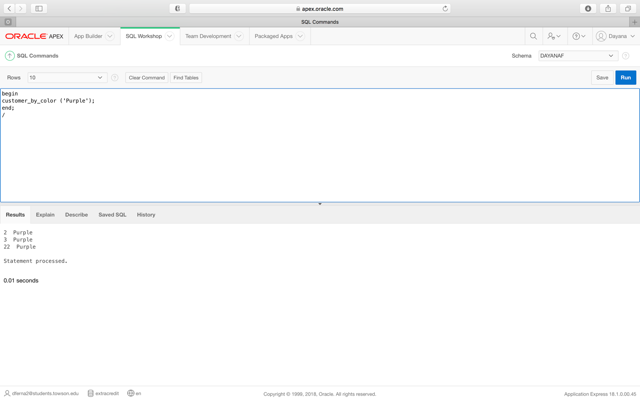

***Requirement 15 error code***

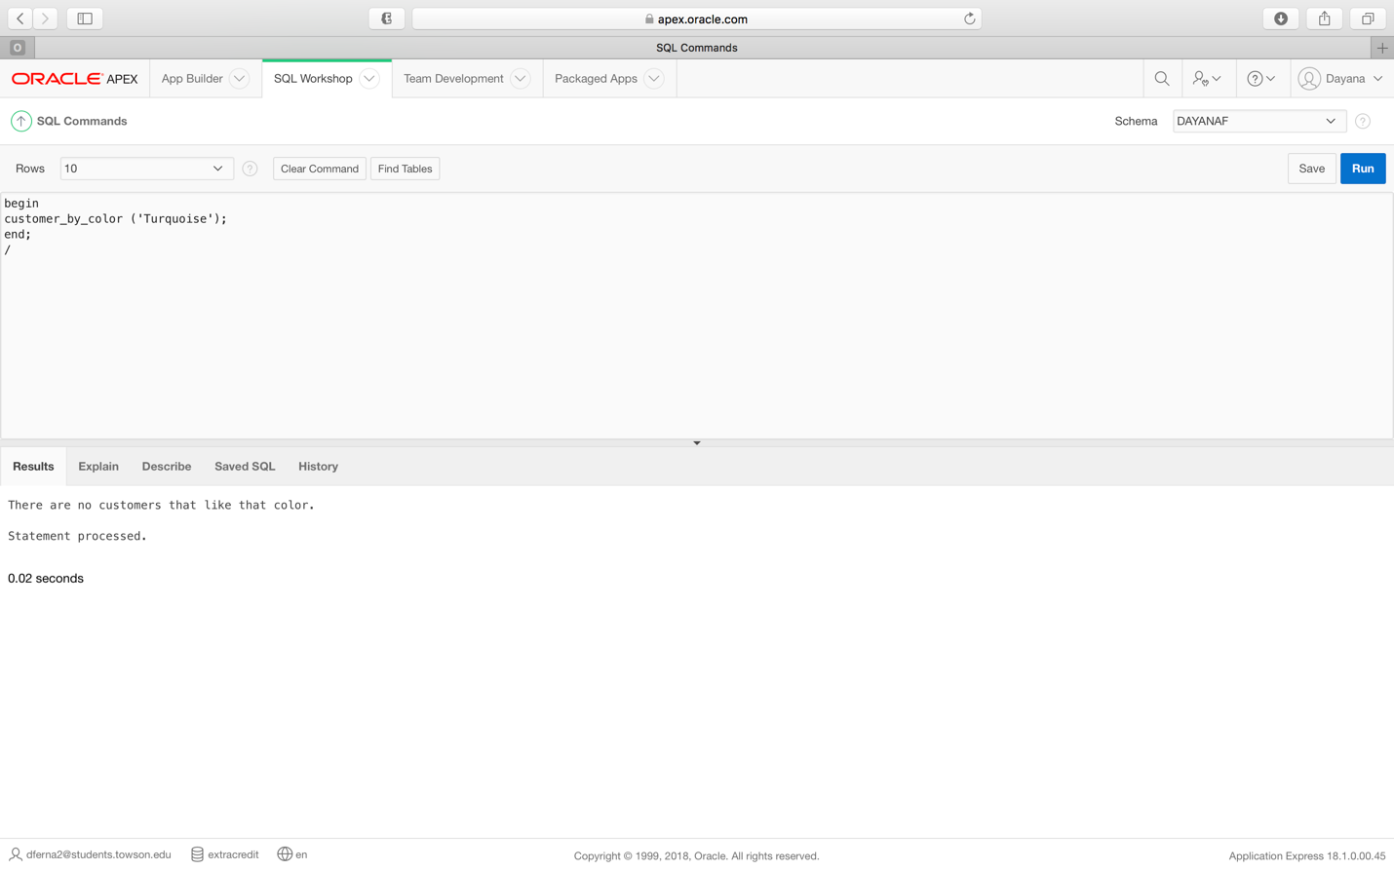

**Requirement 16:** (Using a procedure) Given a city, the system should be able to select all customers that live in that city. If there are no customers that like that color, an error message will be returned.

***Requirement 16 procedure code***

create or replace Procedure customer_by_city

(v_city customers.city%TYPE)

AS

v_count number;

CURSOR c_customers IS

Select customer_ID,name,address,city,state,zip

From customers

where upper(city) = upper(v_city);

begin

select count(*)

into v_count

from customers

where upper(v_city) = (city);

if v_count = 0 then

dbms_output.put_line('There are no customers that live in that city.');

end if;

FOR v_customers_data IN c_customers LOOP

DBMS_OUTPUT.PUT_LINE(TO_CHAR(v_customers_data.customer_id) || ' ' ||

v_customers_data.name || ' ' || TO_CHAR(v_customers_data.address) ||

' ' || v_customers_data.city ||

' ' || TO_CHAR(v_customers_data.state) ||

' ' || v_customers_data.zip);

END LOOP;

END;

***Requirement 16 procedure execution***

begin

customer_by_city ('Towson');

end;

/

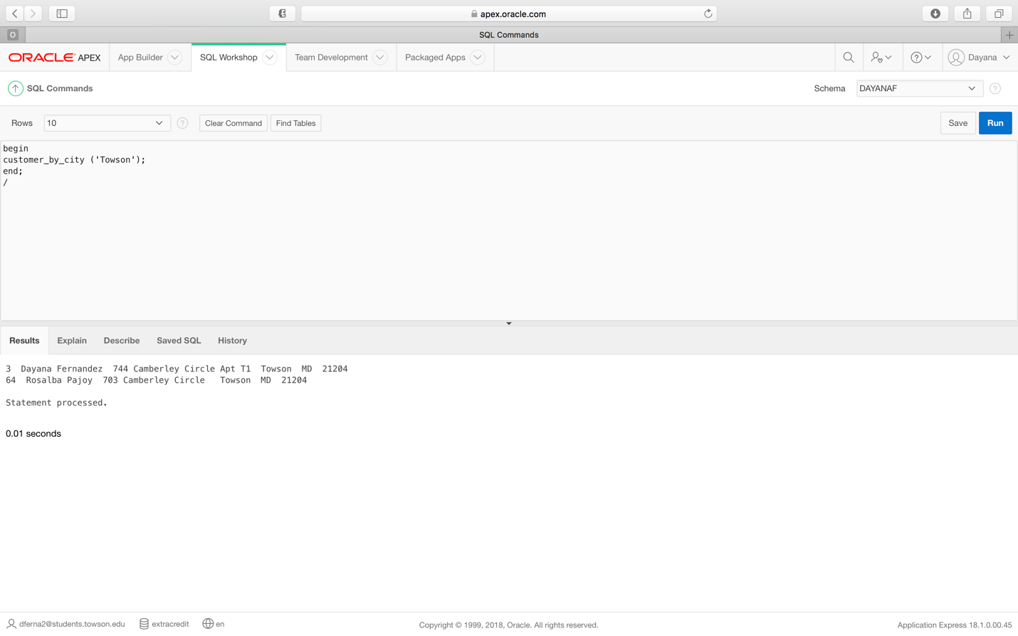

***Requirement 16 error message***

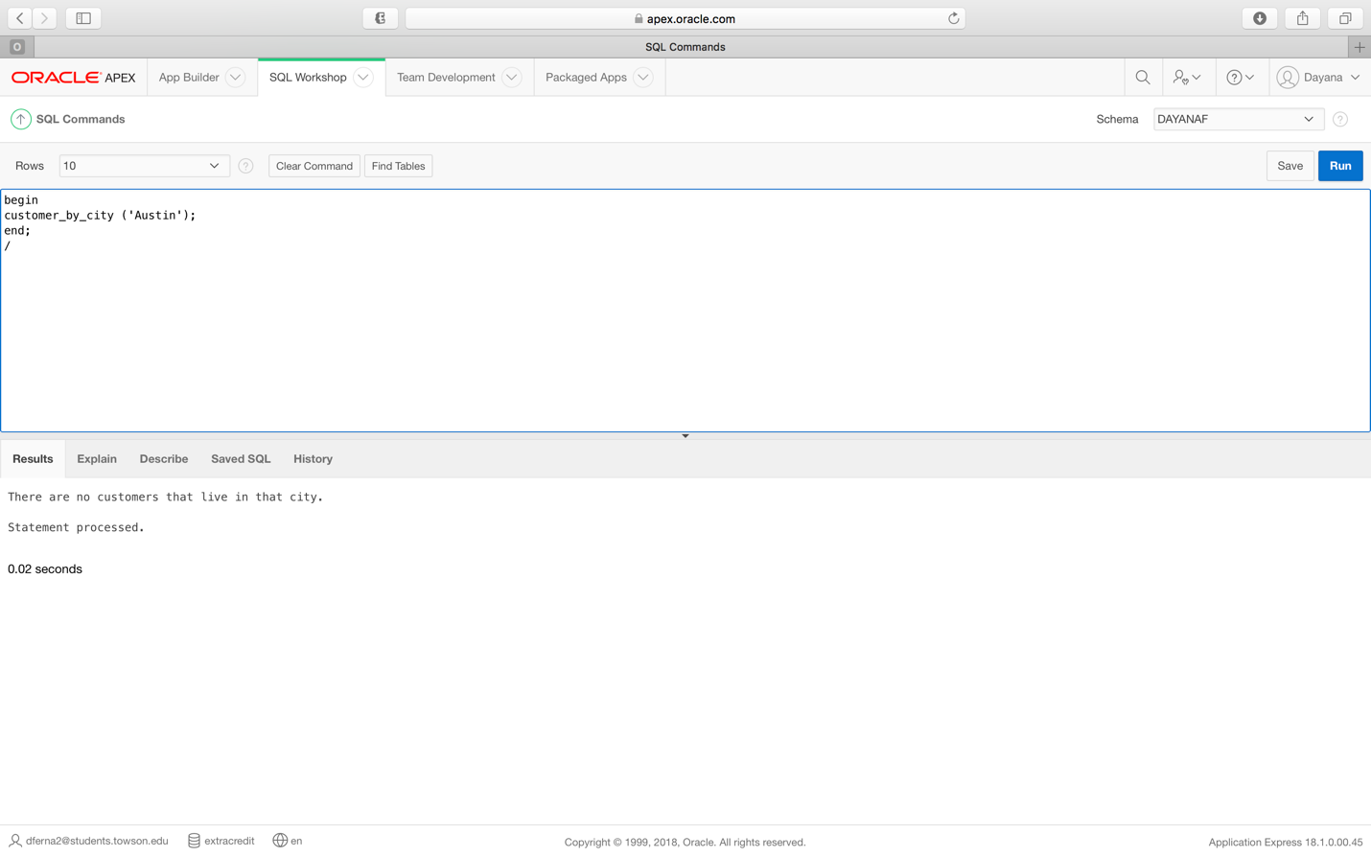

**Requirement 17:** (Using a procedure) Given a zip code, the system should be able to select all customers that live in that zip code. If there are no customers from that zip code, an error message will be returned.

***Requirement 17 procedure code***

create or replace Procedure customer_by_zip

(v_zip customers.zip%TYPE)

AS

v_count number;

CURSOR c_customers IS

Select customer_ID,name,address,city,state,zip

From customers

where upper(zip) = upper(v_zip);

begin

select count(*)

into v_count

from customers

where upper(v_zip) = (zip);

if v_count = 0 then

dbms_output.put_line('There are no customers that live in that zip code.');

end if;

FOR v_customers_data IN c_customers LOOP

DBMS_OUTPUT.PUT_LINE(TO_CHAR(v_customers_data.customer_id) || ' ' ||

v_customers_data.name || ' ' || TO_CHAR(v_customers_data.address) ||

' ' || v_customers_data.city ||

' ' || TO_CHAR(v_customers_data.state) ||

' ' || v_customers_data.zip);

END LOOP;

END;

***Requirement 17 procedure execution***

begin

customer_by_zip ('77358');

end;

/

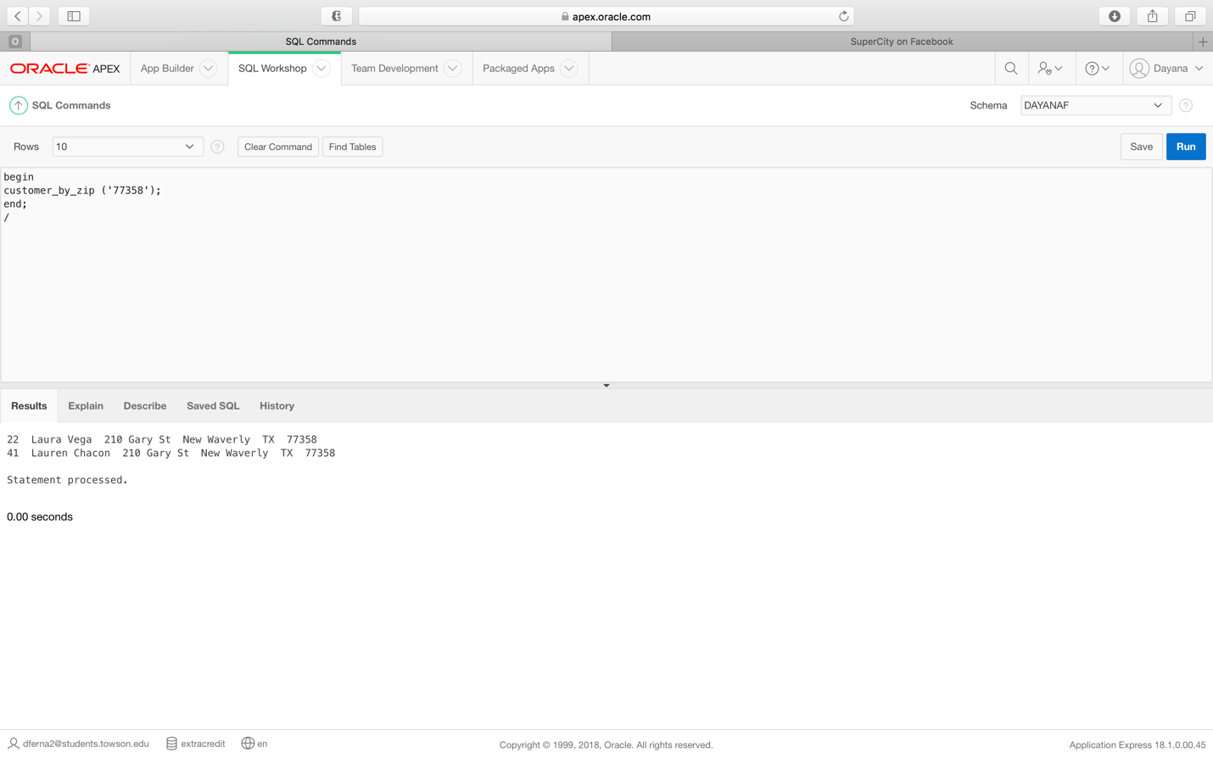

***Requirement 17 error message***

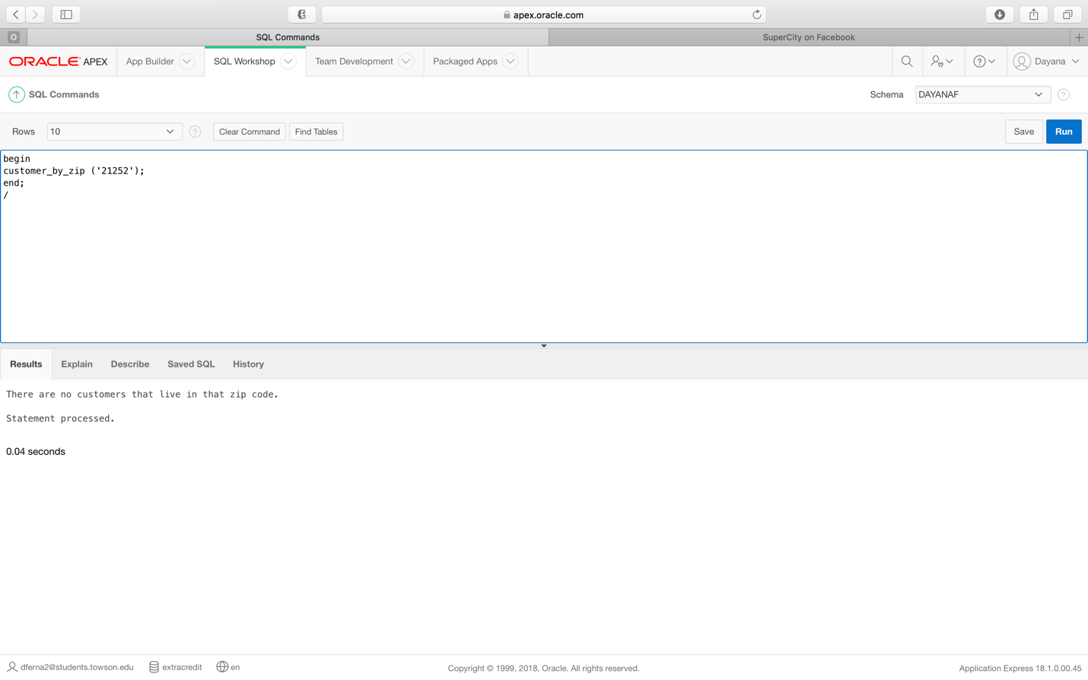

**Requirement 18:** (Using a procedure) Given a collection, the system should be able to select all inventory from that collection, while also making sure that the user has entered a valid collection. If not, a message will be displayed.

***Requirement 18 procedure code***

create or replace Procedure inventory_by_collection

(v_collection_name inventory.collection_name%TYPE)

AS

v_count number;

CURSOR c_inventory IS

Select item_ID,collection_name,item_name,item_type,item_color,quantity_available

From inventory

where upper(collection_name) = upper(v_collection_name);

begin

select count(*)

into v_count

from inventory

where upper(v_collection_name) = (collection_name);

if v_count = 0 then

dbms_output.put_line('Sorry, you have entered an invalid collection name.');

end if;

FOR v_inventory_data IN c_inventory LOOP

DBMS_OUTPUT.PUT_LINE(TO_CHAR(v_inventory_data.item_id) || ' ' ||

v_inventory_data.collection_name || ' ' || TO_CHAR(v_inventory_data.item_type) ||

' ' || v_inventory_data.item_color ||

' ' || TO_CHAR(v_inventory_data.quantity_available));

END LOOP;

END;

***Requirement 18 procedure execution***

begin

inventory_by_collection (‘regular’);

end;

/

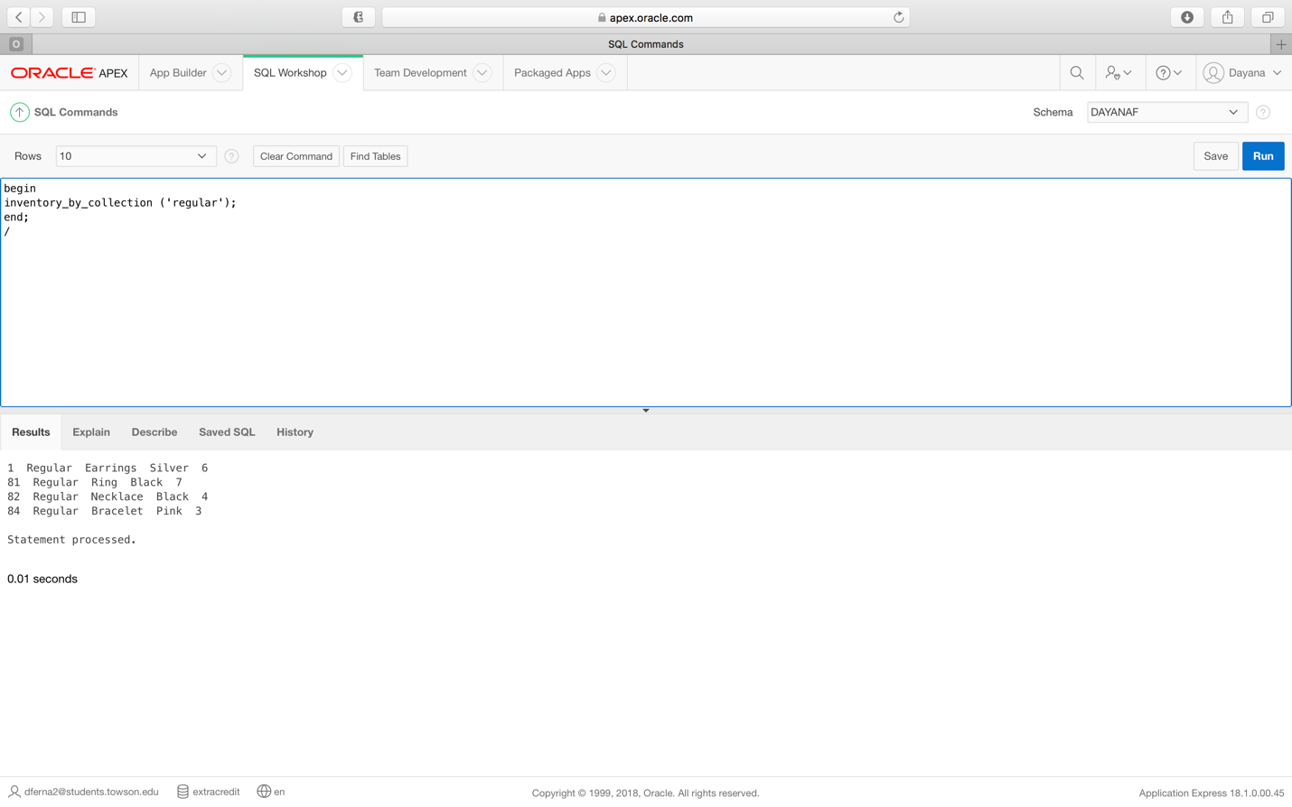

***Requirement 18 error message***

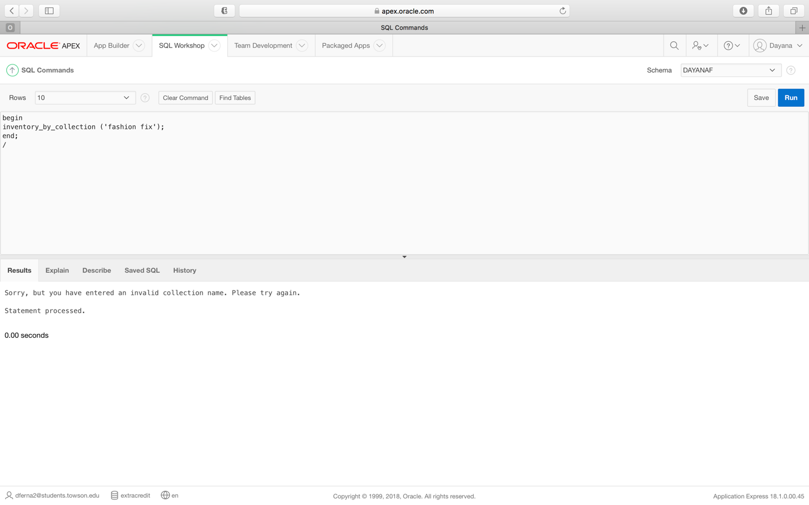

**Requirement 19:** (Using a procedure) Given an item type, the system should be able to select all inventory of that type. If the inventory type is not valid or if there is not inventory of that type, a message will be returned.

***Requirement 19 procedure code***

create or replace Procedure inventory_by_type

(v_item_type inventory.item_type%TYPE)

AS

v_count number;

CURSOR c_inventory IS

Select item_ID,collection_name,item_name,item_type,item_color,quantity_available

From inventory

where upper(item_type) = upper(v_item_type);

begin

select count(*)

into v_count

from inventory

where upper(v_item_type) = (item_type);

if v_count = 0 then

dbms_output.put_line('Sorry, you have entered an invalid item type.');

end if;

FOR v_inventory_data IN c_inventory LOOP

DBMS_OUTPUT.PUT_LINE(TO_CHAR(v_inventory_data.item_id) || ' ' ||

v_inventory_data.collection_name || ' ' || TO_CHAR(v_inventory_data.item_type) ||

' ' || v_inventory_data.item_color ||

' ' || TO_CHAR(v_inventory_data.quantity_available));

END LOOP;

END;

***Requirement 19 procedure execution***

begin

inventory_by_type ('Earrings');

end;

/

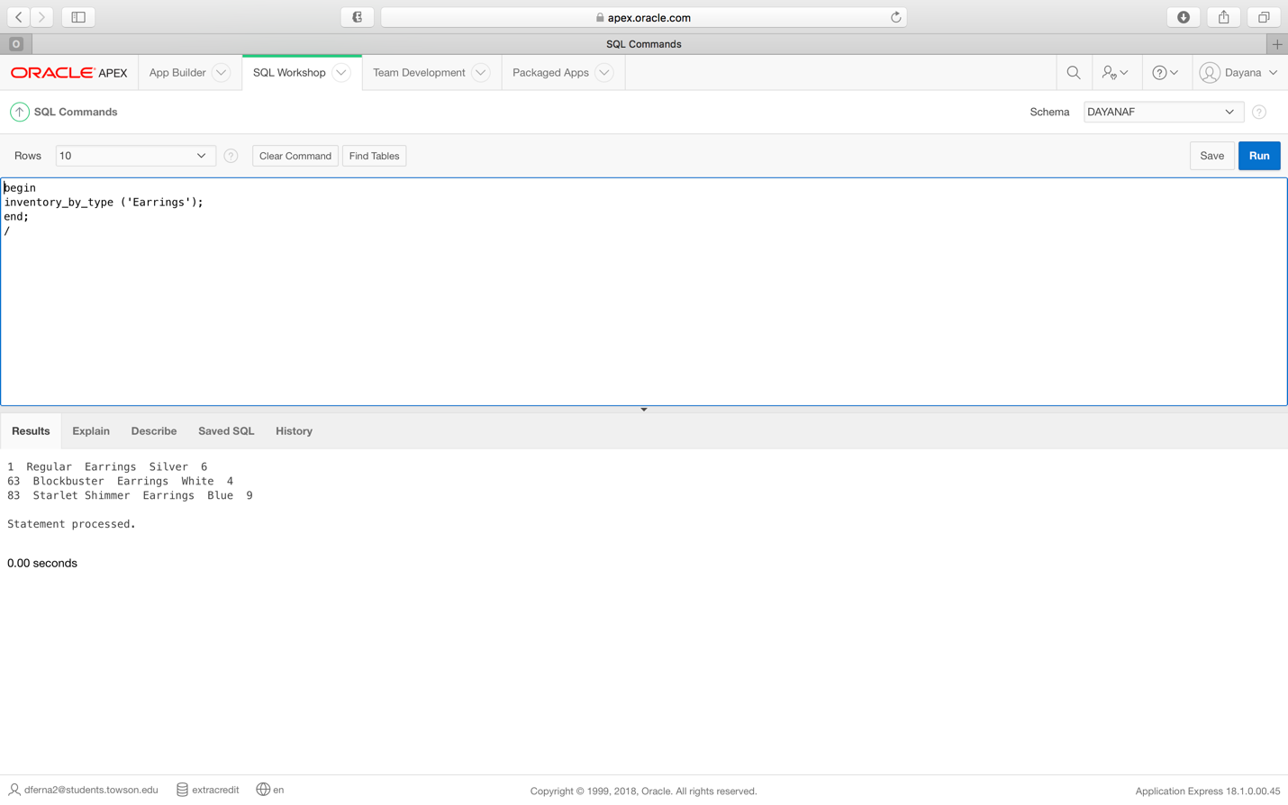

***Requirement 19 error message***

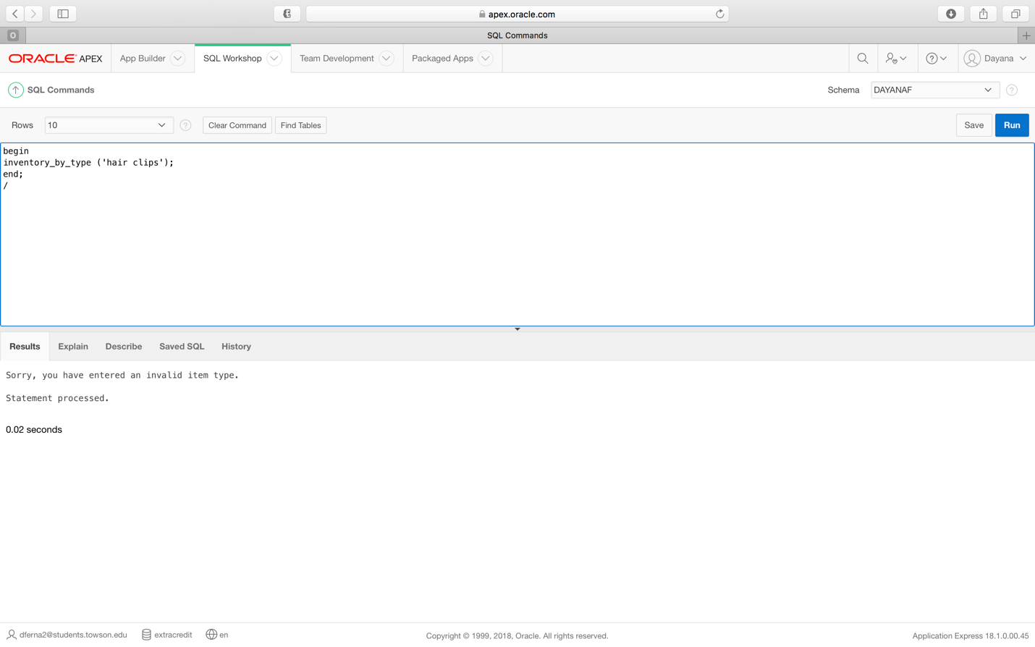

**Requirement 20:** (Using a procedure) Given an item color, the system should be able to select all inventory of that color. If no inventory of that color is available, then a message will be returned.

***Requirement 20 procedure code***

create or replace Procedure inventory_by_color

(v_item_color inventory.item_color%TYPE)

AS

v_count number;

CURSOR c_inventory IS

Select item_ID,collection_name,item_name,item_type,item_color,quantity_available

From inventory

where upper(item_color) = upper(v_item_color);

begin

select count(*)

into v_count

from inventory

where upper(v_item_color) = (item_color);

if v_count = 0 then

dbms_output.put_line('There is no inventory of that color available, sorry!');

end if;

FOR v_inventory_data IN c_inventory LOOP

DBMS_OUTPUT.PUT_LINE(TO_CHAR(v_inventory_data.item_id) || ' ' ||

v_inventory_data.collection_name || ' ' || TO_CHAR(v_inventory_data.item_type) ||

' ' || v_inventory_data.item_color ||

' ' || TO_CHAR(v_inventory_data.quantity_available));

END LOOP;

END;

***Requirement 20 procedure execution***

begin

inventory_by_color ('White');

end;

/

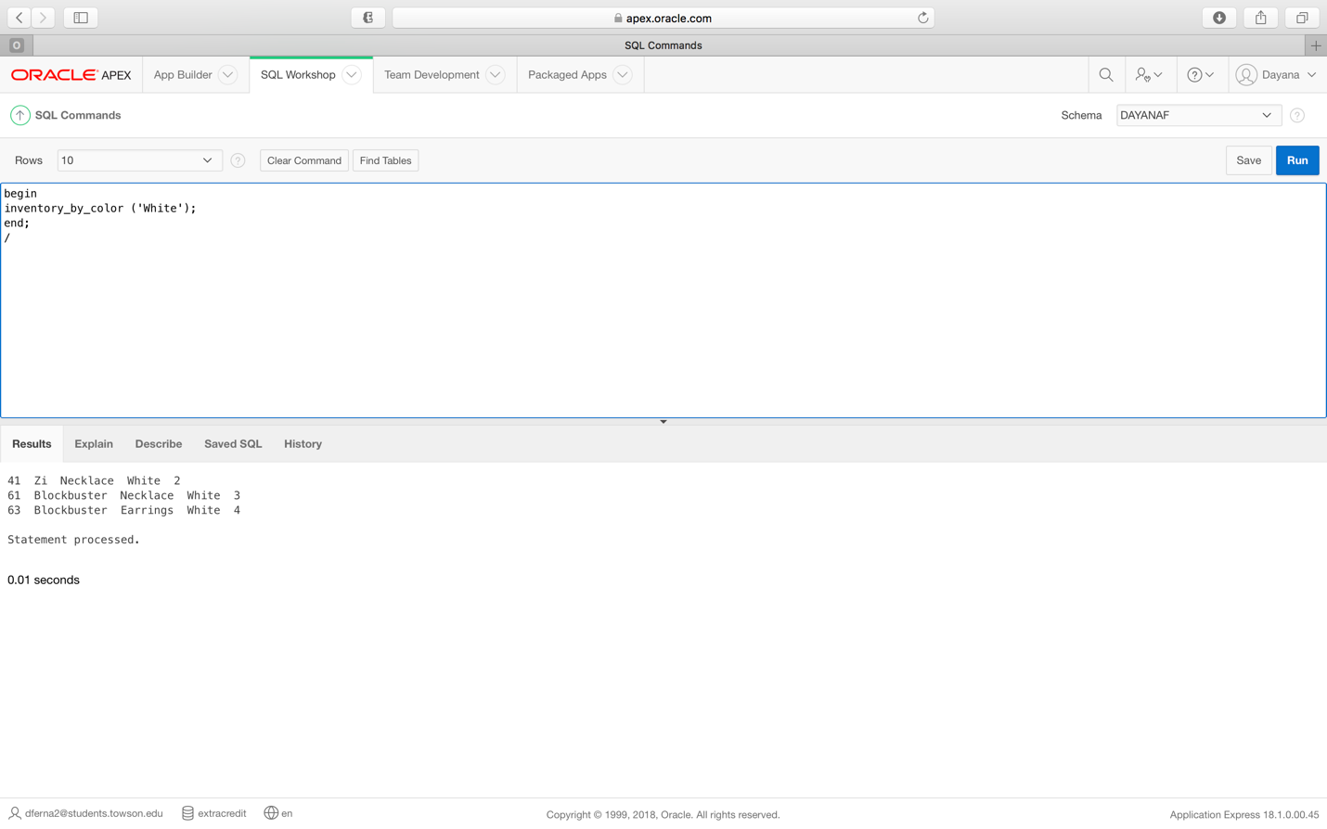

***Requirement 20 error message***

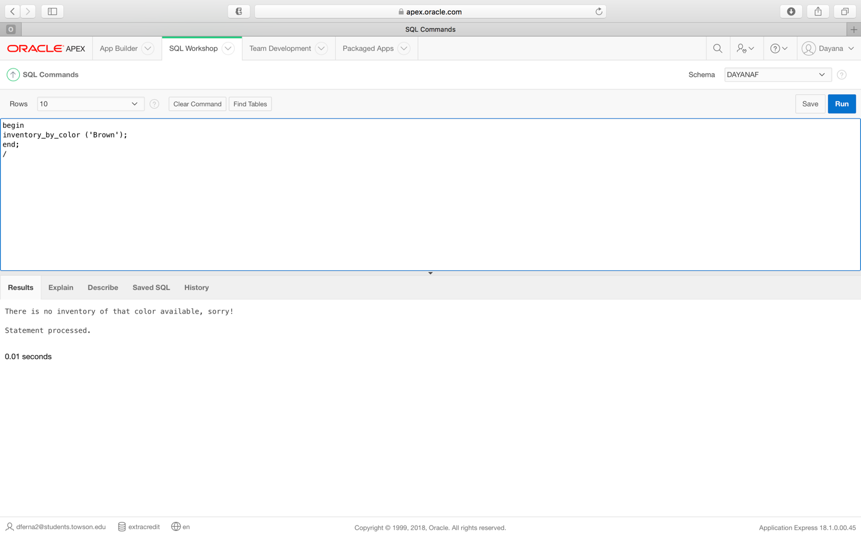

**Requirement 21**: (Using a procedure): Given a month, the system will be able to select all orders placed within that month. If there are no orders during that month, then a message will be returned.

***Requirement 21 procedure code***

create or replace Procedure order_by_date

(v_order_date orders.order_date%TYPE)

AS

v_count number;

CURSOR c_orders IS

Select order_ID,customer_ID,order_date,number_of_items,total_price,payment_status,delivery_status

From orders

where upper(order_date) like '%' || upper(v_order_date) || '%';

begin

select count(*)

into v_count

from orders

where upper(v_order_date) = (order_date);

if v_count = 0 then

dbms_output.put_line('There are no orders for that month.');

end if;

FOR v_orders_data IN c_orders LOOP

DBMS_OUTPUT.PUT_LINE(TO_CHAR(v_orders_data.order_id) || ' ' ||

v_orders_data.customer_ID || ' ' || TO_CHAR(v_orders_data.order_date) ||

' ' || v_orders_data.number_of_items ||

' ' || TO_CHAR(v_orders_data.total_price) ||

' ' || v_orders_data.payment_status || ' ' || TO_CHAR(v_orders_data.delivery_status));

END LOOP;

END;

***Requirement 21 procedure execution***

begin

order_by_date ('July');

end;

/

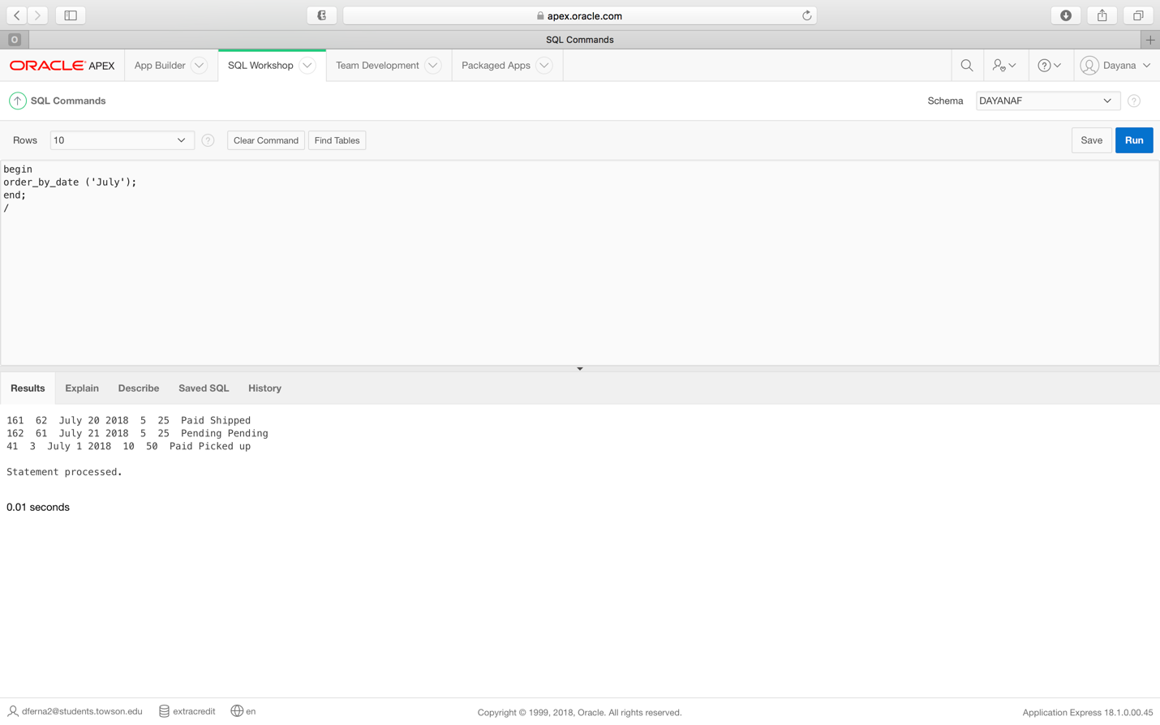

***Requirement 21 error message***

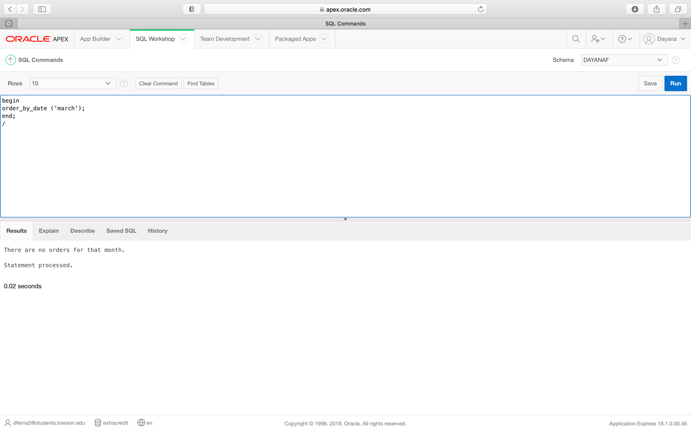

**Requirement 22**: (Using a procedure): Given an Item_ID, the system will be able to select all sales of that item. If there are no sales of that item, then a message will be returned.

***Requirement 22 procedure code***

create or replace Procedure sales_by_item_ID

(v_item_ID sales_by_item.item_ID%TYPE)

AS

v_count number;

CURSOR c_sales_by_item IS

Select sale_ID,item_ID,order_ID,quantity_sold,price

From sales_by_item

where upper(item_ID) = upper(v_item_ID);

begin

select count(*)

into v_count

from sales_by_item

where upper(v_item_ID) = (item_ID);

if v_count = 0 then

dbms_output.put_line('There are no sales of that item.');

end if;

FOR v_sales_by_item_data IN c_sales_by_item LOOP

DBMS_OUTPUT.PUT_LINE(TO_CHAR(v_sales_by_item_data.sale_id) || ' ' ||

v_sales_by_item_data.item_ID || ' ' || TO_CHAR(v_sales_by_item_data.order_ID) ||

' ' || v_sales_by_item_data.quantity_sold ||

' ' || TO_CHAR(v_sales_by_item_data.price));

END LOOP;

END;

***Requirement 22 procedure execution***

begin

sales_by_item_ID ('41');

end;

/

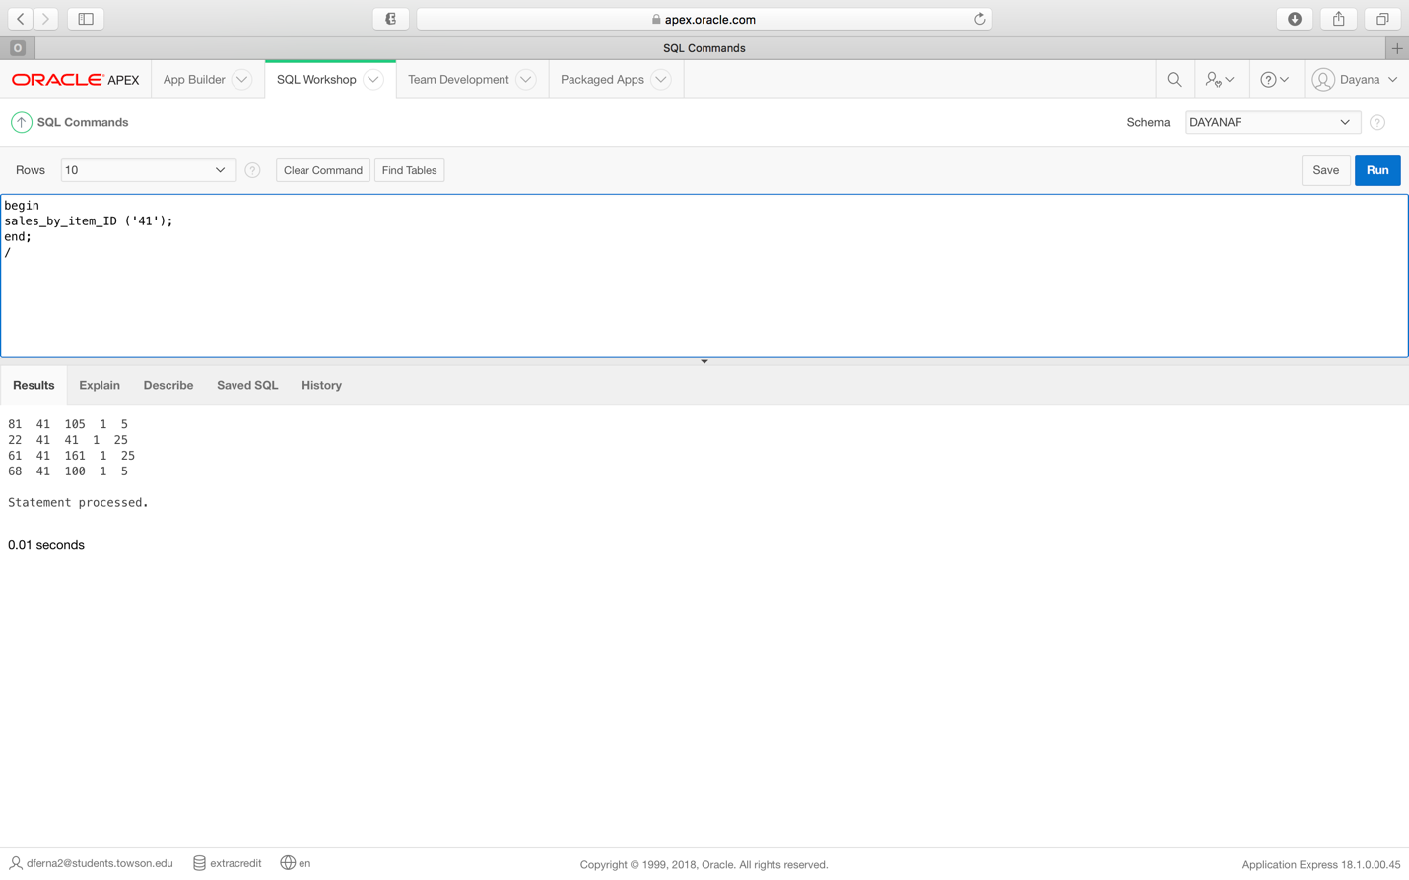

***Requirement 22 error message***

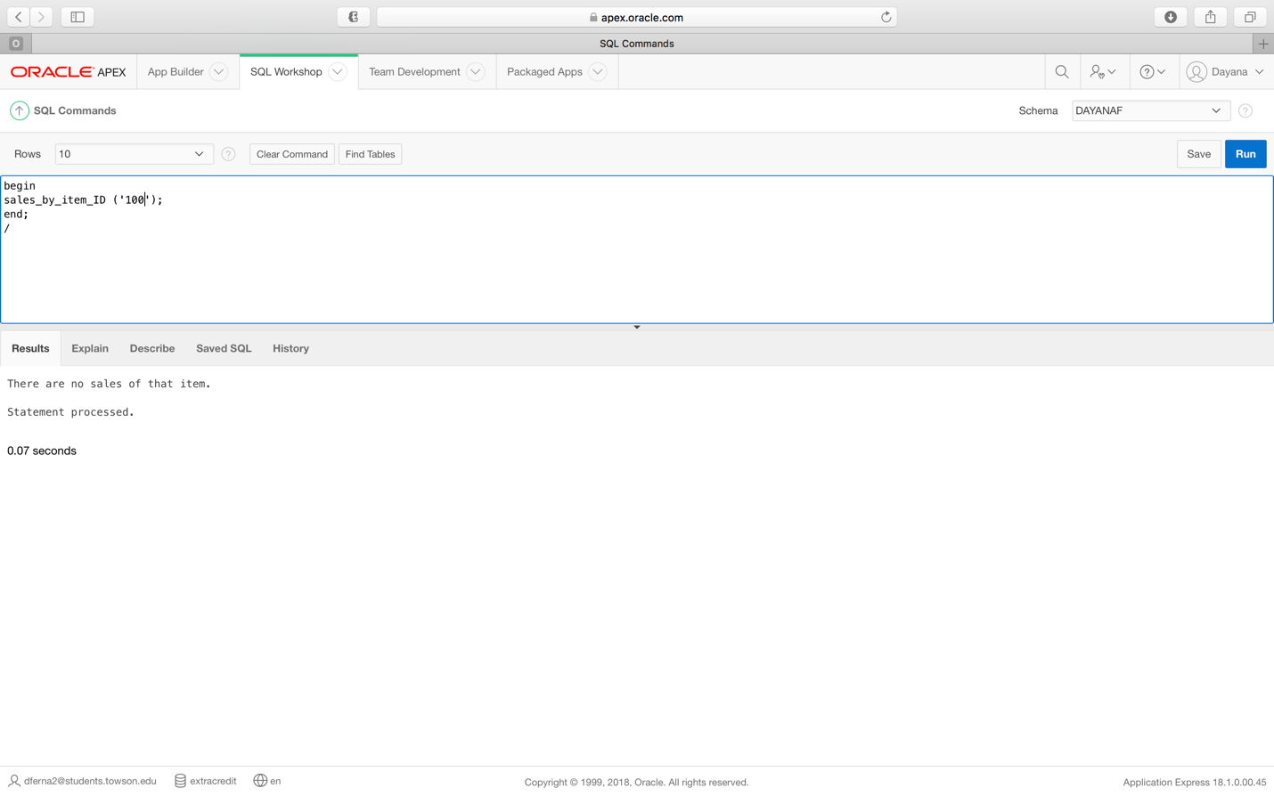

**Requirement 23**: (Using a procedure): Given a payment status, the system should be able to select all orders with that status.

***Requirement 23 procedure code***

create or replace Procedure order_by_payment_status

(v_payment_status orders.payment_status%TYPE)

AS

v_count number;

CURSOR c_orders IS

Select order_ID,customer_ID,order_date,number_of_items,total_price,payment_status,delivery_status

From orders

where upper(payment_status) = upper(v_payment_status);

begin

FOR v_orders_data IN c_orders LOOP

DBMS_OUTPUT.PUT_LINE(TO_CHAR(v_orders_data.order_id) || ' ' ||

v_orders_data.customer_ID || ' ' || TO_CHAR(v_orders_data.order_date) ||

' ' || v_orders_data.number_of_items ||

' ' || TO_CHAR(v_orders_data.total_price) ||

' ' || v_orders_data.payment_status || ' '|| TO_CHAR(v_orders_data.delivery_status));

END LOOP;

END;

***Requirement 23 procedure execution***

begin

order_by_payment_status ('pending');

end;

/

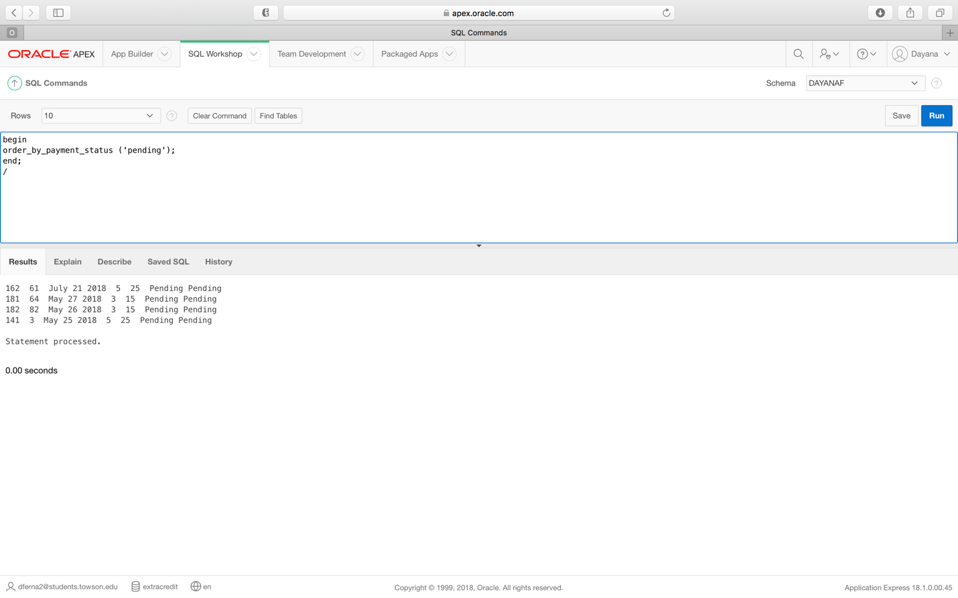

**Requirement 24**: (Using a procedure): Given a delivery status, the system should be able to select all orders with that status.

***Requirement 24 procedure code***

create or replace Procedure order_by_delivery_status

(v_delivery_status orders.delivery_status%TYPE)

AS

v_count number;

CURSOR c_orders IS

Select order_ID,customer_ID,order_date,number_of_items,total_price,payment_status,delivery_status

From orders

where upper(delivery_status) = upper(v_delivery_status);

begin

FOR v_orders_data IN c_orders LOOP

DBMS_OUTPUT.PUT_LINE(TO_CHAR(v_orders_data.order_id) || ' ' ||

v_orders_data.customer_ID || ' ' || TO_CHAR(v_orders_data.order_date) ||

' ' || v_orders_data.number_of_items ||

' ' || TO_CHAR(v_orders_data.total_price) ||

' ' || v_orders_data.payment_status || ' '|| TO_CHAR(v_orders_data.delivery_status));

END LOOP;

END;

***Requirement 24 procedure execution***

begin

order_by_delivery_status ('shipped');

end;

/

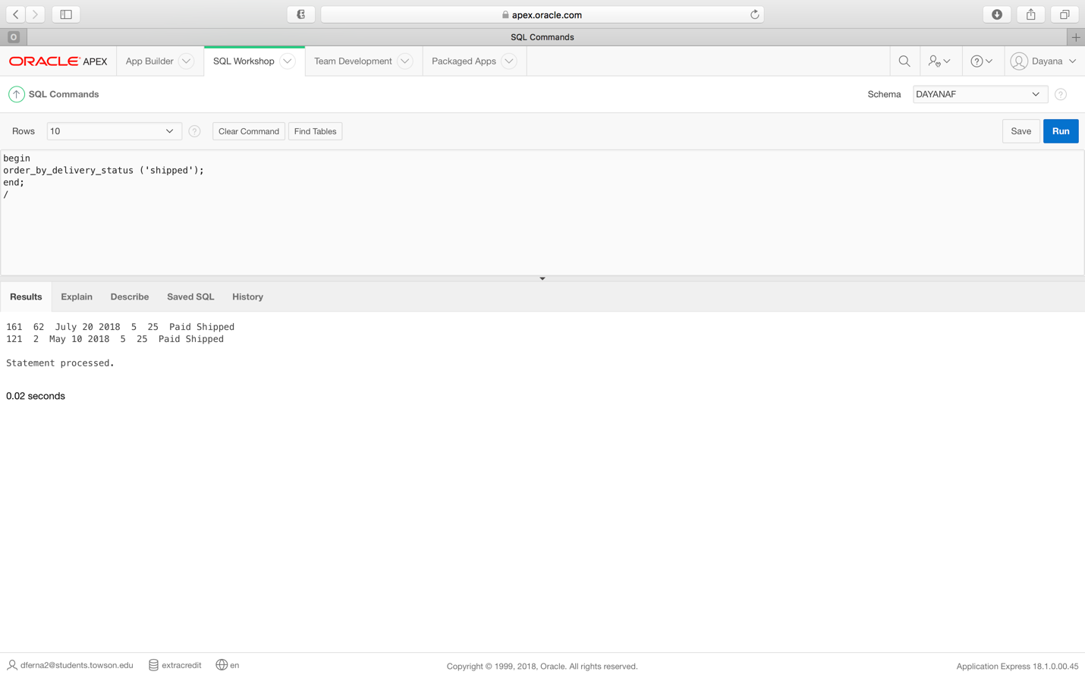

**Requirement 25**: (Using a procedure) Given an item type, the system should be able to select all customers who have frequently bought that particular item type.

***Requirement 25 procedure code***

create or replace Procedure customer_by_item_type

(v_frequently_bought_item_type customers.frequently_bought_item_type%TYPE)

AS

v_count number;

CURSOR c_customers IS

Select customer_ID,name,frequently_bought_item_type,address,city,state,zip,birthday

From customers

where upper(frequently_bought_item_type) = upper(v_frequently_bought_item_type);

begin

FOR v_customers_data IN c_customers LOOP

DBMS_OUTPUT.PUT_LINE(TO_CHAR(v_customers_data.customer_id) || ' ' ||

v_customers_data.name || ' ' || TO_CHAR(v_customers_data.frequently_bought_item_type) ||

' ' || v_customers_data.address ||

' ' || TO_CHAR(v_customers_data.city) ||

' ' || v_customers_data.state || ' ' || TO_CHAR(v_customers_data.zip || ' ' || v_customers_data.birthday));

END LOOP;

END;

***Requirement 25 procedure execution***

begin

customer_by_item_type ('earrings');

end;

/

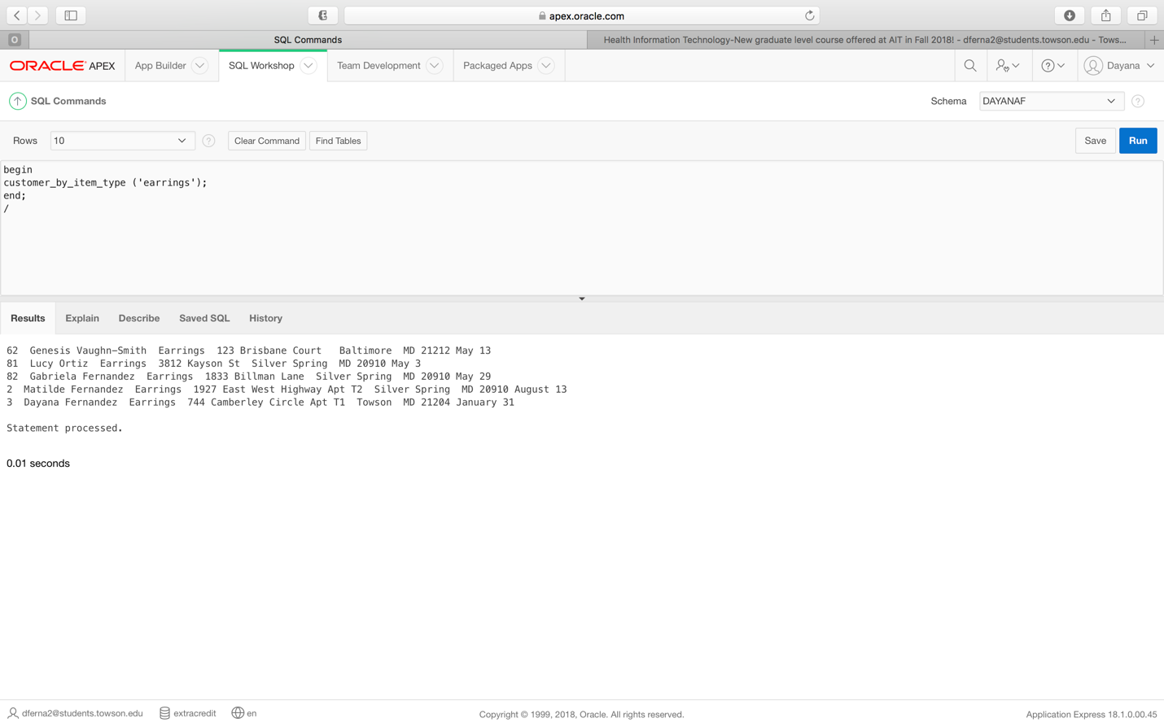

**Requirement 26:** (Using a procedure) Given a customer ID, the system should be able to select all the orders placed by that customer.

***Requirement 26 procedure code***

create or replace Procedure order_by_customer_ID

(v_customer_ID orders.customer_ID%TYPE)

AS

v_count number;

CURSOR c_orders IS

Select order_ID,customer_ID,order_date,number_of_items,total_price,payment_status,delivery_status

From orders

where (customer_ID) = (v_customer_ID);

begin

FOR v_orders_data IN c_orders LOOP

DBMS_OUTPUT.PUT_LINE(TO_CHAR(v_orders_data.order_id) || ' ' ||

v_orders_data.customer_ID || ' ' || TO_CHAR(v_orders_data.order_date) ||

' ' || v_orders_data.number_of_items ||

' ' || TO_CHAR(v_orders_data.total_price) ||

' ' || v_orders_data.payment_status || ' '|| TO_CHAR(v_orders_data.delivery_status));

END LOOP;

END;

***Requirement 26 procedure execution***

begin

order_by_customer_ID (22);

end;

/

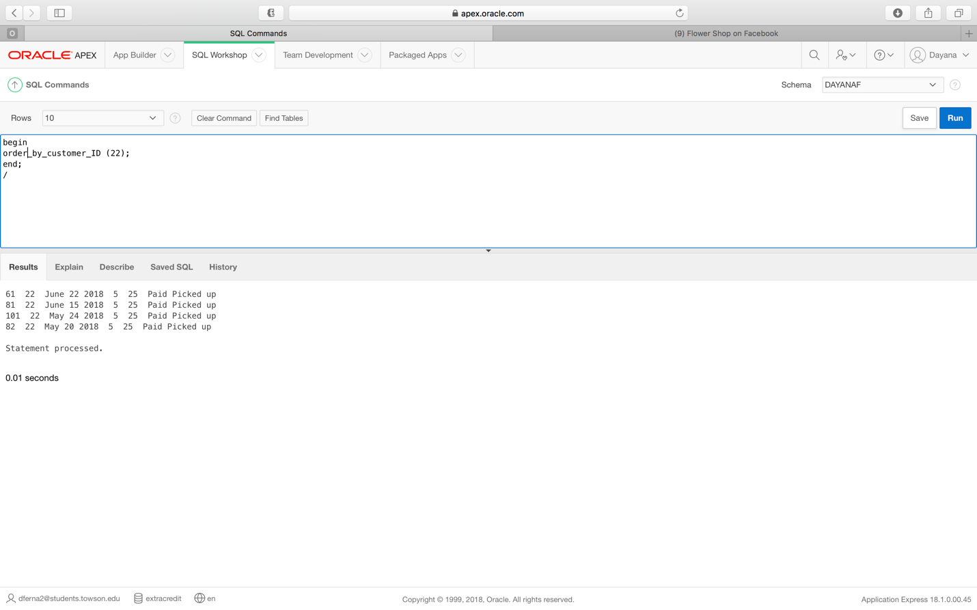

## IX. Proposed Schedule

|  |  |  |
| --- | --- | --- |
| **Activities** | **Estimated Time (in hours)** | **Dates** |
| Case Study Cover Sheet | 10 | 4/27/18 |
| Case Study Detailed Proposal | 10 | 4/27/18 |
| Detailed Requirements Specification | 30 | 6/8/18 |
| Advisor meeting | 1 | 6/15/18 |
| Entity Relationship Diagram | 20 | 6/18/18 |
| Advisor meeting | 1 | 6/20/18 |
| Data Dictionary | 10 | 6/22/18 |
| Advisor meeting | 1 | 6/26/18 |
| Table creation | 10 | 7/3/18 |
| Data input | 10 | 7/10/18 |
| Advisor meeting | 1 | 7/13/18 |
| Architecture Plan | 25 | 7/17/18 |
| Advisor meeting | 1 | 7/24/18 |
| Final Project Package | 10 | 7/31/18 |

## X. Actual Schedule

|  |  |  |
| --- | --- | --- |
| **Activities** | **Estimated Time (in hours)** | **Dates** |
| Case Study Cover Sheet | 10 | 4/27/18 |
| Case Study Detailed Proposal | 10 | 4/27/18 |
| Detailed Requirements Specification | 22 | 6/18/18 |
| Advisor meeting (email) | 15 minutes | 6/18/18 |
| Entity Relationship Diagram | 20 | 7/6/18 |
| Data Dictionary | 10 | 7/6/18 |
| Architecture Plan | 24 | 7/6/18 |
| Advisor meeting (email) | 15 minutes | 7/10/18 |
| Advisor meeting (email) | 15 minutes | 7/14/18 |
| Advisor meeting (email) | 15 minutes | 7/15/18 |
| Advisor meeting (email) | 15 minutes | 7/17/18 |
| Table creation | 10 | 7/18/18 |
| Data input | 10 | 7/18/18 |
| Procedures & triggers | 10 | 7/18/18 |
| Advisor meeting (in person) | 1 | 7/19/18 |
| Advisor meeting (email) | 15 minutes | 7/25/18 |
| Advisor meeting (in person) | 1 | 7/26/18 |
| Advisor meeting (email) | 15 minutes | 7/28/18 |
| Advisor meeting (email) | 15 minutes | 7/30/18 |
| Final Project Package | 10 | 8/5/18 |

## XI. Challenges & Lessons Learned

This case study really tested my patience and confidence. When I started out, I knew it wasn’t going to be easy because of its magnitude and scope, but I was confident because I knew I could code in SQL because I have done it so much. But honestly, I couldn’t have been more wrong, not so much on the coding-side, (although that presented challenges as well) but with every other aspect of the project. Staring with requirements, I wish I had gone with a fictitious company because requirements would have been a bit easier to come up with. I found myself constantly changing them up to the very end because things just weren’t working the way I expected or needed. It was really strange because even though I took both database courses and have been dealing with coding requirements for a while, I found writing them out at a high level to be a bit challenging.

The time crunch that I ended up under was a big factor here because it started out being a normal summer where this case study was the only thing on my plate, but I had many things happen and I ended up having to work on the case study in the midst of chaos, having to turn in several parts at once for feedback because of the race against the clock. Not to mention that I had to re-de several big parts of the project because my laptop died, and I lost everything. Yes, I know I should have backed up things, as this always tends to happen to me at the worst times. I had certainly planned to back things up but with all the craziness, I hadn’t gotten a chance to do it.

Furthermore, to top things off, once I started the actual coding portion in APEX, somehow the entered data and the procedure and trigger coding disappeared from the schema that I had created for this particular project. So, that meant I had to use the previously created schema that I had used for 632 and 732. I had to re-code everything from scratch as well because things never reappeared on the new schema. The biggest lesson to learn here is to pace yourself when working on such a big project, while also keeping in mind that no matter how much you plan, things can still go wrong and you should try to deal with them in a timely fashion and with a leveled head. I think that the most valuable lesson I learned here was the fact that you should never give up when things get tough because there is always a solution, it’s just a question of finding it. The gratifying feeling of getting to the end and seeing the light at the end of the tunnel after a tough situation or a tough project is incredible!

## XII. Acknowledgements

I’d like to extend heartfelt thanks to Prof. Harry Shasho! Prof. thank you so much for everything! Your patience and support throughout this whole crazy roller coaster of a journey, has been invaluable and I couldn’t have gotten to the end without you! A very special thank you especially for your support and understanding during this last month, with everything that has happened. Thank you for accepting the topsy turvy challenge of being my advisor, haha. To semi-quote Cheryl, but referring to me this time, I was your student for both courses and you still said yes to more craziness with me, haha! It has honestly been an honor and a privilege to have been your student for 632 and 732 and now your advisee for 735. You are truly amazing!

Dr. Chakraborty, thank you to you as well for the extension and your understanding! I truly appreciate it! Finally, Andrea Chenowith, thank you for helping with communication back and forth! AIT is truly fortunate to have you!

## XIII. Reading List/Bibliography/Works Cited

# [1] Alvaro, F. (2017). SQL: Easy SQL Programming & Database Management For Beginners, Your Step-By-Step Guide To Learning The SQL Database. Kindle Edition.

[2] Beaulieu, A. (2009). Learning SQL: Master SQL Fundamentals. O’Reiley Media, Inc. Sebastopol, California.

[3] Beighley, L. & Morrison, M. (2009). Head First PHP & MySQL. O’Reiley Media, Inc. Sebastopol, California.

# [4] Beighley, L. (2007). Head First SQL: Your Brain on SQL: A Learner's Guide. O’Reiley Media, Inc. Sebastopol, California.

# [5] ClydeBank Technology. (2016). SQL QuickStart Guide: The Simplified Beginner's Guide To SQL. ClydeBank Media, LLC. Albany, New York.

[6] Connolly, T. & Begg, C. (2015). Database Systems: A Practical Approach to Design, Implementation, and Management. Pearson Education, Inc. Upper Saddle River, New Jersey. Sixth Edition.

# [7] Gennick, J. (2011). SQL Pocket Guide: A Guide to SQL Usage. O’Reiley Media, Inc. Sebastopol, California. Third Edition.

[8] “Oracle Apex”, Oracle. May 24, 2018. [Online.] Available: <https://apex.oracle.com/en/>. [Accessed: June 1, 2018].

[9] “SQL”, Wikipedia, Wikimedia Foundation, Inc. May 23, 2018. [Online.] Available: <https://en.wikipedia.org/wiki/SQL>. [Accessed: May 25, 2018].

# [10] Tale, S. (2016). SQL: The Ultimate Beginners Guide: Learn SQL Today. Kindle Edition.

[11] Taylor, A. (2011). SQL All-in-one for Dummies. John Wiley & Sons, Inc. Hoboken, New Jersey. Second Edition.

[12] Valade, J., Ballad, T. & Ballad, B. (2008). PHP & MySQL Web Development: All-in-One Desk Reference for Dummies. John Wiley & Sons, Inc. Hoboken, New Jersey.

[13] Welling, L. & Thompson, L. (2009). PHP and MySQL Web Development. Pearson Education, Inc. Upper Saddle River, New Jersey. Fourth Edition.